|  |
| --- |
| Barony of Tir-y-Don  The NoD-y-Rit  July-Aug AS 59 (CE 2025)  Volume 45 Issue 2 Society of Creative Anachronism (SCA Inc.) |

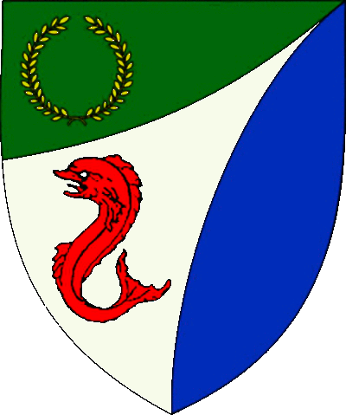

|  |
| --- |
| **Table of Contents**  Weekly Activities in the Barony 2  Arts & Science and Social Schedule 3  Virtual A&S Opportunities 3  Kingdom Calendar 4  The Barony Around the Web 6  Baronial Meeting Notes 7  Baronial Officer Regnum 10  Statement of Ownership 11  Submissions & Disclaimer 11  Marshal Information 12  Award Recommendations 12  Letters from Their Excellencies…….13 |

## The Coronet of the Barony of Tir-y-Don

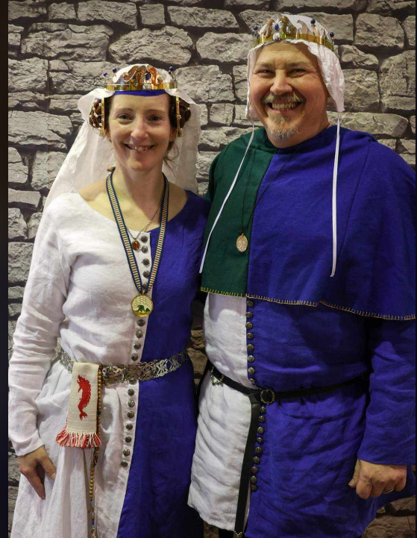

This is the July-Aug 2025 issue of the NoD-Y-Rit, a publication of the Barony of Tir-Y-Don of the Society for Creative Anachronism, Inc. The Nod-Y-Rit is available from Anna van Sint Maartensdyjk at chronicler@tirydon.atlantia.sca.org. Subscriptions are free as all publications are available electronically. This newsletter is not a corporate publication of the Society for Creative Anachronism, Inc., and does not delineate SCA policies.

© Copyright 2025, Society for Creative Anachronism, Inc. For information on reprinting letters and artwork from this publication, please contact the Tir-Y-Don Chronicler, who will assist you in contacting the original creator of the piece. Please respect the legal rights of our contributors.

Their Excellencies:

***Baron Jean-Claude de Calais***

***Baroness Alina of the Ilex***

*Photo Credit: Llwyd Aldrydd*

# Weekly Activities in the Barony

|  |  |  |
| --- | --- | --- |
| Sundays |  |  |
| **10AM** | Archery Practice Contact Marshal of Archery **Newport News City Park**  Archery Range | Call 757-888-3333 for Safety Class Schedule.  Call Marshal of Archery before attending. |
| Take the Archery Safety Class online. You can email the completed test to the parks department.  Your card will be emailed to you.  <https://www.nnva.gov/2561/Archery-Range> | | |
| **1PM** | Fighter Practice and Social Heavy/Rapier  Contact Knight Marshal | Please contact the Marshal if you wish to attend. |
| Tuesdays |  |  |
| **6PM** | Fitness Focus **Cornerstone Community Church**  **1003 Moyer Rd, Newport News, VA 23608** | General fitness training |
| Thursdays |  |  |
| **7PM** | Arts & Sciences and Social Contact MOAS  Arts & Science and Social Schedule | Contact MOAS for more details – In person, some hybrid sessions |

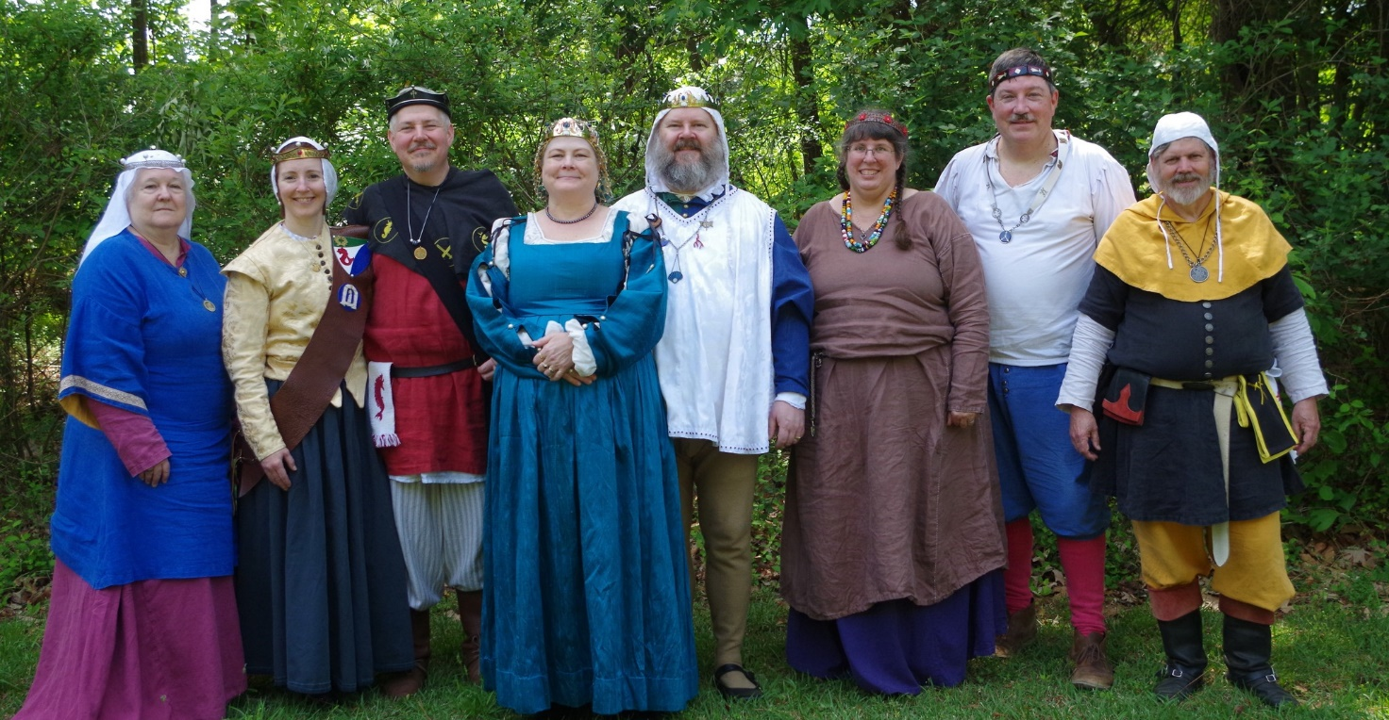

Photo Credit:   
Current and past landed baronage at Baronial Birthday

# Arts & Science and Social Schedule

Classes start at 7pm unless otherwise noted! Classes are held at **Cornerstone Community Church** **1003 Moyer Rd, Newport News, VA 23608**. Business meeting nights will be hybrid in person and online.

|  |
| --- |
| Please check the baronial Facebook group for up to date meeting information. |

**3/6/2025**Learning how to use your sewing machine

**3/13/2025**Scribal Night

**3/20/2025**Business Meeting

**3/27/2025**Japanese Books Make and Take

**4/3/2025**Sari Tying / Veil Draping

**4/10/2025**Scribal Night

**4/17/2025**Business Meeting

**4/24/2025**6 Embroidery Stitches from the 16th C

**5/1/2025**Hedeby Bags

**5/8/2025**Baronial Event last minute planning or tasks

**5/15/2025**Scribal Night

**5/22/2025**Business Meeting and Pennsic Planning

**5/29/2025**Shields: Start to Finish

**6/5/2025**SCA First Aid

**6/7/2025**Group Sewing Day

**6/12/2025**Scribal Night

**6/19/2025**Business Meeting

**6/26/2025**Metal Jewelrymaking

**7/4/2025**July 4 Party and Business meeting

**7/10/2025**Loaner Garb and Gear Sort and Fix (at their Excellencies manor)

**7/12/2025**Group Sewing Day

**7/17/2025**Cheese!

**7/24/2025**Pennsic Packing

**7/31/2025** No class, Pennsic Prep

**9/4/2025** Pennsic Recap and Planning

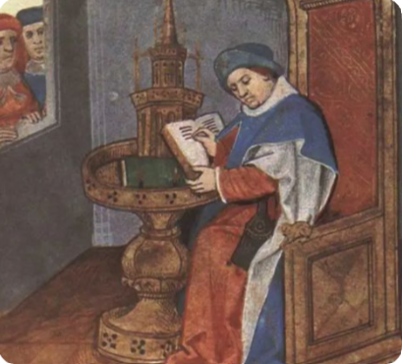

# Virtual A&S Opportunities

|  |  |  |
| --- | --- | --- |
| Virtual Atlantia | Atlantia has setup a Virtual A&S center which includes a calendar of online course offerings, the ability to request a class to be added to the calendar and a way to get credit for the University of Atlantia. Be sure to check it out for an update to date listing of virtual classes throughout the Kingdom. | <http://virtual.atlantia.sca.org/> |
| SCA Virtual Classroom and Artisan Display | Teachers and artisans can share the virtual resources they've created to make them available SCA-wide to continue to foster a learning environment. | <https://www.facebook.com/groups/virtualsca/> |
| Known World Discord | A large discord server that has chat rooms for multiple topics, lots of classes, feedback, and opportunities to connect with artists, fighters, and anyone else across the Known World. | <https://discord.gg/bDavK8> |

Know of any opportunities not listed here? Let us know so we can add them!

Contact the Chronicler via Email, Facebook, or Discord

# Kingdom Calendar

*Please refer to the* [*Kingdom Calendar*](https://atlantia.sca.org/calendar/) *website for up to date information regarding event cancellations or changes.*

#### **Sept-2025**

09-05 - 09-07 : [Sacred Stone Baronial Birthday 2025: A Celebration of Mehregan](https://atlantia.sca.org/event/?event_id=679708a1) :*Boonville NC (Sacred Stone)* (Q K )

09-05 - 09-07 : [Battle on the Bay- Ride of the 4 Horsemen](https://atlantia.sca.org/event/?event_id=67d5aeac) :*Upper Marlboro MD (Storvik)*

09-13 - 09-13 : [Stierbach Baronial Birthday](https://atlantia.sca.org/event/?event_id=678e8e2f) :*Culpeper VA (Stierbach)* (Q K )

09-13 - 09-13 : [Phoenix Rising: A Newcomers Nest](https://atlantia.sca.org/event/?event_id=682888f7) :*Charlotte NC (Charlesbury Crossing)*

09-14 - 09-14 : [Curia](https://atlantia.sca.org/event/?event_id=9477df52) :*(Atlantia)* (Q K Pr P )

09-20 - 09-20 : [Fall University (TBD)](https://atlantia.sca.org/event/?event_id=88ef90b5) :*(Atlantia)*

09-26 - 09-28 : [Trial By Fire & Lochmere Arrow: Alba gu bràth!](https://atlantia.sca.org/event/?event_id=66eb7df7) :*Glen Arm MD (Bright Hills)*

09-27 - 09-27 : [Silver Chalice Novice Tournament](https://atlantia.sca.org/event/?event_id=67b48604) :*Harleyville SC (Hidden Mountain)*

*09-27 - 09-27 :*[*Heralds & Scribes Workshop*](https://atlantia.sca.org/event/?event_id=67e365ad)*:Salem VA (Black Diamond)*

#### **Oct-2025**

10-04 - 10-04 : [Fall Coronation](https://atlantia.sca.org/event/?event_id=687ced7c) :*Bahama NC (Kapellenberg)* (Q K Pr P ) [](https://moas.atlantia.sca.org/cultura-atlantia)

10-10 - 10-13 : [Emerald Hastilude IV](https://atlantia.sca.org/event/?event_id=68a909b3) :*Lanexa VA (Tir-y-Don)*

10-11 - 10-19 : [War of the Wings, 2025](https://atlantia.sca.org/event/?event_id=67901f7d) :*Harmony NC (Atlantia)* (Q K )

10-25 - 10-26 : [Hallowed Market](https://atlantia.sca.org/event/?event_id=680a23a1) :*Culpeper VA (Ponte Alto)*

10-31 - 11-02 : [Memento Mori: The Nightmare Before Yule](https://atlantia.sca.org/event/?event_id=6797c501) :*Old Fort NC (Haukesgate)*

10-31 - 11-02 : [A Festival of Bones](https://atlantia.sca.org/event/?event_id=67a5664f) :*Nanjemoy MD (Dun Carraig)* (Q )

#### **Nov-2025**

11-01 - 11-01 : [Goblin Games](https://atlantia.sca.org/event/?event_id=68249bed) :*Richmond VA (Caer Mear)*

11-07 - 11-09 : [Fall Crown Tournament](https://atlantia.sca.org/event/?event_id=68a1d401) :*Courtland VA (Marinus)* (Q K Pr P ) [](https://moas.atlantia.sca.org/tempore-atlantia)

11-14 - 11-16 : [Highland Havoc; Ride of Enbarr](https://atlantia.sca.org/event/?event_id=68470115) :*Ijamsville MD (Highland Foorde)* (Q K Pr P )

11-21 - 11-23 : [Buckston Birthday](https://atlantia.sca.org/event/?event_id=673feafa) :*Apex NC (Buckston-on-Eno)* (K )

11-22 - 11-22 : [Holiday Faire](https://atlantia.sca.org/event/?event_id=684b160a) :*Fredericksburg VA (Stierbach)*

#### **Dec-2025**

12-06 - 12-06 : [Unevent 2025](https://atlantia.sca.org/event/?event_id=dd54418d) :*(Atlantia)*

12-12 - 12-14 : [Yule Toy Tourney](https://atlantia.sca.org/event/?event_id=6873f79d) :*Pickens SC (Nottinghill Coill)*

#### **Jan-2026**

01-10 - 01-10 : [Kingdom Twelfth Night](https://atlantia.sca.org/event/?event_id=57e32767) :*(Atlantia)* (Q K ) [](https://moas.atlantia.sca.org/tempore-atlantia)

01-16 - 01-18 : [Nottinghill Coill Baronial Birthday XLVI](https://atlantia.sca.org/event/?event_id=687ea9f0) :*Bennettsville SC (Nottinghill Coill)*

01-24 - 01-24 : [Highland Hearthglow](https://atlantia.sca.org/event/?event_id=6805903e) :*Thurmont MD (Highland Foorde)*

01-31 - 01-31 : [Midwinters Revel: The Way of the Pilgrim](https://atlantia.sca.org/event/?event_id=68418e93) :*Lothian MD (Lochmere)*

#### **Feb-2026**

02-07 - 02-07 : [Bright Hills Baronial Birthday](https://atlantia.sca.org/event/?event_id=68379e83) :*Manchester MD (Bright Hills)*

02-07 - 02-08 : [Winter University 2026](https://atlantia.sca.org/event/?event_id=ff45bfbd) :*(Atlantia)*

02-07 - 02-07 : [Sir Walter Raleigh Costume Ball IV](https://atlantia.sca.org/event/?event_id=687e98fb) :*Durham NC (Windmasters' Hill)*

02-14 - 02-14 : [Tourney of Manannan mac Lir XLIV](https://atlantia.sca.org/event/?event_id=68057917) :*Harleyville SC (Tear-Sea's Shore)* (K )

02-27 - 03-01 : [Children of Loki, Raven's Cove Baronial Birthday](https://atlantia.sca.org/event/?event_id=68705323) :*Richalands NC (Raven's Cove)*

# The Barony Around the Web

Many members of the populace have a Web Presence. Please visit their websites and share in the great content. Please contact the Chronicler if you want to promote your site.

Baroness Jane Fox <https://jezebeljane.blogspot.com/>

Baron John Biggeheved <https://biggeheved.com/>

Mistress Kaleeb the Green Eyed <http://kaleeb.galtham.org/>

Learn Fiore <http://learnfiore.org/>

Baron Llwyd Aldrydd <http://baronllwyd.org/>

Lady Mariss Ghijs <https://opusmariss.wordpress.com>

Lady Mevanou verch Reys Yriskynit <https://mvry1sca.wordpress.com/>

## Baronial website

Our Web Minister maintains our baronial website. He can be contacted with any content changes.

<https://www.tirydon.atlantia.sca.org>

## Baronial Facebook Group

We share some informal announcements and share content on our Facebook group. It’s another way to stay connected with those in the Barony.

<https://www.facebook.com/groups/343471645861986/>

## Kingdom eNewsletters

Log in with your SCA Member Portal username and password. This requires at least an associate membership to access. Please contact SCA corporate with any log in issues.

<https://members.sca.org/apps/#SignIn>

# Baronial Meeting Notes

|  |  |
| --- | --- |
| Location: | Cornerstone Community Church and virtual |
| Date and Time:  Aug 21, 2025 | Next Meeting’s Date and Time:  Thurs Sept 13, 7:00pm Cornerstone Community Church |

Baron and Baroness

Their Excellencies extend their thanks to the Pennsic campers for a drama-free event and for helping with hospitality.

Sir Tnek is being elevated to the Order of the Mark at Stierbach.

Please let them know if you will be attending any upcoming events so that sufficient pavilions can be provided. If you are attending War of the Wings, let Her Excellency know if you can be present for land grab.

Please think about flyers that will help us recruit folks.

If you have demo ideas, please let the Chatelaine know. We'd like to get the group more public and there are no bad ideas!

Officer Reports

### Seneschal

### Mariana will be taking over as Exchequer

### Exchequer

### Mariana will be taking over as Exchequer

### Chatelaine

### Hope to see new people from Neppie Wars

### Falloween- we have been accepted in the historic area again this year (with honorarium!)

### Check out ideas on Discord.

### Chronicler

Submission deadline is the 25th. Please send content.

Herald

Quarterly report has been submitted. Some newish people from Pennsic are working on their arms.

### Knight Marshal

### Sunday practice at Nike Park with Marinus now

### Tuesday night TNT is also ongoing at 6pm. Some conditioning and specific training at Cornerstone Church Updates about practices are on Fight Club Discord, Campfire, and Combat by the Sea

### Archery

### 10 people at the most recent practice; Sir Tnek is being elevated to the Order of the Mark

### Equestrian

### There is interest in archery on horseback. The location for the next Hastilude is Emerald Ridge stables (same as last year, but different dates)

### Arts and Sciences

The sewing events went so well that more will be planned.

Social Media

### NTR

### Web Minister

Web needs to be updated for Roster changes - Can get email password changes done if needed

Old & New Business

## Old Business

Update on KASF bid – WE WON!!! It will be the first weekend in March at the Hellenic Center in NN where we had it two years ago. Get those A&S projects started!

Falloween is the first weekend of Oct (opposite War of the Wings ☹). There is limited parking and table space.

Marinus is hosting Crown Tourney with Tir y don’s assistance. If you are interested in helping in any area, please let Their Excellencies know.

## New Business

We are looking at two sites for Baronial Birthday – Riverview Park and Cornerstone Church. The tentative date is April 25th.

We would like to put together a demo and/or booth for Bacon’s Castle Renaissance Faire, which will be held Nov 15-16. If you are interested, please contact Britney.

# Baronial Officer Regnum

|  |  |  |  |
| --- | --- | --- | --- |
| http://tirydon.atlantia.sca.org/wp-content/uploads/2018/11/tyd-1-251x300-1.gif | **Baron:** | Jean-Claude du Calais (Jim Cunningham) | [baron@tirydon.atlantia.sca.org](mailto:baron@tirydon.atlantia.sca.org) 757-968-5303 NLT 9pm |
| http://tirydon.atlantia.sca.org/wp-content/uploads/2018/11/tyd-1-251x300-1.gif | **Baroness:** | Alyna of the Ilex (Holly Cunningham) | [baroness@tirydon.atlantia.sca.org](mailto:baroness@tirydon.atlantia.sca.org) 757-968-5303 NLT 9pm |
| http://tirydon.atlantia.sca.org/wp-content/uploads/2018/11/o_sen.gif | **Seneschal (President):** | Llwyd Aldrydd (Lloyd Eldred) | [seneschal@tirydon.atlantia.sca.org](mailto:seneschal@tirydon.atlantia.sca.org) (757) 875-0033 NLT 9pm |
| http://tirydon.atlantia.sca.org/wp-content/uploads/2018/11/o_exch.gif | **Chancellor of the Exchequer (Treasurer):** | Sarah Kennedy of Glengarry (Sarah Kennedy) | [exchequer@tirydon.atlantia.sca.org](mailto:exchequer@tirydon.atlantia.sca.org) NLT 9pm |
| http://tirydon.atlantia.sca.org/wp-content/uploads/2018/11/o_chat.gif | **Chatelaine (New member support):** | Andrei Barsukov (Andrew LaVinus) | [chatelaine@tirydon.atlantia.sca.org](mailto:chatelaine@tirydon.atlantia.sca.org)  (804) 869-8882 NLT 9:30pm |
| http://tirydon.atlantia.sca.org/wp-content/uploads/2018/11/o_chr.gif | **Chronicler**  **(Secretary):** | Anna van Sintmaartensdyck (Nancy Kiel) | [chronicler@tirydon.atlantia.sca.org](mailto:chronicler@tirydon.atlantia.sca.org) (757) 220-6857, leave a message NLT 9:30pm |
| http://tirydon.atlantia.sca.org/wp-content/uploads/2018/11/o_chr.gif | **Social Media:** | Skye Walker | [socialmedia@tirydon.atlantia.sca.org](mailto:socialmedia@tirydon.atlantia.sca.org) |
| http://tirydon.atlantia.sca.org/wp-content/uploads/2018/11/o_herald.gif | **Herald:** | Catheryn inghean Ui Dhubhshlaine (Amanda Carter) | [herald@tirydon.atlantia.sca.org](mailto:herald@tirydon.atlantia.sca.org) |
| http://tirydon.atlantia.sca.org/wp-content/uploads/2018/11/o_marshal.gif | **Knight’s Marshal:** | Christina O’Cleary  (Jessica Lavinus) | [marshal@tirydon.atlantia.sca.org](mailto:marshal@tirydon.atlantia.sca.org) NLT 9pm |
| http://tirydon.atlantia.sca.org/wp-content/uploads/2018/11/o_marshal.gif | **Marshal of Archery:** | Skye Walker | [archer@tirydon.atlantia.sca.org](mailto:archer@tirydon.atlantia.sca.org) |
| http://tirydon.atlantia.sca.org/wp-content/uploads/2018/11/o_as.gif | **Minister of Arts & Sciences:** | Cairistiona inghean Mhuireadhaigh (Carol Vanderspoel) | [moas@tirydon.atlantia.sca.org](mailto:moas@tirydon.atlantia.sca.org) (757) 819-3296 NLT 9:30pm |
| Office Badge | **Webminister:** | Llwyd Aldrydd (Lloyd Eldred) | [webminister@tirydon.atlantia.sca.org](mailto:webminister@tirydon.atlantia.sca.org) (757) 875-0033 NLT 9:30pm |

# Statement of Ownership, Submissions & Disclaimer

This is the June – July 2025 issue of the NoD-y-Rit, a publication of the Barony of Tir-y-Don of the Society for Creative Anachronism, Inc. The Nod-y-Rit is available from Anna van Sint Maartensdyjk (Nancy Kiel) at [chronicler@tirydon.atlantia.sca.org](mailto:chronicler@tirydon.atlantia.sca.org) and Nancy_kiel@hotmail.com. Subscriptions are free as all publications are available electronically. This newsletter is not a corporate publication of the Society for Creative Anachronism, Inc., and does not delineate SCA policies.

© Copyright 2024, Society for Creative Anachronism, Inc. For information on reprinting letters and artwork from this publication, please contact the Tir-y-Don Chronicler, who will assist you in contacting the original creator of the piece. Please respect the legal rights of our contributors.

Please send submissions to:

Nancy Kiel

108 Wilson Circle, Williamsburg VA

[chronicler@tirydon.atlantia.sca.org](mailto:chronicler@tirydon.atlantia.sca.org)

Nancy_kiel@hotmail.com

***Please, remember that all submissions to the NoD-y-Rit must be accompanied by an SCA release form.*** The first link leads you to the Society Chronicler’s links for forms. The last three links are for the forms that can be submitted on line via Internet Form Fills. Everyone is encouraged to consider contributing to the NoD-y-Rit.

Society Chronicler forms:

<http://chronicler.atlantia.sca.org/Releases.html>

Release form for writing or artwork:

<http://chronicler.atlantia.sca.org/ReleaseCreativeFillable.pdf>

Release form for photographs:

<http://chronicler.atlantia.sca.org/ReleasePhotographerFillable.pdf>

Release form for model(s) (the subject of your artwork or photograph):

<http://chronicler.atlantia.sca.org/ReleaseModelFillable.pdf>

# Marshal Information

## Image result for mINISTER OF LIST BADGE SCABecome a MOL

Want to serve the Fighter Community by providing Tournament organization and keeping the Fighting Authorizations documented? Consider becoming a Minister of the List.

Please visit the Kingdom MOL website for more information and forms: <http://mol.atlantia.sca.org/ForMoLs/index.html>

## Become a Marshal

Do you enjoy fighting activities at events and practices? Many folks invest significant time to keep these activities safe. Consider becoming a marshal to help keep these activities happening in the future.

Please visit the Earl Marshals Website for more information: <https://marshal.atlantia.sca.org/procedures/mit/>

## Marshal Event Report Submission

Participants, Fighters and Marshals can all submit Event reports for fighting activities. If you see something you wish to report visit the Kingdom Earl Marshal Website. Include things like injuries, equipment failures, or other issues you see.

Submit a report here: <https://warrant.atlantia.sca.org/reports/new/1>

## Warranted Marshals

The Kingdom maintains a list of warranted marshals and Marshals in Training. A list of marshals who have expired warrants is also maintained here.

Visit: <https://warrant.atlantia.sca.org/warrants/branch/6/1>

# Award Recommendations

## Baronial Award Recommendations

Baronial Award Recommendations are sent to the Coronet. Please use [baron@tirydon.atlantia.sca.org](https://d.docs.live.net/55395330e2cd57ab/SCA/NODYRIT/baron@tirydon.atlantia.sca.org)  and [baroness@tirydon.atlantia.sca.org](https://d.docs.live.net/55395330e2cd57ab/SCA/NODYRIT/baroness@tirydon.atlantia.sca.org).

## Kingdom Award Recommendations

The Kingdom maintains a database of award recommendations and what events potential recipients will attend in the future. Visit: <https://award.atlantia.sca.org/>

## Review your Order of Precedence Entry

Recent name change or award? Please visit the Atlantia’s Order of Precedence (OP) and request any updates or corrections as needed.

Visit the OP here: <http://op.atlantia.sca.org>

Submit Corrections requests here: <http://op.atlantia.sca.org/corrections.php>

Letters from Their Excellencies

Greetings Tir-y-Don,

This month we will take a little sidestep in our “how to SCA” series with a bit about how to talk about the SCA. We’ve got a handful of opportunities coming up with Neppie Wars and Fall-o-Ween; but we also run into people in our day-to-day adventures that might be interested in the things we do. So let’s think a bit about the concept of “Everyone’s a Chatelaine.”

First, what do we mean by that? We certainly don’t mean that everyone has an official warrant for the Chatelaine Office. But we do mean that you have an opportunity to tell everyone about the SCA; and that they may get their first impressions of the SCA from you (no pressure). To us, this means that if you’re chatting with someone and they seem like they might be interested, bring it up. But bring it up casually and at a high level; there’s no need to overwhelm someone with a bunch of deep knowledge, when a simple “this is that thing I do on the weekends, let me share a (video, link, etc.)” will work just fine.

And that ties into point the second, don’t over explain the SCA. Use the idea of an elevator pitch and have one handy. Think of your elevator pitch as a 30-second invite into our world. We’ve all got variations based on what resonates:

· A brief overview for general curiosity

· A&S pitch for the creatively inclined

· Fighting or fencing pitch for adrenaline lovers

· Feasting and cooking for foodies

· Brewing, woodworking, or medieval games for niche passions

This helps people scan and imagine their own approach

Lastly, to go back to “Everyone’s a Chatelaine” (and this might be a bit controversial) maybe not everyone should be a Chatelaine. Not everyone is good at talking to the public, or talking with people they don’t know in general, or dialing down their excitement about something they love, AND THAT’S OK! We’re a big tent organization with all kinds of people who should feel welcome, and new people knowing there is a place for them is important. If they see someone like them in an organization, they are more likely to want to participate. So having folks who are a little uncomfortable with new people, or those who may not pick up those social cues as easily as others is good for us. We just need to be more comfortable with setting people up for success in the way they are comfortable, and not the way we are comfortable.

As always, the two of us are here for you. We hope that you are comfortable in letting us know where you feel best suited to help the Barony, help new people, and helping the Barony get new people.

**Chronicler’s comment: I usually describe it (at first blow) as medieval re-enacting, since the concept of re-enacting is becoming more widely known.

But wait – there’s more!

With all the talk of upcoming events, the busy calendar, and who’s going to which event, it might be good to talk about how to set yourself up for success when planning for them. You may have heard us talk about the different lists we have based on the types of events we attend, but our list might not be your list. So how do you make the best event experience for you?

Deciding which events to go to can be a task on its own. For some it comes down to drive time, for others it might be what’s being offered. But once you pick some events, save yourself some time and PRE-REGISTER! SCORES has given us the option of being cash free for events, so why not take advantage? A lot of people don’t even bother with checks, and having cash on hand can be iffy, so make sure to pre-register for those events. Don’t forget to do yourself a favor and check the refund policy for the group hosting the event first. For some you might need to request it prior to the event, for others you will have a 7-10 day window after the event to request a refund. So, make sure you go in aware.

Once you’ve picked the event, figure out what you might need to pack. This means asking those difficult questions like, do you need to bring your own food, are you camping, what activities do you plan to participate in, etc. Plan backwards from your day to figure out what you need. Start with the basics, garb, mug, chair. After that, look at activities. Will you be participating in arts, archery, thrown weapons, fighting? Make sure you have all that you need for that activity because there’s nothing worse than getting to the event and realizing you have forgotten something important. Don’t forget to think about food for lunch and if you’re attending feast!

While planning, make sure you plan your drive as well. You don’t want to miss activities because you didn’t realize how long the drive would take. This brings up an important point for travelling to events. Drive time does not necessarily match up with distance in Atlantia. You might see an event in Maryland that has the same drive time as an event in South Carolina. Make use of the information in the Kingdom Calendar to see which events not only look interesting, but which you can make in a time you’re comfortable with.

But back to lists… Alyna is happy to share her lists and give you ideas of how to make them work for you. You may be surprised at some of the things on our lists that run the gambit of things like local events that may take a lot of prep and packing, events where we bring a day shade and fighting gear, day trips to inside sites, eventing with dogs, and Pennsic (note this is not all of the lists, lol).

One other side note before we wrap up. Going to events is better with friends. Let people know what events you’re going to and someone might want to ride along.

Conversely, ask if anyone is going to an event and has an open seat. It’s a great way to get to know people better, and make the drive a little easier.

Feel free to ask questions, it only helps us all learn!

Jean Claude, Baron Alyna, Baroness