|  |
| --- |
| Barony of Tir-y-Don  The NoD-y-Rit  June AS 59 (CE 2025)  Volume 44 Issue 2 Society of Creative Anachronism (SCA Inc.) |

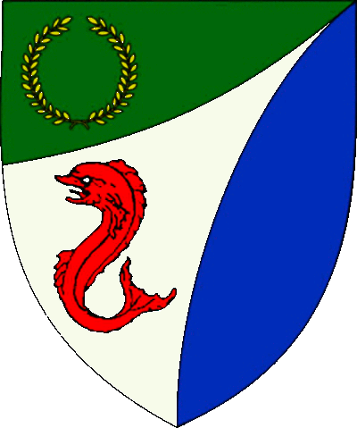

|  |
| --- |
| **Table of Contents**  Weekly Activities in the Barony 2  Arts & Science and Social Schedule 3  Virtual A&S Opportunities 3  Kingdom Calendar 4  The Barony Around the Web 6  Baronial Meeting Notes 7  Baronial Officer Regnum 10  Statement of Ownership 11  Submissions & Disclaimer 11  Marshal Information 12  Award Recommendations 12  Letters from Their Excellencies…….13 |

## The Coronet of the Barony of Tir-y-Don

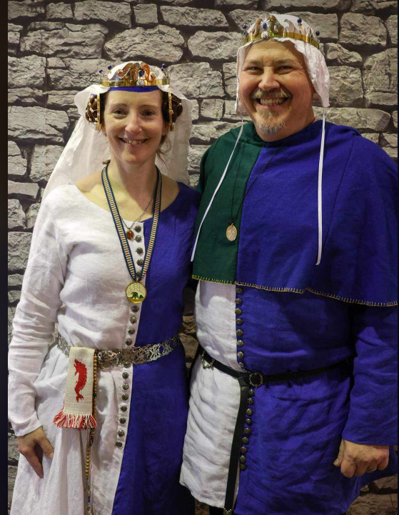

This is the June 2025 issue of the NoD-Y-Rit, a publication of the Barony of Tir-Y-Don of the Society for Creative Anachronism, Inc. The Nod-Y-Rit is available from Anna van Sint Maartensdyjk at chronicler@tirydon.atlantia.sca.org. Subscriptions are free as all publications are available electronically. This newsletter is not a corporate publication of the Society for Creative Anachronism, Inc., and does not delineate SCA policies.

© Copyright 2025, Society for Creative Anachronism, Inc. For information on reprinting letters and artwork from this publication, please contact the Tir-Y-Don Chronicler, who will assist you in contacting the original creator of the piece. Please respect the legal rights of our contributors.

Their Excellencies:

***Baron Jean-Claude de Calais***

***Baroness Alina of the Ilex***

*Photo Credit: Llwyd Aldrydd*

# Weekly Activities in the Barony

|  |  |  |
| --- | --- | --- |
| Sundays |  |  |
| **10AM** | Archery Practice Contact Marshal of Archery **Newport News City Park**  Archery Range | Call 757-888-3333 for Safety Class Schedule.  Call Marshal of Archery before attending. |
| Take the Archery Safety Class online. You can email the completed test to the parks department.  Your card will be emailed to you.  <https://www.nnva.gov/2561/Archery-Range> | | |
| **1PM** | Fighter Practice and Social Heavy/Rapier  Contact Knight Marshal | Please contact the Marshal if you wish to attend. |
| Tuesdays |  |  |
| **6PM** | Fitness Focus **Cornerstone Community Church**  **1003 Moyer Rd, Newport News, VA 23608** | General fitness training |
| Thursdays |  |  |
| **7PM** | Arts & Sciences and Social Contact MOAS  Arts & Science and Social Schedule | Contact MOAS for more details – In person, some hybrid sessions |

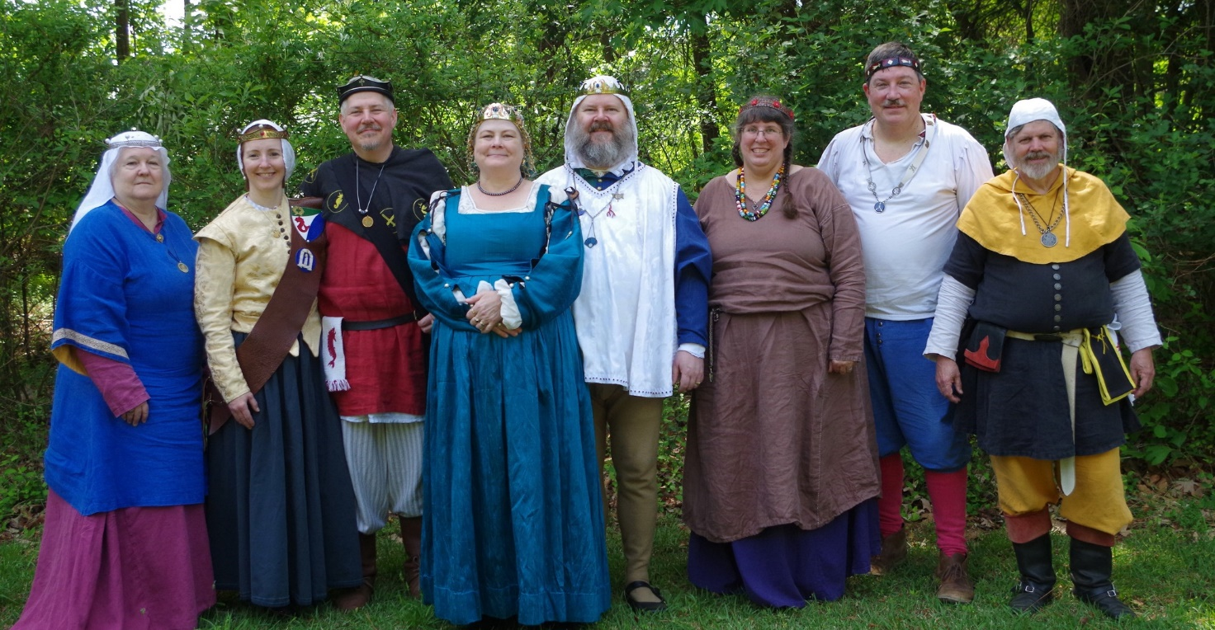

Photo Credit:   
Current and past landed baronage at Baronial Birthday

# Arts & Science and Social Schedule

Classes start at 7pm unless otherwise noted! Classes are held at **Cornerstone Community Church** **1003 Moyer Rd, Newport News, VA 23608**. Business meeting nights will be hybrid in person and online.

|  |
| --- |
| Please check the baronial Facebook group for up to date meeting information. |

**3/6/2025**Learning how to use your sewing machine

**3/13/2025**Scribal Night

**3/20/2025**Business Meeting

**3/27/2025**Japanese Books Make and Take

**4/3/2025**Sari Tying / Veil Draping

**4/10/2025**Scribal Night

**4/17/2025**Business Meeting

**4/24/2025**6 Embroidery Stitches from the 16th C

**5/1/2025**Hedeby Bags

**5/8/2025**Baronial Event last minute planning or tasks

**5/15/2025**Scribal Night

**5/22/2025**Business Meeting and Pennsic Planning

**5/29/2025**Shields: Start to Finish

**6/5/2025**SCA First Aid

**6/7/2025**Group Sewing Day

**6/12/2025**Scribal Night

**6/19/2025**Business Meeting

**6/26/2025**Metal Jewelrymaking

**7/4/2025**July 4 Party and Business meeting

**7/10/2025**Loaner Garb and Gear Sort and Fix (at their Excellencies manor)

**7/12/2025**Group Sewing Day

**7/17/2025**Cheese!

**7/24/2025**Pennsic Packing

**7/31/2025** No class, Pennsic Prep

**9/4/2025** Pennsic Recap and Planning

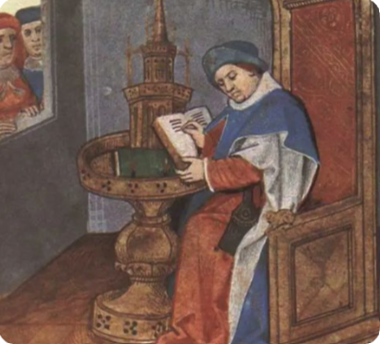

# Virtual A&S Opportunities

|  |  |  |
| --- | --- | --- |
| Virtual Atlantia | Atlantia has setup a Virtual A&S center which includes a calendar of online course offerings, the ability to request a class to be added to the calendar and a way to get credit for the University of Atlantia. Be sure to check it out for an update to date listing of virtual classes throughout the Kingdom. | <http://virtual.atlantia.sca.org/> |
| SCA Virtual Classroom and Artisan Display | Teachers and artisans can share the virtual resources they've created to make them available SCA-wide to continue to foster a learning environment. | <https://www.facebook.com/groups/virtualsca/> |
| Known World Discord | A large discord server that has chat rooms for multiple topics, lots of classes, feedback, and opportunities to connect with artists, fighters, and anyone else across the Known World. | <https://discord.gg/bDavK8> |

Know of any opportunities not listed here? Let us know so we can add them!

Contact the Chronicler via Email, Facebook, or Discord

# Kingdom Calendar

*Please refer to the* [*Kingdom Calendar*](https://atlantia.sca.org/calendar/) *website for up to date information regarding event cancellations or changes.*

#### **July-2025**

07-12 - 07-12 : [Procrastinators Paradise- Last Chance Authorization and Sewing Day](https://atlantia.sca.org/event/?event_id=677dd4bf) :*Waldorf MD (Dun Carraig)*

07-19 - 07-19 : [Warrior’s Games](https://atlantia.sca.org/event/?event_id=6730fead) :*Harleyville SC (Tear-Sea's Shore)*

07-25 - 08-10 : [Pennsic War](https://atlantia.sca.org/event/?event_id=4ff3dfc1) :*(Atlantia)*

#### **Aug-2025**

08-23 - 08-23 : [Nottinghill Coill Baronial Picnic](https://atlantia.sca.org/event/?event_id=681e40a3) :*Prosperity SC (Nottinghill Coill)*

08-23 - 08-23 : [Neppie Wars](https://atlantia.sca.org/event/?event_id=68561b76)*:Carrollton VA (Tir-y-Don)*

#### **Sept-2025**

09-05 - 09-07 : [Sacred Stone Baronial Birthday 2025: A Celebration of Mehregan](https://atlantia.sca.org/event/?event_id=679708a1) :*Boonville NC (Sacred Stone)* (Q K )

09-05 - 09-07 : [Battle on the Bay- Ride of the 4 Horsemen](https://atlantia.sca.org/event/?event_id=67d5aeac) :*Upper Marlboro MD (Storvik)*

09-13 - 09-13 : [Stierbach Baronial Birthday](https://atlantia.sca.org/event/?event_id=678e8e2f) :*Culpeper VA (Stierbach)* (Q K )

09-13 - 09-13 : [Phoenix Rising: A Newcomers Nest](https://atlantia.sca.org/event/?event_id=682888f7) :*Charlotte NC (Charlesbury Crossing)*

09-20 - 09-20 : [Fall University (TBD)](https://atlantia.sca.org/event/?event_id=88ef90b5) :*(Atlantia)*

09-26 - 09-28 : [Trial By Fire & Lochmere Arrow: Alba gu bràth!](https://atlantia.sca.org/event/?event_id=66eb7df7) :*Glen Arm MD (Bright Hills)*

09-27 - 09-27 : [Silver Chalice Novice Tournament](https://atlantia.sca.org/event/?event_id=67b48604) :*Harleyville SC (Hidden Mountain)*

*09-27 - 09-27 :*[*Heralds & Scribes Workshop*](https://atlantia.sca.org/event/?event_id=67e365ad)*:Salem VA (Black Diamond)*

#### **Oct-2025**

10-04 - 10-04 : [Fall Coronation (TBD)](https://atlantia.sca.org/event/?event_id=ddd88316) :*(Atlantia)* (Q ) [](https://moas.atlantia.sca.org/cultura-atlantia)

10-11 - 10-17 : [War of the Wings, 2025](https://atlantia.sca.org/event/?event_id=67901f7d) :*Boonville NC (Atlantia)* (Q K )

10-25 - 10-26 : [Hallowed Market](https://atlantia.sca.org/event/?event_id=680a23a1) :*Culpeper VA (Ponte Alto)*

10-31 - 11-02 : [Dance of the Dead: A Festival of Bones](https://atlantia.sca.org/event/?event_id=67a5664f) :*Nanjemoy MD (Dun Carraig)*

10-31 - 11-02 : [Memento Mori: The Nightmare Before Yule](https://atlantia.sca.org/event/?event_id=6797c501) :*Old Fort NC (Haukesgate)*

#### **Nov-2025**

11-01 - 11-01 : [Goblin Games](https://atlantia.sca.org/event/?event_id=68249bed) :*Richmond VA (Caer Mear)*

11-07 - 11-09 : [Fall Crown Tournament (TBD)](https://atlantia.sca.org/event/?event_id=42e6fbe5) :*(Atlantia)* [](https://moas.atlantia.sca.org/tempore-atlantia)

11-14 - 11-16 : [Highland Havoc; Ride of Enbarr](https://atlantia.sca.org/event/?event_id=68470115) :*Ijamsville MD (Highland Foorde)* (Q K Pr P )

11-21 - 11-23 : [Buckston Birthday](https://atlantia.sca.org/event/?event_id=673feafa) :*Apex NC (Buckston-on-Eno)* (K )

11-22 - 11-22 : [Holiday Faire](https://atlantia.sca.org/event/?event_id=684b160a) :*Fredericksburg VA (Stierbach)*

#### **Dec-2025**

12-06 - 12-06 : [Unevent 2025](https://atlantia.sca.org/event/?event_id=dd54418d) :*(Atlantia)*

#### **Jan-2026**

01-10 - 01-10 : [Kingdom Twelfth Night](https://atlantia.sca.org/event/?event_id=57e32767) :*(Atlantia)* (Q K ) [](https://moas.atlantia.sca.org/tempore-atlantia)

01-24 - 01-24 : [Highland Hearthglow](https://atlantia.sca.org/event/?event_id=6805903e) :*Thurmont MD (Highland Foorde)*

01-31 - 01-31 : [Midwinters Revel: The Way of the Pilgrim](https://atlantia.sca.org/event/?event_id=68418e93) :*Lothian MD (Lochmere)*

#### **Feb-2026**

02-07 - 02-07 : [Bright Hills Baronial Birthday](https://atlantia.sca.org/event/?event_id=68379e83) :*Manchester MD (Bright Hills)*

02-07 - 02-08 : [Winter University 2026](https://atlantia.sca.org/event/?event_id=ff45bfbd) :*(Atlantia)*

02-14 - 02-14 : [Tourney of Manannan mac Lir XLIV](https://atlantia.sca.org/event/?event_id=68057917) :*Harleyville SC (Tear-Sea's Shore)* (K )

# The Barony Around the Web

Many members of the populace have a Web Presence. Please visit their websites and share in the great content. Please contact the Chronicler if you want to promote your site.

Baroness Jane Fox <https://jezebeljane.blogspot.com/>

Baron John Biggeheved <https://biggeheved.com/>

Mistress Kaleeb the Green Eyed <http://kaleeb.galtham.org/>

Learn Fiore <http://learnfiore.org/>

Baron Llwyd Aldrydd <http://baronllwyd.org/>

Lady Mariss Ghijs <https://opusmariss.wordpress.com>

Lady Mevanou verch Reys Yriskynit <https://mvry1sca.wordpress.com/>

## Baronial website

Our Web Minister maintains our baronial website. He can be contacted with any content changes.

<https://www.tirydon.atlantia.sca.org>

## Baronial Facebook Group

We share some informal announcements and share content on our Facebook group. It’s another way to stay connected with those in the Barony.

<https://www.facebook.com/groups/343471645861986/>

## Kingdom eNewsletters

Log in with your SCA Member Portal username and password. This requires at least an associate membership to access. Please contact SCA corporate with any log in issues.

<https://members.sca.org/apps/#SignIn>

# Baronial Meeting Notes

|  |  |
| --- | --- |
| Location: | Cornerstone Community Church and virtual |
| Date and Time:  Jun 19, 2025 | Next Meeting’s Date and Time:  Thurs Aug 21, 7:00pm Cornerstone Community Church |

Baron and Baroness

Their Excellencies extend their thanks to everyone who helped with University. If you missed any classes or there is something you want to teach, please visit the University website at [Teach](https://university.atlantia.sca.org/teach.php) . Also a thank you to those who chatted with newcomers.

Pennsic pre-registration is open.

Please think about flyers that will help us recruit folks.

If you have demo ideas, please let the Chatelaine know. We'd like to get the group more public and there are no bad ideas!

Officer Reports

### Seneschal

### NTR

### Exchequer

### A replacement is needed ASAP! We have $11600 in our account.

### Chatelaine

### Falloween- we have been accepted in the historic area again this year (with honorarium!)

### Check out ideas on Discord.

### Chronicler

Submission deadline is the 25th. Please send content.

Herald

Submissions can now be done completely online!

### Knight Marshal

### Sunday practice at Nike Park with Marinus now

### Tuesday night TNT is also ongoing at 6pm. Some conditioning and specific training at Cornerstone Church Updates about practices are on Fight Club Discord, Campfire, and Combat by the Sea

### Get used to being (and fighting) outside before Pennsic!

### Archery

### Archery ongoing, and Skye is our new Marshall!

### Equestrian

### There is interest in archery on horseback. The location for the next Hastilude is still TBD.

### Arts and Sciences

Report submitted - Going to work on location for sewing days coming up

Social Media

### NTR

### Web Minister

Web needs to be updated for Roster changes - Can get email password changes done if needed

Old & New Business

## Old Business

Update on KASF bid – WE WON!!! It will be the first weekend in March at the Hellenic Center in NN where we had it two years ago. Get those A&S projects started!

No update on Falloween

No update on the bid for Fall Crown; we are partnering with Marinus to host it

## New Business

Neppie’s War is planned for Aug 23. It will be open to the public; planned activities are a fundraiser lunch, archery, A&S displays and a bardic competition and possibly fighting. The site is Nike Park; the plan is to reserve the picnic area with an option for more space if needed.

COME TO FIGHTER PRACTICE!! We get war points!

# Baronial Officer Regnum

|  |  |  |  |
| --- | --- | --- | --- |
| http://tirydon.atlantia.sca.org/wp-content/uploads/2018/11/tyd-1-251x300-1.gif | **Baron:** | Jean-Claude du Calais (Jim Cunningham) | [baron@tirydon.atlantia.sca.org](mailto:baron@tirydon.atlantia.sca.org) 757-968-5303 NLT 9pm |
| http://tirydon.atlantia.sca.org/wp-content/uploads/2018/11/tyd-1-251x300-1.gif | **Baroness:** | Alyna of the Ilex (Holly Cunningham) | [baroness@tirydon.atlantia.sca.org](mailto:baroness@tirydon.atlantia.sca.org) 757-968-5303 NLT 9pm |
| http://tirydon.atlantia.sca.org/wp-content/uploads/2018/11/o_sen.gif | **Seneschal (President):** | Llwyd Aldrydd (Lloyd Eldred) | [seneschal@tirydon.atlantia.sca.org](mailto:seneschal@tirydon.atlantia.sca.org) (757) 875-0033 NLT 9pm |
| http://tirydon.atlantia.sca.org/wp-content/uploads/2018/11/o_exch.gif | **Chancellor of the Exchequer (Treasurer):** | Sarah Kennedy of Glengarry (Sarah Kennedy) | [exchequer@tirydon.atlantia.sca.org](mailto:exchequer@tirydon.atlantia.sca.org) NLT 9pm |
| http://tirydon.atlantia.sca.org/wp-content/uploads/2018/11/o_chat.gif | **Chatelaine (New member support):** | Andrei Barsukov (Andrew LaVinus) | [chatelaine@tirydon.atlantia.sca.org](mailto:chatelaine@tirydon.atlantia.sca.org)  (804) 869-8882 NLT 9:30pm |
| http://tirydon.atlantia.sca.org/wp-content/uploads/2018/11/o_chr.gif | **Chronicler**  **(Secretary):** | Anna van Sintmaartensdyck (Nancy Kiel) | [chronicler@tirydon.atlantia.sca.org](mailto:chronicler@tirydon.atlantia.sca.org) (757) 220-6857, leave a message NLT 9:30pm |
| http://tirydon.atlantia.sca.org/wp-content/uploads/2018/11/o_chr.gif | **Social Media:** | Skye Walker | [socialmedia@tirydon.atlantia.sca.org](mailto:socialmedia@tirydon.atlantia.sca.org) |
| http://tirydon.atlantia.sca.org/wp-content/uploads/2018/11/o_herald.gif | **Herald:** | Catheryn inghean Ui Dhubhshlaine (Amanda Carter) | [herald@tirydon.atlantia.sca.org](mailto:herald@tirydon.atlantia.sca.org) |
| http://tirydon.atlantia.sca.org/wp-content/uploads/2018/11/o_marshal.gif | **Knight’s Marshal:** | Christina O’Cleary  (Jessica Lavinus) | [marshal@tirydon.atlantia.sca.org](mailto:marshal@tirydon.atlantia.sca.org) NLT 9pm |
| http://tirydon.atlantia.sca.org/wp-content/uploads/2018/11/o_marshal.gif | **Marshal of Archery:** | Skye Walker | [archer@tirydon.atlantia.sca.org](mailto:archer@tirydon.atlantia.sca.org) |
| http://tirydon.atlantia.sca.org/wp-content/uploads/2018/11/o_as.gif | **Minister of Arts & Sciences:** | Cairistiona inghean Mhuireadhaigh (Carol Vanderspoel) | [moas@tirydon.atlantia.sca.org](mailto:moas@tirydon.atlantia.sca.org) (757) 819-3296 NLT 9:30pm |
| Office Badge | **Webminister:** | Llwyd Aldrydd (Lloyd Eldred) | [webminister@tirydon.atlantia.sca.org](mailto:webminister@tirydon.atlantia.sca.org) (757) 875-0033 NLT 9:30pm |

# Statement of Ownership, Submissions & Disclaimer

This is the June – July 2025 issue of the NoD-y-Rit, a publication of the Barony of Tir-y-Don of the Society for Creative Anachronism, Inc. The Nod-y-Rit is available from Anna van Sint Maartensdyjk (Nancy Kiel) at [chronicler@tirydon.atlantia.sca.org](mailto:chronicler@tirydon.atlantia.sca.org) and Nancy_kiel@hotmail.com. Subscriptions are free as all publications are available electronically. This newsletter is not a corporate publication of the Society for Creative Anachronism, Inc., and does not delineate SCA policies.

© Copyright 2024, Society for Creative Anachronism, Inc. For information on reprinting letters and artwork from this publication, please contact the Tir-y-Don Chronicler, who will assist you in contacting the original creator of the piece. Please respect the legal rights of our contributors.

Please send submissions to:

Nancy Kiel

108 Wilson Circle, Williamsburg VA

[chronicler@tirydon.atlantia.sca.org](mailto:chronicler@tirydon.atlantia.sca.org)

Nancy_kiel@hotmail.com

***Please, remember that all submissions to the NoD-y-Rit must be accompanied by an SCA release form.*** The first link leads you to the Society Chronicler’s links for forms. The last three links are for the forms that can be submitted on line via Internet Form Fills. Everyone is encouraged to consider contributing to the NoD-y-Rit.

Society Chronicler forms:

<http://chronicler.atlantia.sca.org/Releases.html>

Release form for writing or artwork:

<http://chronicler.atlantia.sca.org/ReleaseCreativeFillable.pdf>

Release form for photographs:

<http://chronicler.atlantia.sca.org/ReleasePhotographerFillable.pdf>

Release form for model(s) (the subject of your artwork or photograph):

<http://chronicler.atlantia.sca.org/ReleaseModelFillable.pdf>

# Marshal Information

## Image result for mINISTER OF LIST BADGE SCABecome a MOL

Want to serve the Fighter Community by providing Tournament organization and keeping the Fighting Authorizations documented? Consider becoming a Minister of the List.

Please visit the Kingdom MOL website for more information and forms: <http://mol.atlantia.sca.org/ForMoLs/index.html>

## Become a Marshal

Do you enjoy fighting activities at events and practices? Many folks invest significant time to keep these activities safe. Consider becoming a marshal to help keep these activities happening in the future.

Please visit the Earl Marshals Website for more information: <https://marshal.atlantia.sca.org/procedures/mit/>

## Marshal Event Report Submission

Participants, Fighters and Marshals can all submit Event reports for fighting activities. If you see something you wish to report visit the Kingdom Earl Marshal Website. Include things like injuries, equipment failures, or other issues you see.

Submit a report here: <https://warrant.atlantia.sca.org/reports/new/1>

## Warranted Marshals

The Kingdom maintains a list of warranted marshals and Marshals in Training. A list of marshals who have expired warrants is also maintained here.

Visit: <https://warrant.atlantia.sca.org/warrants/branch/6/1>

# Award Recommendations

## Baronial Award Recommendations

Baronial Award Recommendations are sent to the Coronet. Please use [baron@tirydon.atlantia.sca.org](https://d.docs.live.net/55395330e2cd57ab/SCA/NODYRIT/baron@tirydon.atlantia.sca.org)  and [baroness@tirydon.atlantia.sca.org](https://d.docs.live.net/55395330e2cd57ab/SCA/NODYRIT/baroness@tirydon.atlantia.sca.org).

## Kingdom Award Recommendations

The Kingdom maintains a database of award recommendations and what events potential recipients will attend in the future. Visit: <https://award.atlantia.sca.org/>

## Review your Order of Precedence Entry

Recent name change or award? Please visit the Atlantia’s Order of Precedence (OP) and request any updates or corrections as needed.

Visit the OP here: <http://op.atlantia.sca.org>

Submit Corrections requests here: <http://op.atlantia.sca.org/corrections.php>

Letters from Their Excellencies

Greetings Tir-y-Don,

Last month we talked about Peer/Student relationships, this month we’re talking Households! Let’s start with the same disclaimer… The opinions expressed here are solely based on the experiences that we have had in the SCA. Other people may do things differently than we do, but we will discuss these from a high-level overview based on Atlantian cultural traditions. As always, your experiences may vary.

A Household is a group of people that get together to do things in the SCA and want to make themselves “official.” That level of official can be anything from a group who travels together and, “We call ourselves Napping Otters;” to a Peer (or group of Peers) with Students who have a registered name and badge for their group; livery for the students, etc. There can be a LOT between those two places.

There can also be a wide variety of attitudes, goals, and experiences in households that seem the same on the surface. That’s why we tell people to wait for at least a year in the SCA before joining one. You want to make sure that the SCA experience you are looking for matches with others in the group.

Traditionally (but not always), Households in Atlantia have a Peer or group of Peers that are head(s) of the Household. They will take students, go to events as a group, help guide those students, introduce them to other like-minded folk, etc. They will often have a day shade set up at events to gather under, sit together for feast, and do things as a group.

The same can be said for non-Peer households. The only difference being that they won’t have those Peer/Student relationships. Is one better than the other? That depends on what you want out of the SCA.

You might ask, how do I join a Household? Maybe you’ve seen some people that are into the same things you are, or maybe you’ve met a Peer who embodies what you would like from the SCA or you feel would be a good teacher, but how do you get in with those people? Everyone is a little different in this. Some want you to ask them, some want you to express interest and they ask you, some will seek you out. The key is, you don’t know until you ask. Reach out to someone in the household or the Peer and see what they are looking for.

Now we’ll go back to an earlier comment. Wait before joining a Household. You might not know your path in the SCA yet, you might not know how you get along with the people in that group yet, and you probably don’t want the anxiety of finding out you don’t mesh with them and figuring out how to leave. Most Households will have a trial period where you get to know each other before any commitment is made. If they don’t you probably want to avoid them.

Feel free to ask questions, it only helps us all learn!

Jean Claude, Baron Alyna, Baroness

The Story of Neppie Wars

Today I tell you a tale of hunting and friendship and, perhaps, war.

Twas the 10th of May when the people of Tir-y-don returned to Sherwood Forest, and archers from far and wide had come to participate in the esteemed Baronial Archery Competition. The competition was fierce, and the challenges were many. Archers were to shoot through windows and around trees, shoot moving targets, and even compete in a challenge inspired by both dungeons and dragons. But there is one challenge in particular I shall tell you of today.

A foreign dignitary of great renown was to be hung that day on the count of hunting King Richard's prized deer. This was a heavy crime indeed, but times had been hard of late. The cost of food was too high for some to bear, and someone unfamiliar with our market would have an even more difficult time. The people of Tir-y-don cried for mercy.

And so the famed Neptunius Duckington of Marinus, fondly known as Neppie, was presented to the archers, sentenced to hang by the hangman's surprisingly-balloon-like rope. The task ahead of the archers was simple: if there be a hero among them that can rescue Neppie from their fate, one arrow to sever the hangman's rope, Neppie will be freed and their transgression forgiven.

All archers in attendance, be they from Tir-y-Don, Marinus, or even Caer Mear, joined together in kinship to exonerate Neppie. But let this be known for the record: 'twas a Tir-y-donian arrow that saved Neppie from their fate, severing the rope before any others.

There was much rejoicing. Neppie would live to see another day, and live they did. Now free, Neppie made several Tir-y-donian friends and merriment was had all day long. There was even a feast!

In fact, they had so much fun that returning home filled them with dread. They wanted to stay with their new Tir-y-donian friends. And why shouldn't they?

But 'twas duck hunting season, friends, and it is duck season still. Marinusians continued pursuing Neppie, beseeching Tir-y-don return Neppie to their home and causing great distress.

So I tell this story so that all may know: Neppie remains with Tir-y-don of their own volition. When next you find a Marinusian on the hunt for Neppie, send them to me post-haste. I, the Archery Champion of Tir-y-don, guard our friend, and we do not take kindly to theft.

If it be war that Marinus wants, then war they shall have. I will meet them on the field of battle on the 23rd day of August.

Respectfully,

La Signora Anastasia Vasilia Morozzi e D'Oria