|  |
| --- |
| Barony of Tir-y-Don  The NoD-y-Rit  May AS 59 (CE 2025)  Volume 44 Issue 1 Society of Creative Anachronism (SCA Inc.) |

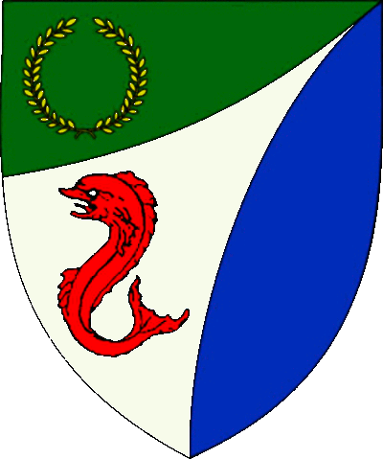

|  |
| --- |
| **Table of Contents**  Weekly Activities in the Barony 2  Arts & Science and Social Schedule 3  Virtual A&S Opportunities 3  Kingdom Calendar 4  The Barony Around the Web 6  Baronial Meeting Notes 7  Baronial Officer Regnum 10  Statement of Ownership 11  Submissions & Disclaimer 11  Marshal Information 12  Award Recommendations 12  Letters from Their Excellencies…….13 |

## The Coronet of the Barony of Tir-y-Don

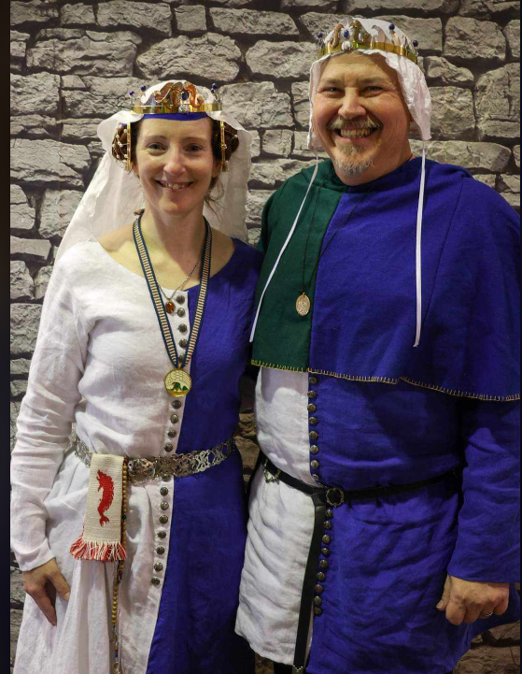

This is the May 2025 issue of the NoD-Y-Rit, a publication of the Barony of Tir-Y-Don of the Society for Creative Anachronism, Inc. The Nod-Y-Rit is available from Anna van Sint Maartensdyjk at chronicler@tirydon.atlantia.sca.org. Subscriptions are free as all publications are available electronically. This newsletter is not a corporate publication of the Society for Creative Anachronism, Inc., and does not delineate SCA policies.

© Copyright 2025, Society for Creative Anachronism, Inc. For information on reprinting letters and artwork from this publication, please contact the Tir-Y-Don Chronicler, who will assist you in contacting the original creator of the piece. Please respect the legal rights of our contributors.

Their Excellencies:

***Baron Jean-Claude de Calais***

***Baroness Alina of the Ilex***

*Photo Credit: Llwyd Aldrydd*

# Weekly Activities in the Barony

|  |  |  |
| --- | --- | --- |
| Sundays |  |  |
| **10AM** | Archery Practice Contact Marshal of Archery **Newport News City Park**  Archery Range | Call 757-888-3333 for Safety Class Schedule.  Call Marshal of Archery before attending. |
| Take the Archery Safety Class online. You can email the completed test to the parks department.  Your card will be emailed to you.  <https://www.nnva.gov/2561/Archery-Range> | | |
| **1PM** | Fighter Practice and Social Heavy/Rapier  Contact Knight Marshal | Please contact the Marshal if you wish to attend. |
| Tuesdays |  |  |
| **6PM** | Fitness Focus **Cornerstone Community Church** **1003 Moyer Rd, Newport News, VA 23608** | General fitness training |
| Thursdays |  |  |
| **7PM** | Arts & Sciences and Social Contact MOAS  Arts & Science and Social Schedule | Contact MOAS or Baroness Kaleeb for more details – In person, some hybrid sessions |

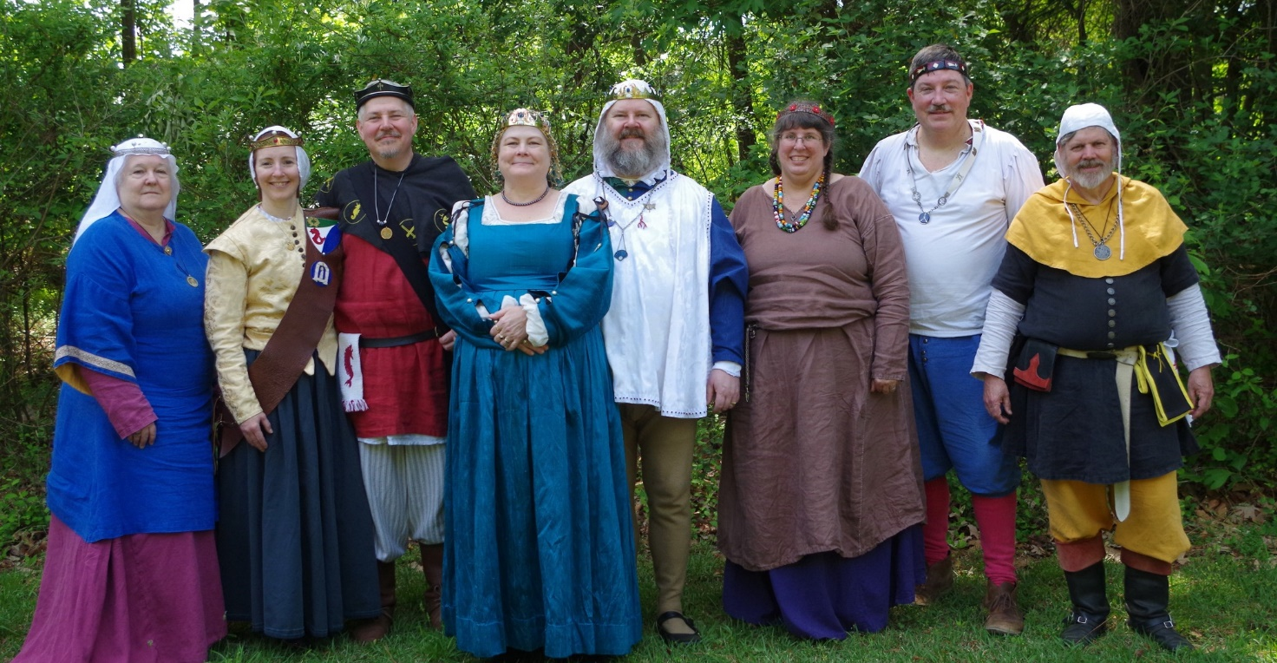

Photo Credit:   
Current and past landed baronage at Baronial Birthday

# Arts & Science and Social Schedule

Classes start at 7pm unless otherwise noted! Classes are held at **Cornerstone Community Church** **1003 Moyer Rd, Newport News, VA 23608**. Business meeting nights will be hybrid in person and online.

|  |
| --- |
| Please check the baronial Facebook group for up to date meeting information. |

**3/6/2025**Learning how to use your sewing machine

**3/13/2025**Scribal Night

**3/20/2025**Business Meeting

**3/27/2025**Japanese Books Make and Take

**4/3/2025**Sari Tying / Veil Draping

**4/10/2025**Scribal Night

**4/17/2025**Business Meeting

**4/24/2025**6 Embroidery Stitches from the 16th C

**5/1/2025**Hedeby Bags

**5/8/2025**Baronial Event last minute planning or tasks

**5/15/2025**Scribal Night

**5/22/2025**Business Meeting and Pennsic Planning

**5/29/2025**Shields: Start to Finish

**6/5/2025**SCA First Aid

**6/7/2025**Group Sewing Day

**6/12/2025**Scribal Night

**6/19/2025**Business Meeting

**6/26/2025**Metal Jewelrymaking

**7/4/2025**July 4 Party and Business meeting

**7/10/2025**Loaner Garb and Gear Sort and Fix (at their Excellencies manor)

**7/12/2025**Group Sewing Day

**7/17/2025**Cheese!

**7/24/2025**Pennsic Packing

**7/31/2025** No class, Pennsic Prep

**9/4/2025** Pennsic Recap and Planning

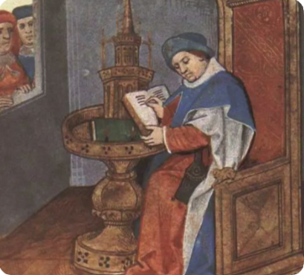

# Virtual A&S Opportunities

|  |  |  |
| --- | --- | --- |
| Virtual Atlantia | Atlantia has setup a Virtual A&S center which includes a calendar of online course offerings, the ability to request a class to be added to the calendar and a way to get credit for the University of Atlantia. Be sure to check it out for an update to date listing of virtual classes throughout the Kingdom. | <http://virtual.atlantia.sca.org/> |
| SCA Virtual Classroom and Artisan Display | Teachers and artisans can share the virtual resources they've created to make them available SCA-wide to continue to foster a learning environment. | <https://www.facebook.com/groups/virtualsca/> |
| Known World Discord | A large discord server that has chat rooms for multiple topics, lots of classes, feedback, and opportunities to connect with artists, fighters, and anyone else across the Known World. | <https://discord.gg/bDavK8> |

Know of any opportunities not listed here? Let us know so we can add them!

Contact the Chronicler via Email, Facebook, or Discord

# Kingdom Calendar

*Please refer to the* [*Kingdom Calendar*](https://atlantia.sca.org/calendar/) *website for up to date information regarding event cancellations or changes.*

#### **June-2025**

06-06 - 06-08 : [Rumors of War- Part Deux](https://atlantia.sca.org/event/?event_id=678ee87a) :*Bryson City NC (Stormwall)*

06-06 - 06-08 : [Royal Archery Tournament](https://atlantia.sca.org/event/?event_id=678e9efe) :*Booneville NC (Sacred Stone)*

06-14 - 06-14 :  [University of Atlantia](https://atlantia.sca.org/event/?event_id=67ab94b1) :*Virginia Beach VA (Marinus)* (Q )

06-20 - 06-22 : [Storvik Novice Tournament](https://atlantia.sca.org/event/?event_id=678e684e) :*Upper Marlboro MD (Storvik)*

06-27 - 06-29 : [King's Assessment](https://atlantia.sca.org/event/?event_id=67b22aca) :*Callaway VA (Black Diamond)* (K )

#### **July-2025**

07-12 - 07-12 : [Procrastinators Paradise- Last Chance Authorization and Sewing Day](https://atlantia.sca.org/event/?event_id=677dd4bf) :*Waldorf MD (Dun Carraig)*

07-19 - 07-19 : [Warrior’s Games](https://atlantia.sca.org/event/?event_id=6730fead) :*Harleyville SC (Tear-Sea's Shore)*

07-25 - 08-10 : [Pennsic War](https://atlantia.sca.org/event/?event_id=4ff3dfc1) :*(Atlantia)*

#### **Aug-2025**

08-23 - 08-23 : [Nottinghill Coill Baronial Picnic](https://atlantia.sca.org/event/?event_id=681e40a3) :*Prosperity SC (Nottinghill Coill)*

#### **Sept-2025**

09-05 - 09-07 : [Sacred Stone Baronial Birthday 2025: A Celebration of Mehregan](https://atlantia.sca.org/event/?event_id=679708a1) :*Boonville NC (Sacred Stone)* (Q K )

09-05 - 09-07 : [Battle on the Bay- Ride of the 4 Horsemen](https://atlantia.sca.org/event/?event_id=67d5aeac) :*Upper Marlboro MD (Storvik)*

09-13 - 09-13 : [Stierbach Baronial Birthday](https://atlantia.sca.org/event/?event_id=678e8e2f) :*Culpeper VA (Stierbach)* (Q K )

09-13 - 09-13 : [Phoenix Rising: A Newcomers Nest](https://atlantia.sca.org/event/?event_id=682888f7) :*Charlotte NC (Charlesbury Crossing)*

09-20 - 09-20 : [Fall University (TBD)](https://atlantia.sca.org/event/?event_id=88ef90b5) :*(Atlantia)*

09-26 - 09-28 : [Trial By Fire & Lochmere Arrow: Alba gu bràth!](https://atlantia.sca.org/event/?event_id=66eb7df7) :*Glen Arm MD (Bright Hills)*

09-27 - 09-27 : [Silver Chalice Novice Tournament](https://atlantia.sca.org/event/?event_id=67b48604) :*Harleyville SC (Hidden Mountain)*

*09-27 - 09-27 :*[*Heralds & Scribes Workshop*](https://atlantia.sca.org/event/?event_id=67e365ad)*:Salem VA (Black Diamond)*

#### **Oct-2025**

10-04 - 10-04 : [Fall Coronation (TBD)](https://atlantia.sca.org/event/?event_id=ddd88316) :*(Atlantia)* (Q ) [](https://moas.atlantia.sca.org/cultura-atlantia)

10-11 - 10-17 : [War of the Wings, 2025](https://atlantia.sca.org/event/?event_id=67901f7d) :*Boonville NC (Atlantia)* (Q K )

10-31 - 11-02 : [Dance of the Dead: A Festival of Bones](https://atlantia.sca.org/event/?event_id=67a5664f) :*Nanjemoy MD (Dun Carraig)*

10-31 - 11-02 : [Memento Mori: The Nightmare Before Yule](https://atlantia.sca.org/event/?event_id=6797c501) :*Old Fort NC (Haukesgate)*

#### **Nov-2025**

11-01 - 11-01 : [Goblin Games](https://atlantia.sca.org/event/?event_id=68249bed) :*Richmond VA (Caer Mear)*

11-07 - 11-09 : [Fall Crown Tournament (TBD)](https://atlantia.sca.org/event/?event_id=42e6fbe5) :*(Atlantia)* [](https://moas.atlantia.sca.org/tempore-atlantia)

11-14 - 11-16 : [Buckston Birthday](https://atlantia.sca.org/event/?event_id=673feafa) :*Apex NC (Buckston-on-Eno)*

#### **Dec-2025**

12-06 - 12-06 : [Unevent 2025](https://atlantia.sca.org/event/?event_id=dd54418d) :*(Atlantia)*

#### **Jan-2026**

01-10 - 01-10 : [Kingdom Twelfth Night](https://atlantia.sca.org/event/?event_id=57e32767) :*(Atlantia)* (Q K ) [](https://moas.atlantia.sca.org/tempore-atlantia)

01-24 - 01-24 : [Highland Hearthglow](https://atlantia.sca.org/event/?event_id=6805903e) :*Thurmont MD (Highland Foorde)*

#### **Feb-2026**

02-14 - 02-14 : [Tourney of Manannan mac Lir XLIV](https://atlantia.sca.org/event/?event_id=68057917) :*Harleyville SC (Tear-Sea's Shore)* (K )

# The Barony Around the Web

Many members of the populace have a Web Presence. Please visit their websites and share in the great content. Please contact the Chronicler if you want to promote your site.

Baroness Jane Fox <https://jezebeljane.blogspot.com/>

Baron John Biggeheved <https://biggeheved.com/>

Mistress Kaleeb the Green Eyed <http://kaleeb.galtham.org/>

Learn Fiore <http://learnfiore.org/>

Baron Llwyd Aldrydd <http://baronllwyd.org/>

Lady Mariss Ghijs <https://opusmariss.wordpress.com>

Lady Mevanou verch Reys Yriskynit <https://mvry1sca.wordpress.com/>

## Baronial website

Our Web Minister maintains our baronial website. He can be contacted with any content changes.

<https://www.tirydon.atlantia.sca.org>

## Baronial Facebook Group

We share some informal announcements and share content on our Facebook group. It’s another way to stay connected with those in the Barony.

<https://www.facebook.com/groups/343471645861986/>

## Kingdom eNewsletters

Log in with your SCA Member Portal username and password. This requires at least an associate membership to access. Please contact SCA corporate with any log in issues.

<https://members.sca.org/apps/#SignIn>

# Baronial Meeting Notes

|  |  |
| --- | --- |
| Location: | Cornerstone Community Church and virtual |
| Date and Time:  Apr 21, 2025 | Next Meeting’s Date and Time:  Thurs May 15, 7:00pm Cornerstone Community Church |

Baron and Baroness

Their Excellencies extend their thanks to everyone who helped with making Return to Sherwood a success.

Upcoming events – University will be held in person and online at the Barony of Marinus. If you are planning to go to Storvik Novice Tourney, please let Their Excellencies know so appropriate tentage can be arranged.

If you have demo ideas, please let the Chatelaine know. We'd like to get the group more public and there are no bad ideas!

Officer Reports

### Seneschal

### Please volunteer to help with University at Marinus.

### Exchequer

### A replacement is needed ASAP! Classes are being offered at University.

### Chatelaine

### Falloween- we have been accepted in the historic area again this year (with honorarium!)

### Check out ideas on Discord.

### Chronicler

Submission deadline is the 25th. Please send content.

Herald

The consult table was busy at Return to Sherwood, and three devices have been submitted.

### Knight Marshal

### Sunday practice at Nike Park with Marinus now

### Tuesday night TNT is also ongoing at 6pm. Some conditioning and specific training at Cornerstone Church Updates about practices are on Fight Club Discord, Campfire, and Combat by the Sea

### Archery

### Archery ongoing, the park had tree fall damage, pics were sent to Tnek.

### Equestrian

### There will be equestrian events at Baronial Birthday! There is interest in archery on horseback.

### Arts and Sciences

Report submitted - Going to work on location for sewing days coming up

Social Media

### Good job with online presence for Return to Sherwood

### Submit spotlights

### Web Minister

Web needs to be updated for Roster changes - Can get email password changes done if needed

Old & New Business

## Old Business

Update on KASF bid - No updates, bid committee had no further questions

Update on Artisan Faire bid? None

Jane- wants to Autocrat a feast, revel, bardic, historic event. She's going to research things and come back with a bid.

## New Business

A bid for Fall Crown is under consideration.

# Baronial Officer Regnum

|  |  |  |  |
| --- | --- | --- | --- |
| http://tirydon.atlantia.sca.org/wp-content/uploads/2018/11/tyd-1-251x300-1.gif | **Baron:** | Jean-Claude du Calais (Jim Cunningham) | [baron@tirydon.atlantia.sca.org](mailto:baron@tirydon.atlantia.sca.org) 757-968-5303 NLT 9pm |
| http://tirydon.atlantia.sca.org/wp-content/uploads/2018/11/tyd-1-251x300-1.gif | **Baroness:** | Alyna of the Ilex (Holly Cunningham) | [baroness@tirydon.atlantia.sca.org](mailto:baroness@tirydon.atlantia.sca.org) 757-968-5303 NLT 9pm |
| http://tirydon.atlantia.sca.org/wp-content/uploads/2018/11/o_sen.gif | **Seneschal (President):** | Llwyd Aldrydd (Lloyd Eldred) | [seneschal@tirydon.atlantia.sca.org](mailto:seneschal@tirydon.atlantia.sca.org) (757) 875-0033 NLT 9pm |
| http://tirydon.atlantia.sca.org/wp-content/uploads/2018/11/o_exch.gif | **Chancellor of the Exchequer (Treasurer):** | Sarah Kennedy of Glengarry (Sarah Kennedy) | [exchequer@tirydon.atlantia.sca.org](mailto:exchequer@tirydon.atlantia.sca.org) NLT 9pm |
| http://tirydon.atlantia.sca.org/wp-content/uploads/2018/11/o_chat.gif | **Chatelaine (New member support):** | Andrei Barsukov (Andrew LaVinus) | [chatelaine@tirydon.atlantia.sca.org](mailto:chatelaine@tirydon.atlantia.sca.org)  (804) 869-8882 NLT 9:30pm |
| http://tirydon.atlantia.sca.org/wp-content/uploads/2018/11/o_chr.gif | **Chronicler**  **(Secretary):** | Anna van Sintmaartensdyck (Nancy Kiel) | [chronicler@tirydon.atlantia.sca.org](mailto:chronicler@tirydon.atlantia.sca.org) (757) 220-6857, leave a message NLT 9:30pm |
| http://tirydon.atlantia.sca.org/wp-content/uploads/2018/11/o_chr.gif | **Social Media:** | Skye Walker | [socialmedia@tirydon.atlantia.sca.org](mailto:socialmedia@tirydon.atlantia.sca.org) |
| http://tirydon.atlantia.sca.org/wp-content/uploads/2018/11/o_herald.gif | **Herald:** | Catheryn inghean Ui Dhubhshlaine (Amanda Carter) | [herald@tirydon.atlantia.sca.org](mailto:herald@tirydon.atlantia.sca.org) |
| http://tirydon.atlantia.sca.org/wp-content/uploads/2018/11/o_marshal.gif | **Knight’s Marshal:** | Christina O’Cleary  (Jessica Lavinus) | [marshal@tirydon.atlantia.sca.org](mailto:marshal@tirydon.atlantia.sca.org) NLT 9pm |
| http://tirydon.atlantia.sca.org/wp-content/uploads/2018/11/o_marshal.gif | **Marshal of Archery:** | Leofric of Oxenford (Mike Durling) | [archer@tirydon.atlantia.sca.org](mailto:archer@tirydon.atlantia.sca.org) |
| http://tirydon.atlantia.sca.org/wp-content/uploads/2018/11/o_as.gif | **Minister of Arts & Sciences:** | Cairistiona inghean Mhuireadhaigh (Carol Vanderspoel) | [moas@tirydon.atlantia.sca.org](mailto:moas@tirydon.atlantia.sca.org) (757) 819-3296 NLT 9:30pm |
| Office Badge | **Webminister:** | Llwyd Aldrydd (Lloyd Eldred) | [webminister@tirydon.atlantia.sca.org](mailto:webminister@tirydon.atlantia.sca.org) (757) 875-0033 NLT 9:30pm |

# Statement of Ownership, Submissions & Disclaimer

This is the May 2025 issue of the NoD-y-Rit, a publication of the Barony of Tir-y-Don of the Society for Creative Anachronism, Inc. The Nod-y-Rit is available from Anna van Sint Maartensdyjk (Nancy Kiel) at [chronicler@tirydon.atlantia.sca.org](mailto:chronicler@tirydon.atlantia.sca.org) and Nancy_kiel@hotmail.com. Subscriptions are free as all publications are available electronically. This newsletter is not a corporate publication of the Society for Creative Anachronism, Inc., and does not delineate SCA policies.

© Copyright 2024, Society for Creative Anachronism, Inc. For information on reprinting letters and artwork from this publication, please contact the Tir-y-Don Chronicler, who will assist you in contacting the original creator of the piece. Please respect the legal rights of our contributors.

Please send submissions to:

Nancy Kiel

108 Wilson Circle, Williamsburg VA

[chronicler@tirydon.atlantia.sca.org](mailto:chronicler@tirydon.atlantia.sca.org)

Nancy_kiel@hotmail.com

***Please, remember that all submissions to the NoD-y-Rit must be accompanied by an SCA release form.*** The first link leads you to the Society Chronicler’s links for forms. The last three links are for the forms that can be submitted on line via Internet Form Fills. Everyone is encouraged to consider contributing to the NoD-y-Rit.

Society Chronicler forms:

<http://chronicler.atlantia.sca.org/Releases.html>

Release form for writing or artwork:

<http://chronicler.atlantia.sca.org/ReleaseCreativeFillable.pdf>

Release form for photographs:

<http://chronicler.atlantia.sca.org/ReleasePhotographerFillable.pdf>

Release form for model(s) (the subject of your artwork or photograph):

<http://chronicler.atlantia.sca.org/ReleaseModelFillable.pdf>

# Marshal Information

## Image result for mINISTER OF LIST BADGE SCABecome a MOL

Want to serve the Fighter Community by providing Tournament organization and keeping the Fighting Authorizations documented? Consider becoming a Minister of the List.

Please visit the Kingdom MOL website for more information and forms: <http://mol.atlantia.sca.org/ForMoLs/index.html>

## Become a Marshal

Do you enjoy fighting activities at events and practices? Many folks invest significant time to keep these activities safe. Consider becoming a marshal to help keep these activities happening in the future.

Please visit the Earl Marshals Website for more information: <https://marshal.atlantia.sca.org/procedures/mit/>

## Marshal Event Report Submission

Participants, Fighters and Marshals can all submit Event reports for fighting activities. If you see something you wish to report visit the Kingdom Earl Marshal Website. Include things like injuries, equipment failures, or other issues you see.

Submit a report here: <https://warrant.atlantia.sca.org/reports/new/1>

## Warranted Marshals

The Kingdom maintains a list of warranted marshals and Marshals in Training. A list of marshals who have expired warrants is also maintained here.

Visit: <https://warrant.atlantia.sca.org/warrants/branch/6/1>

# Award Recommendations

## Baronial Award Recommendations

Baronial Award Recommendations are sent to the Coronet. Please use [baron@tirydon.atlantia.sca.org](https://d.docs.live.net/55395330e2cd57ab/SCA/NODYRIT/baron@tirydon.atlantia.sca.org)  and [baroness@tirydon.atlantia.sca.org](https://d.docs.live.net/55395330e2cd57ab/SCA/NODYRIT/baroness@tirydon.atlantia.sca.org).

## Kingdom Award Recommendations

The Kingdom maintains a database of award recommendations and what events potential recipients will attend in the future. Visit: <https://award.atlantia.sca.org/>

## Review your Order of Precedence Entry

Recent name change or award? Please visit the Atlantia’s Order of Precedence (OP) and request any updates or corrections as needed.

Visit the OP here: <http://op.atlantia.sca.org>

Submit Corrections requests here: <http://op.atlantia.sca.org/corrections.php>

Letters from Their Excellencies

Greetings Tir-y-Don,

We had an interesting question come up at Return to Sherwood about Peer and Student relationships and thought, what a great thing to talk about this month. Disclaimer that the opinions expressed here are solely based on the experiences that we have had in the SCA. Other people may do things differently than we do, but we will discuss these from a high-level overview based on Atlantian cultural traditions. As always, your experiences may vary.

Let’s start by breaking down the traditional Peers and Students. This will change with the addition of the Order of the Mark, but this is how things (normally) stand now. Our current Peerages and their common students and accessories are:

- Knights – Squires (red belt)

- Laurels – Apprentices (green belt)

- Pelicans – Proteges (yellow belt)

- Order of Defense – Student or Cadet (red collar)

Note: not all Peers use the same titles or same accoutrement for their students.

Peers will form a relationship with their students based on their traditions and desires. Some Peers will ask for an Oath of Fealty, some have a Contract, others just an understanding that they’re together now. This relationship varies from Peer to Peer and can even vary between students of the same Peer. Just like coaches will have different styles for different players on a team.

You may ask, “what do they get from this relationship?” Well, it should be that the student learns from the Peer and gets guidance on their path towards being a Peer themselves. They also get what we call “a voice in the Order.” This means that the Peer will speak for their student when the time is right to tell the Order in question what great things they have done and if they are ready to be recognized as part of that Order. They may also get the support of a household (more on that next month) of like-minded people.

The Peer gets the enjoyment of helping someone along their path, seeing them grow, and giving back to the organization. The Peer may also ask for help with things like setting up day shades, taking things to events, and general help (it goes both ways). Most importantly, they both should end up with a lifelong friend.

Feel free to ask questions, it only helps us all learn!

Jean Claude, Baron Alyna, Baroness