|  |
| --- |
| Barony of Tir-y-Don  The NoD-y-Rit  Apr AS 59 (CE 2025)  Volume 43 Issue 12 Society of Creative Anachronism (SCA Inc.) |

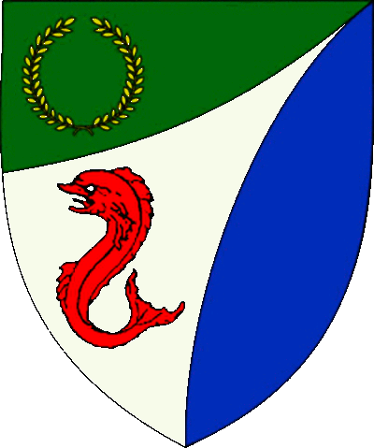

|  |
| --- |
| **Table of Contents**  Weekly Activities in the Barony 2  Arts & Science and Social Schedule 3  Virtual A&S Opportunities 3  Kingdom Calendar 4  The Barony Around the Web 6  Baronial Meeting Notes 7  Baronial Officer Regnum 10  Statement of Ownership 11  Submissions & Disclaimer 11  Marshal Information 12  Award Recommendations 12  Letters from Their Excellencies…….13 |

## The Coronet of the Barony of Tir-y-Don

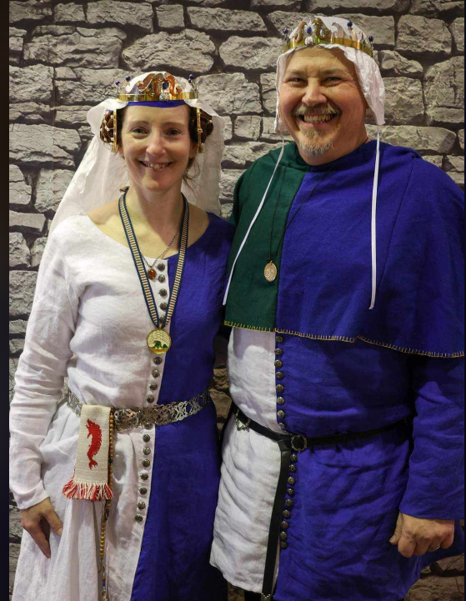

This is the Apr 2025 issue of the NoD-Y-Rit, a publication of the Barony of Tir-Y-Don of the Society for Creative Anachronism, Inc. The Nod-Y-Rit is available from Anna van Sint Maartensdyjk at chronicler@tirydon.atlantia.sca.org. Subscriptions are free as all publications are available electronically. This newsletter is not a corporate publication of the Society for Creative Anachronism, Inc., and does not delineate SCA policies.

© Copyright 2025, Society for Creative Anachronism, Inc. For information on reprinting letters and artwork from this publication, please contact the Tir-Y-Don Chronicler, who will assist you in contacting the original creator of the piece. Please respect the legal rights of our contributors.

Their Excellencies:

***Baron Jean-Claude de Calais***

***Baroness Alina of the Ilex***

*Photo Credit: Llwyd Aldrydd*

# Weekly Activities in the Barony

|  |  |  |
| --- | --- | --- |
| Sundays |  |  |
| **10AM** | Archery Practice Contact Marshal of Archery **Newport News City Park**  Archery Range | Call 757-888-3333 for Safety Class Schedule.  Call Marshal of Archery before attending. |
| Take the Archery Safety Class online. You can email the completed test to the parks department.  Your card will be emailed to you.  <https://www.nnva.gov/2561/Archery-Range> | | |
| **1PM** | Fighter Practice and Social Heavy/Rapier  Contact Knight Marshal | Please contact the Marshal if you wish to attend. |
| Mondays |  |  |
| **7PM** | Armory Night Contact Tim Prickett | Contact Tim before attending. |
| Thursdays |  |  |
| **7PM** | Arts & Sciences and Social Contact MOAS  Arts & Science and Social Schedule | Contact MOAS or Baroness Kaleeb for more details – In person, some hybrid sessions |

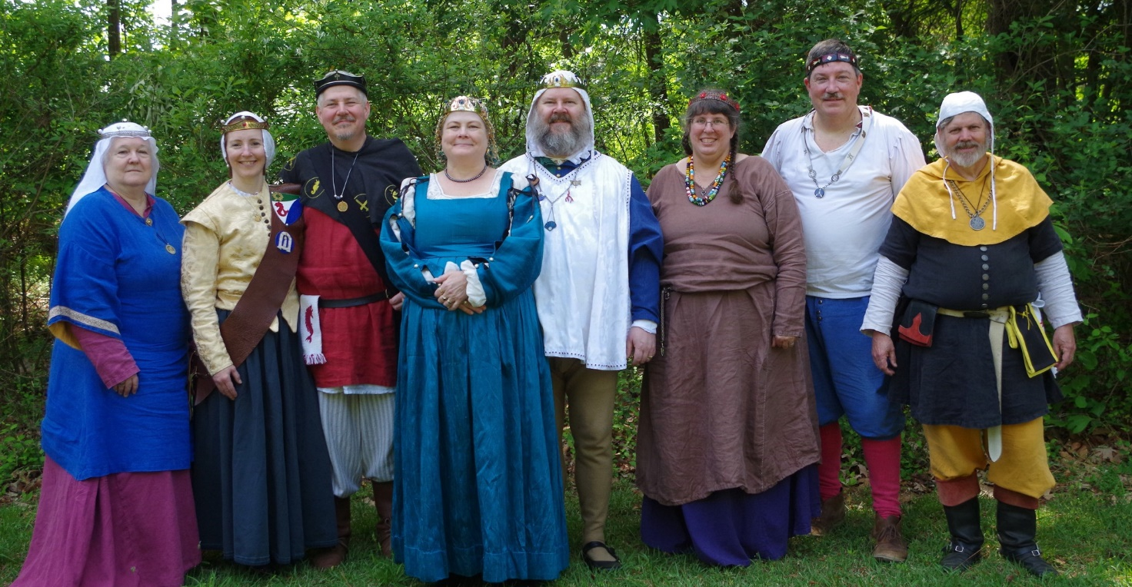

Photo Credit:   
Current and past landed baronage at Baronial Birthday

# Arts & Science and Social Schedule

Classes start at 7pm unless otherwise noted! Classes are held at **Cornerstone Community Church** **1003 Moyer Rd, Newport News, VA 23608**. Business meeting nights will be hybrid in person and online.

|  |
| --- |
| Please check the baronial Facebook group for up to date meeting information. |

**3/6/2025**Learning how to use your sewing machine

**3/13/2025**Scribal Night

**3/20/2025**Business Meeting

**3/27/2025**Japanese Books Make and Take

**4/3/2025**Sari Tying / Veil Draping

**4/10/2025**Scribal Night

**4/17/2025**Business Meeting

**4/24/2025**6 Embroidery Stitches from the 16th C

**5/1/2025**Hedeby Bags

**5/8/2025**Baronial Event last minute planning or tasks

**5/15/2025**Scribal Night

**5/22/2025**Business Meeting and Pennsic Planning

**5/29/2025**Shields: Start to Finish

**6/5/2025**SCA First Aid

**6/7/2025**Group Sewing Day

**6/12/2025**Scribal Night

**6/19/2025**Business Meeting

**6/26/2025**Metal Jewelrymaking

**7/4/2025**July 4 Party and Business meeting

**7/10/2025**Loaner Garb and Gear Sort and Fix (at their Excellencies manor)

**7/12/2025**Group Sewing Day

**7/17/2025**Cheese!

**7/24/2025**Pennsic Packing

**7/31/2025** No class, Pennsic Prep

**9/4/2025** Pennsic Recap and Planning



# Virtual A&S Opportunities

|  |  |  |
| --- | --- | --- |
| Virtual Atlantia | Atlantia has setup a Virtual A&S center which includes a calendar of online course offerings, the ability to request a class to be added to the calendar and a way to get credit for the University of Atlantia. Be sure to check it out for an update to date listing of virtual classes throughout the Kingdom. | <http://virtual.atlantia.sca.org/> |
| SCA Virtual Classroom and Artisan Display | Teachers and artisans can share the virtual resources they've created to make them available SCA-wide to continue to foster a learning environment. | <https://www.facebook.com/groups/virtualsca/> |
| Known World Discord | A large discord server that has chat rooms for multiple topics, lots of classes, feedback, and opportunities to connect with artists, fighters, and anyone else across the Known World. | <https://discord.gg/bDavK8> |

Know of any opportunities not listed here? Let us know so we can add them!

Contact the Chronicler via Email, Facebook, or Discord

# Kingdom Calendar

*Please refer to the* [*Kingdom Calendar*](https://atlantia.sca.org/calendar/) *website for up to date information regarding event cancellations or changes.*

#### **May-2025**

05-03 - 05-03 : [Spring Crown Tournament (TBD)](https://atlantia.sca.org/event/?event_id=427fa35d) :*(Atlantia)* [](https://moas.atlantia.sca.org/tempore-atlantia)

**05-09 - 05-11 :**[**Return to Sherwood**](https://atlantia.sca.org/event/?event_id=665cc924)**:*Hayes VA (Tir-y-Don)* (Q K )**

05-09 - 05-11 : [Hawkwood's XXI Baronial Birthday: One Night In Marrakesh](https://atlantia.sca.org/event/?event_id=671562b4) :*Old Fort NC (Hawkwood)*

05-17 - 05-18 : [Victory on the Vine II](https://atlantia.sca.org/event/?event_id=671e206e) :*Culpeper VA (Ponte Alto)*

05-17 - 05-17 : [Not Quite Quarterly Braggin Rights Tournament V](https://atlantia.sca.org/event/?event_id=6771f317):*AIKEN SC (Ritterwald)* (Q K Pr P )

05-17 - 05-17 : [Skewered! V: Tenoch's Table](https://atlantia.sca.org/event/?event_id=6703fcf3) :*Gaithersburg MD (Roxbury Mill)*

*05-23 - 05-26 :*[*Gem Joust / Investiture*](https://atlantia.sca.org/event/?event_id=6792ed55)*:Ashland VA (Caer Mear) (Q K Pr P )*

05-31 - 05-31 : [On Target!](https://atlantia.sca.org/event/?event_id=67560dbe) :*Annapolis MD (Lochmere)*

#### **June-2025**

06-06 - 06-08 : [Rumors of War- Part Deux](https://atlantia.sca.org/event/?event_id=678ee87a) :*Bryson City NC (Stormwall)*

06-06 - 06-08 : [Royal Archery Tournament](https://atlantia.sca.org/event/?event_id=678e9efe) :*Booneville NC (Sacred Stone)*

06-14 - 06-14 :  [University of Atlantia](https://atlantia.sca.org/event/?event_id=67ab94b1) :*Virginia Beach VA (Marinus)* (Q )

06-20 - 06-22 : [Storvik Novice Tournament](https://atlantia.sca.org/event/?event_id=678e684e) :*Upper Marlboro MD (Storvik)*

06-27 - 06-29 : [King's Assessment](https://atlantia.sca.org/event/?event_id=67b22aca) :*Callaway VA (Black Diamond)* (K )

#### **July-2025**

07-12 - 07-12 : [Procrastinators Paradise- Last Chance Authorization and Sewing Day](https://atlantia.sca.org/event/?event_id=677dd4bf) :*Waldorf MD (Dun Carraig)*

07-19 - 07-19 : [Warrior’s Games](https://atlantia.sca.org/event/?event_id=6730fead) :*Harleyville SC (Tear-Sea's Shore)*

07-25 - 08-10 : [Pennsic War](https://atlantia.sca.org/event/?event_id=4ff3dfc1) :*(Atlantia)*

#### **Sept-2025**

09-05 - 09-07 : [Sacred Stone Baronial Birthday 2025: A Celebration of Mehregan](https://atlantia.sca.org/event/?event_id=679708a1) :*Boonville NC (Sacred Stone)* (Q K )

09-05 - 09-07 : [Battle on the Bay- Ride of the 4 Horsemen](https://atlantia.sca.org/event/?event_id=67d5aeac) :*Upper Marlboro MD (Storvik)*

09-13 - 09-13 : [Stierbach Baronial Birthday](https://atlantia.sca.org/event/?event_id=678e8e2f) :*Culpeper VA (Stierbach)* (Q K )

09-20 - 09-20 : [Fall University (TBD)](https://atlantia.sca.org/event/?event_id=88ef90b5) :*(Atlantia)*

09-26 - 09-28 : [Trial By Fire & Lochmere Arrow: Alba gu bràth!](https://atlantia.sca.org/event/?event_id=66eb7df7) :*Glen Arm MD (Bright Hills)*

09-27 - 09-27 : [Silver Chalice Novice Tournament](https://atlantia.sca.org/event/?event_id=67b48604) :*Harleyville SC (Hidden Mountain)*

*09-27 - 09-27 :*[*Heralds & Scribes Workshop*](https://atlantia.sca.org/event/?event_id=67e365ad)*:Salem VA (Black Diamond)*

#### **Oct-2025**

10-04 - 10-04 : [Fall Coronation (TBD)](https://atlantia.sca.org/event/?event_id=ddd88316) :*(Atlantia)* (Q ) [](https://moas.atlantia.sca.org/cultura-atlantia)

10-11 - 10-17 : [War of the Wings, 2025](https://atlantia.sca.org/event/?event_id=67901f7d) :*Boonville NC (Atlantia)* (Q K )

10-31 - 11-02 : [Dance of the Dead: A Festival of Bones](https://atlantia.sca.org/event/?event_id=67a5664f) :*Nanjemoy MD (Dun Carraig)*

#### **Nov-2025**

11-07 - 11-09 : [Fall Crown Tournament (TBD)](https://atlantia.sca.org/event/?event_id=42e6fbe5) :*(Atlantia)* [](https://moas.atlantia.sca.org/tempore-atlantia)

11-14 - 11-16 : [Buckston Birthday](https://atlantia.sca.org/event/?event_id=673feafa) :*Apex NC (Buckston-on-Eno)*

#### **Dec-2025**

12-06 - 12-06 : [Unevent 2025](https://atlantia.sca.org/event/?event_id=dd54418d) :*(Atlantia)*

# The Barony Around the Web

Many members of the populace have a Web Presence. Please visit their websites and share in the great content. Please contact the Chronicler if you want to promote your site.

Baroness Jane Fox <https://jezebeljane.blogspot.com/>

Baron John Biggeheved <https://biggeheved.com/>

Mistress Kaleeb the Green Eyed <http://kaleeb.galtham.org/>

Learn Fiore <http://learnfiore.org/>

Baron Llwyd Aldrydd <http://baronllwyd.org/>

Lady Mariss Ghijs <https://opusmariss.wordpress.com>

Lady Mevanou verch Reys Yriskynit <https://mvry1sca.wordpress.com/>

## Baronial website

Our Web Minister maintains our baronial website. He can be contacted with any content changes.

<https://www.tirydon.atlantia.sca.org>

## Baronial Facebook Group

We share some informal announcements and share content on our Facebook group. It’s another way to stay connected with those in the Barony.

<https://www.facebook.com/groups/343471645861986/>

## Kingdom eNewsletters

Log in with your SCA Member Portal username and password. This requires at least an associate membership to access. Please contact SCA corporate with any log in issues.

<https://members.sca.org/apps/#SignIn>

# Baronial Meeting Notes

|  |  |
| --- | --- |
| Location: | Cornerstone Community Church and virtual |
| Date and Time:  Apr 21, 2025 | Next Meeting’s Date and Time:  Thurs May 15, 7:00pm Cornerstone Community Church |

Baron and Baroness

Coronation awards: Tannis & Eleanor received Golden Elephants for scribal work during the reign and Baroness Kaleeb received a Fountain for her work on the KASF needlebook site tokens. Baron Llwyd was given a writ to join the Order of the Laurel at our Sherwood event!

Thank you for award recs, reminder to let us know if you submitted a Royal award recommendation

Are you interested in being a Baronial Champion? Consult with Their Excellencies about duties and expectations!

Upcoming events: Crown, Sherwood, Gem Joust, University, Storvik Novice (if you are also attending Storvik Novice let us know so we arrange for a day shade), Pennsic

If you have demo ideas, please let the Chatelaine know. We'd like to get the group more public and there are no bad ideas!

Officer Reports

### Seneschal

### Award Recommendations are needed.

### Exchequer

### We’re rich! We’re rich! We’re financially secure - $11,788!

### Chatelaine

### It's Christina now! - Falloween- we have been accepted in the historic area again this year (with honorarium!)

### Breweries? Samantha had a good idea for an event at one

### Chronicler

Submission deadline is the 25th. Please send content.

### Herald

### Several names are being worked on for submission.

### Knight Marshal

### It’s Gabriel, Sunday practice at Nike Park with Marinus now

### Titan Tournament at Sherwood event! Both Armoured & Rapier

### Tuesday night TNT is also ongoing at 6pm. Some conditioning and specific training - Updates about practices are on Fight Club Discord, Campfire, and Combat by the Sea

### Archery

### Archery ongoing, the park had tree fall damage, pics were sent to Tnek.

### Equestrian

### There will be equestrian events at Baronial Birthday! There is interest in archery on horseback.

### Arts and Sciences

Report submitted - Going to work on location for sewing days coming up

Competitions for Sherwood have been posted, let her know if any questions

University class submissions due by Monday 4/21, it's in Marinus so close by, good opportunity to teach. Carpooling is recommended.

Social Media

### Posts incoming on Baronial Birthday

### Keep up engagement on posts and events

### Submit spotlights

### Web Minister

Web needs to be updated for Roster changes - Can get email password changes done if needed

Old & New Business

## Old Business

Sherwood: added Thrown Weapons, Bardic, Titan Tournament; Mem is running bardic, Friday 7pm, or Sat 3-4; Pickups on the field Fri PM Titan Tournament Rapier Bedford Points, Armoured same - Champion fights TBD - MoL is Seraphina –

Scores is live - Pennsic - camp: stove replacement has been purchased, will need help getting it to site. - How do people want to communicate camp related things? Discord, FB Messenger, email? Make FB group

WoW camp - We are listed as an established camp

Update on KASF bid - No updates, bid committee had no further questions

Update on Artisan Faire bid? None

## New Business

Jane- wants to Autocrat a feast, revel, bardic, historic event. She's going to research things and come back with a bid.

# Baronial Officer Regnum

|  |  |  |  |
| --- | --- | --- | --- |
| http://tirydon.atlantia.sca.org/wp-content/uploads/2018/11/tyd-1-251x300-1.gif | **Baron:** | Jean-Claude du Calais (Jim Cunningham) | [baron@tirydon.atlantia.sca.org](mailto:baron@tirydon.atlantia.sca.org) 757-968-5303 NLT 9pm |
| http://tirydon.atlantia.sca.org/wp-content/uploads/2018/11/tyd-1-251x300-1.gif | **Baroness:** | Alyna of the Ilex (Holly Cunningham) | [baroness@tirydon.atlantia.sca.org](mailto:baroness@tirydon.atlantia.sca.org) 757-968-5303 NLT 9pm |
| http://tirydon.atlantia.sca.org/wp-content/uploads/2018/11/o_sen.gif | **Seneschal (President):** | Llwyd Aldrydd (Lloyd Eldred) | [seneschal@tirydon.atlantia.sca.org](mailto:seneschal@tirydon.atlantia.sca.org) (757) 875-0033 NLT 9pm |
| http://tirydon.atlantia.sca.org/wp-content/uploads/2018/11/o_exch.gif | **Chancellor of the Exchequer (Treasurer):** | Sarah Kennedy of Glengarry (Sarah Kennedy) | [exchequer@tirydon.atlantia.sca.org](mailto:exchequer@tirydon.atlantia.sca.org) NLT 9pm |
| http://tirydon.atlantia.sca.org/wp-content/uploads/2018/11/o_chat.gif | **Chatelaine (New member support):** | Andrei Barsukov (Andrew LaVinus) | [chatelaine@tirydon.atlantia.sca.org](mailto:chatelaine@tirydon.atlantia.sca.org)  (804) 869-8882 NLT 9:30pm |
| http://tirydon.atlantia.sca.org/wp-content/uploads/2018/11/o_chr.gif | **Chronicler**  **(Secretary):** | Anna van Sintmaartensdyck (Nancy Kiel) | [chronicler@tirydon.atlantia.sca.org](mailto:chronicler@tirydon.atlantia.sca.org) (757) 220-6857, leave a message NLT 9:30pm |
| http://tirydon.atlantia.sca.org/wp-content/uploads/2018/11/o_chr.gif | **Social Media:** | Skye Walker | [socialmedia@tirydon.atlantia.sca.org](mailto:socialmedia@tirydon.atlantia.sca.org) |
| http://tirydon.atlantia.sca.org/wp-content/uploads/2018/11/o_herald.gif | **Herald:** | Catheryn inghean Ui Dhubhshlaine (Amanda Carter) | [herald@tirydon.atlantia.sca.org](mailto:herald@tirydon.atlantia.sca.org) |
| http://tirydon.atlantia.sca.org/wp-content/uploads/2018/11/o_marshal.gif | **Knight’s Marshal:** | Christina O’Cleary  (Jessica Lavinus) | [marshal@tirydon.atlantia.sca.org](mailto:marshal@tirydon.atlantia.sca.org) NLT 9pm |
| http://tirydon.atlantia.sca.org/wp-content/uploads/2018/11/o_marshal.gif | **Marshal of Archery:** | Leofric of Oxenford (Mike Durling) | [archer@tirydon.atlantia.sca.org](mailto:archer@tirydon.atlantia.sca.org) |
| http://tirydon.atlantia.sca.org/wp-content/uploads/2018/11/o_as.gif | **Minister of Arts & Sciences:** | Cairistiona inghean Mhuireadhaigh (Carol Vanderspoel) | [moas@tirydon.atlantia.sca.org](mailto:moas@tirydon.atlantia.sca.org) (757) 819-3296 NLT 9:30pm |
| Office Badge | **Webminister:** | Llwyd Aldrydd (Lloyd Eldred) | [webminister@tirydon.atlantia.sca.org](mailto:webminister@tirydon.atlantia.sca.org) (757) 875-0033 NLT 9:30pm |

# Statement of Ownership, Submissions & Disclaimer

This is the April 2025 issue of the NoD-y-Rit, a publication of the Barony of Tir-y-Don of the Society for Creative Anachronism, Inc. The Nod-y-Rit is available from Anna van Sint Maartensdyjk (Nancy Kiel) at [chronicler@tirydon.atlantia.sca.org](mailto:chronicler@tirydon.atlantia.sca.org) and Nancy_kiel@hotmail.com. Subscriptions are free as all publications are available electronically. This newsletter is not a corporate publication of the Society for Creative Anachronism, Inc., and does not delineate SCA policies.

© Copyright 2024, Society for Creative Anachronism, Inc. For information on reprinting letters and artwork from this publication, please contact the Tir-y-Don Chronicler, who will assist you in contacting the original creator of the piece. Please respect the legal rights of our contributors.

Please send submissions to:

Nancy Kiel

108 Wilson Circle, Williamsburg VA

[chronicler@tirydon.atlantia.sca.org](mailto:chronicler@tirydon.atlantia.sca.org)

Nancy_kiel@hotmail.com

***Please, remember that all submissions to the NoD-y-Rit must be accompanied by an SCA release form.*** The first link leads you to the Society Chronicler’s links for forms. The last three links are for the forms that can be submitted on line via Internet Form Fills. Everyone is encouraged to consider contributing to the NoD-y-Rit.

Society Chronicler forms:

<http://chronicler.atlantia.sca.org/Releases.html>

Release form for writing or artwork:

<http://chronicler.atlantia.sca.org/ReleaseCreativeFillable.pdf>

Release form for photographs:

<http://chronicler.atlantia.sca.org/ReleasePhotographerFillable.pdf>

Release form for model(s) (the subject of your artwork or photograph):

<http://chronicler.atlantia.sca.org/ReleaseModelFillable.pdf>

# Marshal Information

## Image result for mINISTER OF LIST BADGE SCABecome a MOL

Want to serve the Fighter Community by providing Tournament organization and keeping the Fighting Authorizations documented? Consider becoming a Minister of the List.

Please visit the Kingdom MOL website for more information and forms: <http://mol.atlantia.sca.org/ForMoLs/index.html>

## Become a Marshal

Do you enjoy fighting activities at events and practices? Many folks invest significant time to keep these activities safe. Consider becoming a marshal to help keep these activities happening in the future.

Please visit the Earl Marshals Website for more information: <https://marshal.atlantia.sca.org/procedures/mit/>

## Marshal Event Report Submission

Participants, Fighters and Marshals can all submit Event reports for fighting activities. If you see something you wish to report visit the Kingdom Earl Marshal Website. Include things like injuries, equipment failures, or other issues you see.

Submit a report here: <https://warrant.atlantia.sca.org/reports/new/1>

## Warranted Marshals

The Kingdom maintains a list of warranted marshals and Marshals in Training. A list of marshals who have expired warrants is also maintained here.

Visit: <https://warrant.atlantia.sca.org/warrants/branch/6/1>

# Award Recommendations

## Baronial Award Recommendations

Baronial Award Recommendations are sent to the Coronet. Please use [baron@tirydon.atlantia.sca.org](https://d.docs.live.net/55395330e2cd57ab/SCA/NODYRIT/baron@tirydon.atlantia.sca.org)  and [baroness@tirydon.atlantia.sca.org](https://d.docs.live.net/55395330e2cd57ab/SCA/NODYRIT/baroness@tirydon.atlantia.sca.org).

## Kingdom Award Recommendations

The Kingdom maintains a database of award recommendations and what events potential recipients will attend in the future. Visit: <https://award.atlantia.sca.org/>

## Review your Order of Precedence Entry

Recent name change or award? Please visit the Atlantia’s Order of Precedence (OP) and request any updates or corrections as needed.

Visit the OP here: <http://op.atlantia.sca.org>

Submit Corrections requests here: <http://op.atlantia.sca.org/corrections.php>

Letters from Their Excellencies



Greetings Tir-y-Don,

Warm weather has arrived and soon it will really impact our SCA events. We want you to be able to participate in all the activities you want with us throughout the summer so now is the time to get your body (and your pets) acclimated to the heat and humidity. While no one is expected to thrive when it’s in the mid 90’s, it takes several days (7-14) to get your body ready for high heat so try these activities today!

1. **Gradual Exposure to Heat** Spend an increasing amount of time outdoors in the heat each day leading up to the event. Start with 20–30 minutes, then gradually extend this to an hour or more. This will help your body adjust to higher temperatures over time. Have dinner or lunch outside.
2. **Stay Hydrated** Begin hydrating several days before the event. Aim to drink plenty of water and electrolyte-rich beverages like sports drinks to maintain proper hydration. Avoid caffeine and alcohol, as they can dehydrate you.
3. **Light Physical Activity** Start incorporating light physical activity outdoors, such as walking or stretching, during the acclimation period. This will help your body adjust to both the heat and the effort required for movement in hot conditions. You can try this at fighter practice.
4. **Dress Smart** Wear lightweight, breathable, and light-colored clothing that allows heat to escape. A wide-brimmed hat and sunglasses can protect you from the sun. Apply sunscreen to prevent burns, which can make it harder for your body to cool down. This is where thoughtful armour construction and finding garb options (such as Roman) come into play.
5. **Practice Heat-Coping Strategies** Familiarize yourself with ways to stay cool, such as using cold towels, finding shade, or using a portable fan. Knowing how to cool off during breaks will help prevent overheating during the event.

**If you have suffered heat injuries in the past you are more likely to have issues in the future. Know your body’s signs and start taking cooling measures before things escalate.**

Keep in mind that your pet is covered in a fur coat. They need time to acclimate as well but more importantly they need cooling options readily available. Be very careful not to put your dog into shock by cooling too rapidly (ice cubes or ice water can shrink the blood vessels in your dog’s tongue making it harder for them to cool by panting). Wrapping your dog in a wet towel can trap body heat, but cool water on the belly and foot pads can help. If your dog is overheating it is a medical emergency and they need to be treated by a veterinarian as soon as possible.

1. **Hydration is Key**: Always have plenty of fresh, cool water available for your dog. Consider using collapsible water bowls or insulated bottles to keep water cool during your camping trip.
2. **Provide Shade**: Set up shaded areas using tarps, umbrellas, or natural shade like trees. A reflective tarp can help reduce heat exposure.
3. **Cooling Accessories**: Use cooling mats, vests, or bandanas designed for dogs. These can help regulate their body temperature effectively.
4. **Limit Activity During Peak Heat**: Avoid strenuous activities during the hottest parts of the day (typically midday to early afternoon). Opt for early morning or late evening walks instead.
5. **Never Leave Them in a Hot Tent or Car**: Ensure your dog has proper ventilation and is never left in a confined, hot space. Use portable fans or ventilated tents to keep the air circulating.

**Danger Signs to Watch For**

* **Excessive Panting and Drooling**: These are early signs of overheating.
* **Lethargy or Weakness**: If your dog seems unusually tired or unresponsive, it could indicate heat exhaustion.
* **Vomiting or Diarrhea**: These symptoms may signal heatstroke.
* **Bright Red or Pale Gums**: Changes in gum color can indicate overheating or dehydration.
* **Collapse or Seizures**: These are severe signs of heatstroke and require immediate veterinary attention.

There are resources available for marshals and participants on the Atlantia Marshal’s page under “Paperwork.” <https://marshal.atlantia.sca.org/paperwork/>

Make sure to keep an eye on each other out there.

Jean Claude, Baron Alyna, Baroness

Editorial comment: Speaking from personal experience, please be aware that wearing a corset, especially in hot weather, can make it hard for your stomach to process the usual amount of food you might eat. When in doubt, graze!