|  |
| --- |
| Barony of Tir-y-Don  The NoD-y-Rit  Mar AS 59 (CE 2025)  Volume 43 Issue 11 Society of Creative Anachronism (SCA Inc.) |

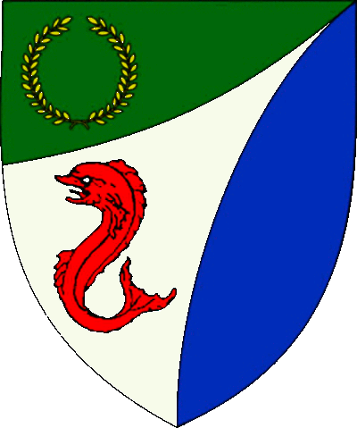

|  |
| --- |
| **Table of Contents**  Weekly Activities in the Barony 2  Arts & Science and Social Schedule 3  Virtual A&S Opportunities 3  Kingdom Calendar 4  The Barony Around the Web 6  Baronial Meeting Notes 7  Baronial Officer Regnum 10  Statement of Ownership 11  Submissions & Disclaimer 11  Marshal Information 12  Award Recommendations 12  Letters from Their Excellencies…….13 |

## The Coronet of the Barony of Tir-y-Don

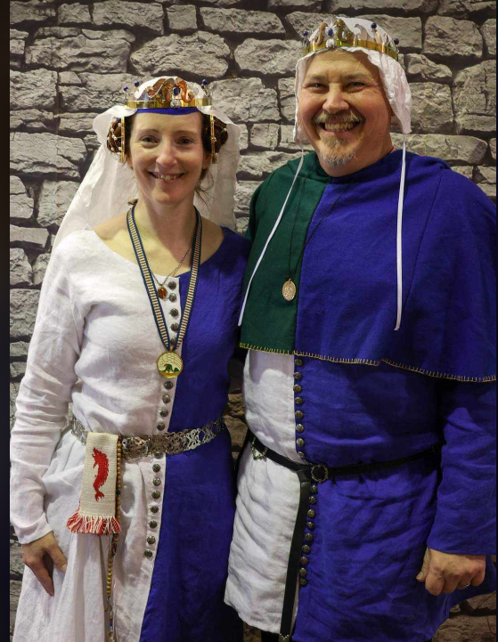

This is the Mar 2025 issue of the NoD-Y-Rit, a publication of the Barony of Tir-Y-Don of the Society for Creative Anachronism, Inc. The Nod-Y-Rit is available from Anna van Sint Maartensdyjk at chronicler@tirydon.atlantia.sca.org. Subscriptions are free as all publications are available electronically. This newsletter is not a corporate publication of the Society for Creative Anachronism, Inc., and does not delineate SCA policies.

© Copyright 2025, Society for Creative Anachronism, Inc. For information on reprinting letters and artwork from this publication, please contact the Tir-Y-Don Chronicler, who will assist you in contacting the original creator of the piece. Please respect the legal rights of our contributors.

Their Excellencies:

***Baron Jean-Claude de Calais***

***Baroness Alina of the Ilex***

*Photo Credit: Llwyd Aldrydd*

# Weekly Activities in the Barony

|  |  |  |
| --- | --- | --- |
| Sundays |  |  |
| **10AM** | Archery Practice Contact Marshal of Archery **Newport News City Park**  Archery Range | Call 757-888-3333 for Safety Class Schedule.  Call Marshal of Archery before attending. |
| Take the Archery Safety Class online. You can email the completed test to the parks department.  Your card will be emailed to you.  <https://www.nnva.gov/2561/Archery-Range> | | |
| **1PM** | Fighter Practice and Social Heavy/Rapier  Contact Knight Marshal | Please contact the Marshal if you wish to attend. |
| Mondays |  |  |
| **7PM** | Armory Night Contact Tim Prickett | Contact Tim before attending. |
| Thursdays |  |  |
| **7PM** | Arts & Sciences and Social Contact MOAS  Arts & Science and Social Schedule | Contact MOAS or Baroness Kaleeb for more details – In person, some hybrid sessions |

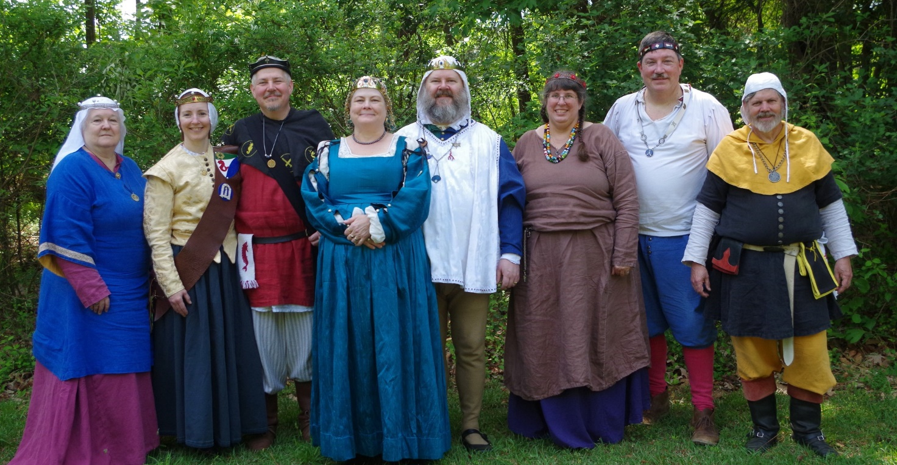

Photo Credit:   
Current and past landed baronage at Baronial Birthday

# Arts & Science and Social Schedule

Classes start at 7pm unless otherwise noted! Classes are held at **Cornerstone Community Church** **1003 Moyer Rd, Newport News, VA 23608**. Business meeting nights will be hybrid in person and online.

|  |
| --- |
| Please check the baronial Facebook group for up to date meeting information. |

**3/6/2025**Learning how to use your sewing machine

**3/13/2025**Scribal Night

**3/20/2025**Business Meeting

**3/27/2025**Japanese Books Make and Take

**4/3/2025**Sari Tying / Veil Draping

**4/10/2025**Scribal Night

**4/17/2025**Business Meeting

**4/24/2025**6 Embroidery Stitches from the 16th C

**5/1/2025**Hedeby Bags

**5/8/2025**Baronial Event last minute planning or tasks

**5/15/2025**Scribal Night

**5/22/2025**Business Meeting and Pennsic Planning

**5/29/2025**Shields: Start to Finish

**6/5/2025**SCA First Aid

**6/7/2025**Group Sewing Day

**6/12/2025**Scribal Night

**6/19/2025**Business Meeting

**6/26/2025**Metal Jewelrymaking

**7/4/2025**July 4 Party and Business meeting

**7/10/2025**Loaner Garb and Gear Sort and Fix (at their Excellencies manor)

**7/12/2025**Group Sewing Day

**7/17/2025**Cheese!

**7/24/2025**Pennsic Packing

**7/31/2025** No class, Pennsic Prep

**9/4/2025** Pennsic Recap and Planning

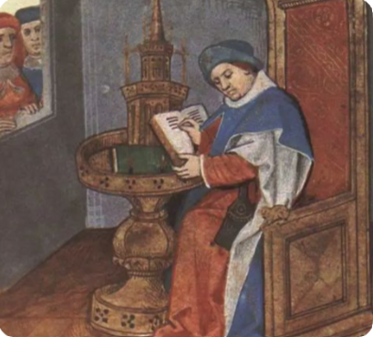

# Virtual A&S Opportunities

|  |  |  |
| --- | --- | --- |
| Virtual Atlantia | Atlantia has setup a Virtual A&S center which includes a calendar of online course offerings, the ability to request a class to be added to the calendar and a way to get credit for the University of Atlantia. Be sure to check it out for an update to date listing of virtual classes throughout the Kingdom. | <http://virtual.atlantia.sca.org/> |
| SCA Virtual Classroom and Artisan Display | Teachers and artisans can share the virtual resources they've created to make them available SCA-wide to continue to foster a learning environment. | <https://www.facebook.com/groups/virtualsca/> |
| Known World Discord | A large discord server that has chat rooms for multiple topics, lots of classes, feedback, and opportunities to connect with artists, fighters, and anyone else across the Known World. | <https://discord.gg/bDavK8> |

Know of any opportunities not listed here? Let us know so we can add them!

Contact the Chronicler via Email, Facebook, or Discord

# Kingdom Calendar

*Please refer to the* [*Kingdom Calendar*](https://atlantia.sca.org/calendar/) *website for up to date information regarding event cancellations or changes.*

#### **April-2025**

04-05 - 04-05 : [Spring Coronation (TBD)](https://atlantia.sca.org/event/?event_id=e0b05df1) : (Atlantia) [](https://moas.atlantia.sca.org/cultura-atlantia)

04-12 - 04-12 : [Dragons Fire IV: Birth of the Dragon](https://atlantia.sca.org/event/?event_id=664b66f7) :Easley SC (Saint Georges)

04-12 - 04-12 : [Festival of Elvegast](https://atlantia.sca.org/event/?event_id=e92a913c) :Hillsborough NC (Elvegast)

04-12 - 04-12 : [Night at the Faire](https://atlantia.sca.org/event/?event_id=677af308) :*Severn MD (Lochmere)*

04-18 - 04-20 : [Queen's Rapier 2025](https://atlantia.sca.org/event/?event_id=67a55cf1) :*Halifax NC (Raven's Cove)* (Q )

04-18 - 04-20 : [Canterbury Tales: Missile Madness Reloaded](https://atlantia.sca.org/event/?event_id=6752d140) :*Monroe VA (Seven Hills)*

04-24 - 04-27 : [LEAFS (Learning Equestrian, Agriculture, and Forestry Symposium)](https://atlantia.sca.org/event/?event_id=66852824) :Upper Marlboro MD (Highland Foorde)

04-25 - 04-27 : [Revenge of the Stitch X](https://atlantia.sca.org/event/?event_id=66bcbea5) :*Denton MD ()*

04-25 - 04-27 : [Baronial Spring Camp](https://atlantia.sca.org/event/?event_id=a6face14) :Apex NC (Windmasters' Hill)

#### **May-2025**

05-03 - 05-03 : [Spring Crown Tournament (TBD)](https://atlantia.sca.org/event/?event_id=427fa35d) :*(Atlantia)* [](https://moas.atlantia.sca.org/tempore-atlantia)

**05-09 - 05-11 :**[**Return to Sherwood**](https://atlantia.sca.org/event/?event_id=665cc924)**:*Hayes VA (Tir-y-Don)* (Q K )**

05-09 - 05-11 : [Hawkwood's XXI Baronial Birthday: One Night In Marrakesh](https://atlantia.sca.org/event/?event_id=671562b4) :*Old Fort NC (Hawkwood)*

05-17 - 05-18 : [Victory on the Vine II](https://atlantia.sca.org/event/?event_id=671e206e) :*Culpeper VA (Ponte Alto)*

05-17 - 05-17 : [Not Quite Quarterly Braggin Rights Tournament V](https://atlantia.sca.org/event/?event_id=6771f317):*AIKEN SC (Ritterwald)* (Q K Pr P )

05-17 - 05-17 : [Skewered! V: Tenoch's Table](https://atlantia.sca.org/event/?event_id=6703fcf3) :*Gaithersburg MD (Roxbury Mill)*

*05-23 - 05-26 :*[*Gem Joust / Investiture*](https://atlantia.sca.org/event/?event_id=6792ed55)*:Ashland VA (Caer Mear) (Q K Pr P )*

05-31 - 05-31 : [On Target!](https://atlantia.sca.org/event/?event_id=67560dbe) :*Annapolis MD (Lochmere)*

#### **June-2025**

06-06 - 06-08 : [Rumors of War- Part Deux](https://atlantia.sca.org/event/?event_id=678ee87a) :*Bryson City NC (Stormwall)*

06-06 - 06-08 : [Royal Archery Tournament](https://atlantia.sca.org/event/?event_id=678e9efe) :*Booneville NC (Sacred Stone)*

06-14 - 06-14 :  [University of Atlantia](https://atlantia.sca.org/event/?event_id=67ab94b1) :*Virginia Beach VA (Marinus)* (Q )

06-20 - 06-22 : [Storvik Novice Tournament](https://atlantia.sca.org/event/?event_id=678e684e) :*Upper Marlboro MD (Storvik)*

#### **July-2025**

07-12 - 07-12 : [Procrastinators Paradise- Last Chance Authorization and Sewing Day](https://atlantia.sca.org/event/?event_id=677dd4bf) :*Waldorf MD (Dun Carraig)*

07-19 - 07-19 : [Warrior’s Games](https://atlantia.sca.org/event/?event_id=6730fead) :*Harleyville SC (Tear-Sea's Shore)*

07-25 - 08-10 : [Pennsic War](https://atlantia.sca.org/event/?event_id=4ff3dfc1) :*(Atlantia)*

#### **Sept-2025**

09-05 - 09-07 : [Sacred Stone Baronial Birthday 2025: A Celebration of Mehregan](https://atlantia.sca.org/event/?event_id=679708a1) :*Boonville NC (Sacred Stone)* (Q K )

09-13 - 09-13 : [Stierbach Baronial Birthday](https://atlantia.sca.org/event/?event_id=678e8e2f) :*Culpeper VA (Stierbach)* (Q K )

09-20 - 09-20 : [Fall University (TBD)](https://atlantia.sca.org/event/?event_id=88ef90b5) :*(Atlantia)*

09-26 - 09-28 : [Trial By Fire & Lochmere Arrow: Alba gu bràth!](https://atlantia.sca.org/event/?event_id=66eb7df7) :*Glen Arm MD (Bright Hills)*

09-27 - 09-27 : [Silver Chalice Novice Tournament](https://atlantia.sca.org/event/?event_id=67b48604) :*Harleyville SC (Hidden Mountain)*

#### **Oct-2025**

10-04 - 10-04 : [Fall Coronation (TBD)](https://atlantia.sca.org/event/?event_id=ddd88316) :*(Atlantia)* (Q ) [](https://moas.atlantia.sca.org/cultura-atlantia)

10-11 - 10-17 : [War of the Wings, 2025](https://atlantia.sca.org/event/?event_id=67901f7d) :*Boonville NC (Atlantia)* (Q K )

10-31 - 11-02 : [Dance of the Dead: A Festival of Bones](https://atlantia.sca.org/event/?event_id=67a5664f) :*Nanjemoy MD (Dun Carraig)*

#### **Nov-2025**

11-07 - 11-09 : [Fall Crown Tournament (TBD)](https://atlantia.sca.org/event/?event_id=42e6fbe5) :*(Atlantia)* [](https://moas.atlantia.sca.org/tempore-atlantia)

11-14 - 11-16 : [Buckston Birthday](https://atlantia.sca.org/event/?event_id=673feafa) :*Apex NC (Buckston-on-Eno)*

#### **Dec-2025**

12-06 - 12-06 : [Unevent 2025](https://atlantia.sca.org/event/?event_id=dd54418d) :*(Atlantia)*

# The Barony Around the Web

Many members of the populace have a Web Presence. Please visit their websites and share in the great content. Please contact the Chronicler if you want to promote your site.

Baroness Jane Fox <https://jezebeljane.blogspot.com/>

Baron John Biggeheved <https://biggeheved.com/>

Mistress Kaleeb the Green Eyed <http://kaleeb.galtham.org/>

Learn Fiore <http://learnfiore.org/>

Baron Llwyd Aldrydd <http://baronllwyd.org/>

Lady Mariss Ghijs <https://opusmariss.wordpress.com>

Lady Mevanou verch Reys Yriskynit <https://mvry1sca.wordpress.com/>

## Baronial website

Our Web Minister maintains our baronial website. He can be contacted with any content changes.

<https://www.tirydon.atlantia.sca.org>

## Baronial Facebook Group

We share some informal announcements and share content on our Facebook group. It’s another way to stay connected with those in the Barony.

<https://www.facebook.com/groups/343471645861986/>

## Kingdom eNewsletters

Log in with your SCA Member Portal username and password. This requires at least an associate membership to access. Please contact SCA corporate with any log in issues.

<https://members.sca.org/apps/#SignIn>

# Baronial Meeting Notes

|  |  |
| --- | --- |
| Location: | Cornerstone Community Church and virtual |
| Date and Time:  Mar 20, 2025 | Next Meeting’s Date and Time:  Thurs Apr 17, 7:00pm Cornerstone Community Church |

Baron and Baroness

Thanks to everyone who helped at the Marinus demo. They have offered to help in return.

Do you have any award recommendations? Please let Their Excellencies know!

Are you interested in being a Baronial Champion? Consult with Their Excellencies about duties and expectations!

Officer Reports

### Seneschal

### University site walk through; some ADA issues. Kingdom emails are being updated – stay tuned.

### Exchequer

### Finalizing money for our last event.

### Chatelaine

We will not be able to attend the Mosaic Festival.

### Chronicler

Submission deadline is the 25th. Please send content.

### Herald

### Several names are being worked on for submission.

### Knight Marshal

### Gabriel Leoson is taking over; we are looking at combining our practice with Marinus, possibly in Isle of Wight.

### Archery

### Practices will be held at Newport News Park, as the weather has warmed up. Please make sure you are cleared to shoot.

### Equestrian

### There will be equestrian events at Baronial Birthday! There is interest in archery on horseback.

### Arts and Sciences

The schedule has been posted. Group sewing events for Pennsic may be scheduled.

Social Media

Please let the Social Media Minister know if you have any ideas or suggestions to expand our media footprint.

### Web Minister

Addresses are changing – stay tuned!

Old & New Business

## Old Business

05-09 - 05-11 : [Tir-y-Don Baronial Birthday](https://atlantia.sca.org/event/?event_id=665cc924) :*Hayes VA (Tir-y-Don)* 50th year anniversary of first event. The theme is, Return to Sherwood! So dust off those clothes of Lincoln green and prepare to join Robin and his merry band of thieves! Please think of ideas for A&S competitions – this is a chance to display all that the SCA does. If anyone is interested in staff position, let Pam & Michelle know. - Sarah will head registration and gate - Christina will do Newcomers Point.

WE NEED HELP! Please volunteer to help at the gate, at Newcomer’s Point, at A&S competitions, as herald, as retainer, and most especially, IN THE KITCHEN!

MOL is also in need of help.

Proposed we put deadline on requesting refund for feast. Caer Mear states must request refund at least 7 days before, otherwise unless we re-sell the spot, no refund. Field space at Ice Castles, being researched by JC. Pennsic camp - land has been registered. We need to replace the stove and a new shower head, needs a button to turn off flow on the head (check camper supply store). Procedures written by Llwyd and Kaleeb going to be posted for reference. Michelle had an idea about an artisan faire, think of date or location (Community Center, library, fighter practice shelter), and what we would want to display. Invite newcomers, public.

Please think about the baronial camp for Gem Joust (Memorial Day weekend) if you are planning on attending. Also, if you are attending Pennsic (July 25 – Aug 10) and/or War of the Wings (Oct 11 – 17), Her Excellency is coordinating camping. Please contact her regarding dining information.

## New Business

KASF 2026 bid has been submitted.

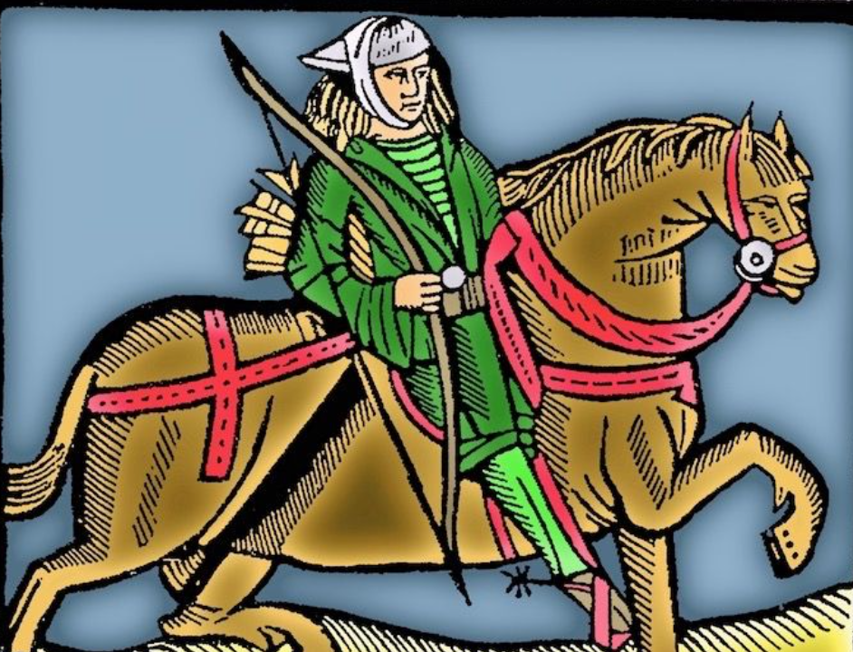

This woodcut was used by the medieval printer Caxton to illustrate both the Gest of Robin Hood and Chaucer's Canterbury Tales.

# Baronial Officer Regnum

|  |  |  |  |
| --- | --- | --- | --- |
| http://tirydon.atlantia.sca.org/wp-content/uploads/2018/11/tyd-1-251x300-1.gif | **Baron:** | Jean-Claude du Calais (Jim Cunningham) | [baron@tirydon.atlantia.sca.org](mailto:baron@tirydon.atlantia.sca.org) 757-968-5303 NLT 9pm |
| http://tirydon.atlantia.sca.org/wp-content/uploads/2018/11/tyd-1-251x300-1.gif | **Baroness:** | Alyna of the Ilex (Holly Cunningham) | [baroness@tirydon.atlantia.sca.org](mailto:baroness@tirydon.atlantia.sca.org) 757-968-5303 NLT 9pm |
| http://tirydon.atlantia.sca.org/wp-content/uploads/2018/11/o_sen.gif | **Seneschal (President):** | Llwyd Aldrydd (Lloyd Eldred) | [seneschal@tirydon.atlantia.sca.org](mailto:seneschal@tirydon.atlantia.sca.org) (757) 875-0033 NLT 9pm |
| http://tirydon.atlantia.sca.org/wp-content/uploads/2018/11/o_exch.gif | **Chancellor of the Exchequer (Treasurer):** | Sarah Kennedy of Glengarry (Sarah Kennedy) | [exchequer@tirydon.atlantia.sca.org](mailto:exchequer@tirydon.atlantia.sca.org) NLT 9pm |
| http://tirydon.atlantia.sca.org/wp-content/uploads/2018/11/o_chat.gif | **Chatelaine (New member support):** | Andrei Barsukov (Andrew LaVinus) | [chatelaine@tirydon.atlantia.sca.org](mailto:chatelaine@tirydon.atlantia.sca.org)  (804) 869-8882 NLT 9:30pm |
| http://tirydon.atlantia.sca.org/wp-content/uploads/2018/11/o_chr.gif | **Chronicler**  **(Secretary):** | Anna van Sintmaartensdyck (Nancy Kiel) | [chronicler@tirydon.atlantia.sca.org](mailto:chronicler@tirydon.atlantia.sca.org) (757) 220-6857, leave a message NLT 9:30pm |
| http://tirydon.atlantia.sca.org/wp-content/uploads/2018/11/o_chr.gif | **Social Media:** | Skye Walker | [socialmedia@tirydon.atlantia.sca.org](mailto:socialmedia@tirydon.atlantia.sca.org) |
| http://tirydon.atlantia.sca.org/wp-content/uploads/2018/11/o_herald.gif | **Herald:** | Catheryn inghean Ui Dhubhshlaine (Amanda Carter) | [herald@tirydon.atlantia.sca.org](mailto:herald@tirydon.atlantia.sca.org) |
| http://tirydon.atlantia.sca.org/wp-content/uploads/2018/11/o_marshal.gif | **Knight’s Marshal:** | Christina O’Cleary  (Jessica Lavinus) | [marshal@tirydon.atlantia.sca.org](mailto:marshal@tirydon.atlantia.sca.org) NLT 9pm |
| http://tirydon.atlantia.sca.org/wp-content/uploads/2018/11/o_marshal.gif | **Marshal of Archery:** | Leofric of Oxenford (Mike Durling) | [archer@tirydon.atlantia.sca.org](mailto:archer@tirydon.atlantia.sca.org) |
| http://tirydon.atlantia.sca.org/wp-content/uploads/2018/11/o_as.gif | **Minister of Arts & Sciences:** | Cairistiona inghean Mhuireadhaigh (Carol Vanderspoel) | [moas@tirydon.atlantia.sca.org](mailto:moas@tirydon.atlantia.sca.org) (757) 819-3296 NLT 9:30pm |
| Office Badge | **Webminister:** | Llwyd Aldrydd (Lloyd Eldred) | [webminister@tirydon.atlantia.sca.org](mailto:webminister@tirydon.atlantia.sca.org) (757) 875-0033 NLT 9:30pm |

# Statement of Ownership, Submissions & Disclaimer

This is the March 2025 issue of the NoD-y-Rit, a publication of the Barony of Tir-y-Don of the Society for Creative Anachronism, Inc. The Nod-y-Rit is available from Anna van Sint Maartensdyjk (Nancy Kiel) at [chronicler@tirydon.atlantia.sca.org](mailto:chronicler@tirydon.atlantia.sca.org) and Nancy_kiel@hotmail.com. Subscriptions are free as all publications are available electronically. This newsletter is not a corporate publication of the Society for Creative Anachronism, Inc., and does not delineate SCA policies.

© Copyright 2024, Society for Creative Anachronism, Inc. For information on reprinting letters and artwork from this publication, please contact the Tir-y-Don Chronicler, who will assist you in contacting the original creator of the piece. Please respect the legal rights of our contributors.

Please send submissions to:

Nancy Kiel

108 Wilson Circle, Williamsburg VA

[chronicler@tirydon.atlantia.sca.org](mailto:chronicler@tirydon.atlantia.sca.org)

Nancy_kiel@hotmail.com

***Please, remember that all submissions to the NoD-y-Rit must be accompanied by an SCA release form.*** The first link leads you to the Society Chronicler’s links for forms. The last three links are for the forms that can be submitted on line via Internet Form Fills. Everyone is encouraged to consider contributing to the NoD-y-Rit.

Society Chronicler forms:

<http://chronicler.atlantia.sca.org/Releases.html>

Release form for writing or artwork:

<http://chronicler.atlantia.sca.org/ReleaseCreativeFillable.pdf>

Release form for photographs:

<http://chronicler.atlantia.sca.org/ReleasePhotographerFillable.pdf>

Release form for model(s) (the subject of your artwork or photograph):

<http://chronicler.atlantia.sca.org/ReleaseModelFillable.pdf>

# Marshal Information

## Image result for mINISTER OF LIST BADGE SCABecome a MOL

Want to serve the Fighter Community by providing Tournament organization and keeping the Fighting Authorizations documented? Consider becoming a Minister of the List.

Please visit the Kingdom MOL website for more information and forms: <http://mol.atlantia.sca.org/ForMoLs/index.html>

## Become a Marshal

Do you enjoy fighting activities at events and practices? Many folks invest significant time to keep these activities safe. Consider becoming a marshal to help keep these activities happening in the future.

Please visit the Earl Marshals Website for more information: <https://marshal.atlantia.sca.org/procedures/mit/>

## Marshal Event Report Submission

Participants, Fighters and Marshals can all submit Event reports for fighting activities. If you see something you wish to report visit the Kingdom Earl Marshal Website. Include things like injuries, equipment failures, or other issues you see.

Submit a report here: <https://warrant.atlantia.sca.org/reports/new/1>

## Warranted Marshals

The Kingdom maintains a list of warranted marshals and Marshals in Training. A list of marshals who have expired warrants is also maintained here.

Visit: <https://warrant.atlantia.sca.org/warrants/branch/6/1>

# Award Recommendations

## Baronial Award Recommendations

Baronial Award Recommendations are sent to the Coronet. Please use [baron@tirydon.atlantia.sca.org](https://d.docs.live.net/55395330e2cd57ab/SCA/NODYRIT/baron@tirydon.atlantia.sca.org)  and [baroness@tirydon.atlantia.sca.org](https://d.docs.live.net/55395330e2cd57ab/SCA/NODYRIT/baroness@tirydon.atlantia.sca.org).

## Kingdom Award Recommendations

The Kingdom maintains a database of award recommendations and what events potential recipients will attend in the future. Visit: <https://award.atlantia.sca.org/>

## Review your Order of Precedence Entry

Recent name change or award? Please visit the Atlantia’s Order of Precedence (OP) and request any updates or corrections as needed.

Visit the OP here: <http://op.atlantia.sca.org>

Submit Corrections requests here: <http://op.atlantia.sca.org/corrections.php>

Letters from Their Excellencies



Greetings Tir-y-Don!

As warmer weather approaches, we start to think more about outdoor events. It’s not just about the tournaments; it’s about spending time under a day shade, chatting with friends and (yes) tournaments. But this time of year, we often go through the process of remembering how to go to events all over again. As you plan out your spring and summer, let’s go back over some of the basics.

First, a thing near and dear to our hearts…. Snacks!  Think about how long you will be at the event, check to see if they have a lunch option and plan accordingly. You can also see if anyone else in the Barony is going, and if there is a plan for a dayboard. Either way, you want to make sure that your dietary needs are covered. When planning your food for the day, make sure you also cover your drinks. Bring something to keep you hydrated, and something to keep you awake if necessary (especially for the ride home). Speaking of which, don’t forget a mug or cup to drink from for the day.

Next, where will you sit? Make sure you have a chair or bench to sit on for the day. While many will bring an extra, it’s best not to rely on the kindness of others. If you’re bringing a modern chair you will want to bring something to cover it for the day. A blanket, some fabric, even a cloak that you might need later will do wonders to make things a little less modern.

 And now Alyna’s favorite (even more than snacks), a list!  Make sure to create a good list for you to make your event easier. A good packing list can be the difference between having a great event and wondering what you’ll do for the day. While we are happy to provide some starter lists, you’ll certainly want to make one that suits you. Do you need to bring archery supplies, A&S displays, armor, weapons, the chair, mug, and snacks we talked about earlier?  Put it on the list! That way you’re less likely to show up to the event doing a live version of the facepalm.  Feel free to ask what’s on our lists, as we have different lists for different events (day tripping, camping, fighting, feasting, local, etc.).

Speaking of events, we currently plan to attend the following events:

5 Apr: Coronation – Caer Mear (Powhatan, VA)

18 April: Queens Rapier – Ravens Cove (Halifax, NC)

3 May: Crown Tourney – Elchenburg Castle (Boonville, NC)

9-11 May: Return to Sherwood – That’s here! (Hayes, VA)

See you soon and let us know if you need anything!

Jean Claude, Baron     Alyna, Baroness

**Baronial Spotlight:**

**Oye, oye!**On this day we spotlight the Scadian tale of Lord Gabriel Leoson, once known as Joshua. Lord Gabriel is our Baronial Rapier Champion, and the sponsor for our monthly challenges. The February challenge was "Frills & Drills."

**Well met, Lord Gabriel! How and when didst thee discover the SCA?**

I have known about the SCA since high school, but I am still a newer member since I did not actually start until a little bit before the plague. When I moved here, some friends of mine pointed me to the local group and I said why not? I needed something to keep me busy. I fell in love with the dream and have come to call Tir-y-Don home.

**What doth thee do in the SCA and what doth thee wish to learn next?**

I like to fence; I will not make claims to how well I do though. Stabbing things repeatedly is always fun so I also dabble in making garb. I would say my wire work is probably the best thing that I am known for in the arts though. I am still learning and making improvements, but I think it is pretty. Next projects I am looking forward to doing are going to be sterling silver pieces and some armbands in copper or bronze from Roman Britanica. Additionally, this year's big goal is to authorize in heavy and cut and thrust.

**What has kept thee active in the SCA?**

My passions in history, archeology, anthropology, stories, and being able to experience life through another’s reality. I can explore experimental archeology in “how it was made/done/experienced” while still being able to see how life has or hasn’t changed in many cases. The people also are a big important part, we are a bunch of nerds in one way or another and created an international community together.

**Pray tell, what doth thee wish ye had known as a newcomer?**

Historical accuracy gives way to anachronisms. Meaning what we assume and accept to be period are, in fact, not, but we accept it because it fits the atmosphere. For example, armor requirements being met, you can have a fighter that spans centuries and cultures. Even more so, the fighting techniques have evolved to be competitive in our sport versus historically accurate. Granted there are only so many ways the human body moves, but it is a combination of anachronisms that make up the majority of what you see used on the battlefield. Just because it is not accurate does not mean it is not valid!!! I am not going to sew by hand! We have technology for safety and convenience use it. But when you brew a period beer, make a period piece of garb or jewelry using period techniques it just shines all the better.

**Prithee tell us a tale or fun fact that the populous may not know about you or your persona.**

I took inspiration from Pope Leo I for my name Leoson. Pope Leo the Great was the Pope who negotiated with Atilla the Hun and turned him away from attacking northern Italy. This is enshrined in the painting by Raphael titled The Meeting of Leo the Great and Attila. Raphael changed the face of Leo I to Leo X after the death of Pope Julius II. Take that bit of info as you will when thinking about renaissance painters.

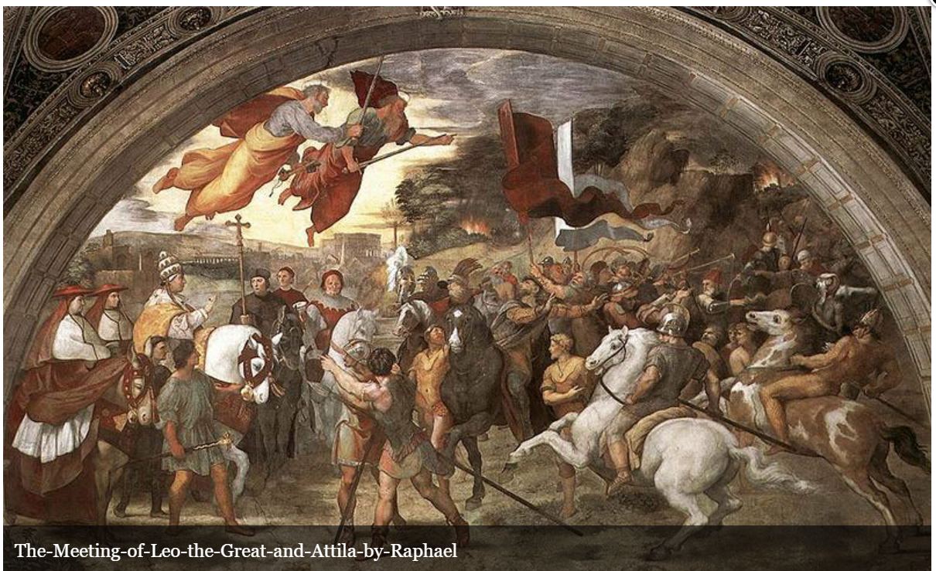

Thanks to Lord Gabriel Leoson for his continued dedication to our Barony!

Best regards, Asya (Social Media Minister)