|  |
| --- |
| Barony of Tir-y-Don  The NoD-y-Rit  Feb AS 59 (CE 2025)  Volume 43 Issue 11 Society of Creative Anachronism (SCA Inc.) |

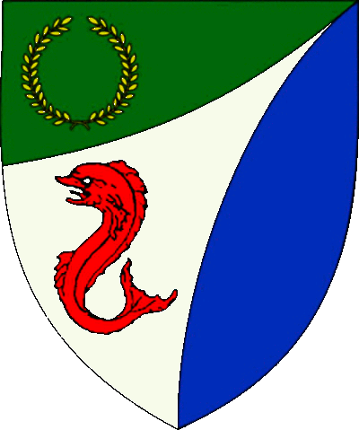

|  |
| --- |
| **Table of Contents**  Weekly Activities in the Barony 2  Arts & Science and Social Schedule 3  Virtual A&S Opportunities 3  Kingdom Calendar 4  The Barony Around the Web 6  Baronial Meeting Notes 7  Baronial Officer Regnum 10  Statement of Ownership 11  Submissions & Disclaimer 11  Marshal Information 12  Award Recommendations 12  Letters from Their Excellencies…….13 |

## The Coronet of the Barony of Tir-y-Don

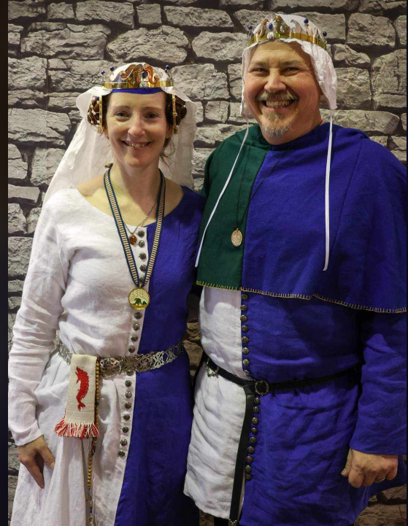

This is the Feb 2025 issue of the NoD-Y-Rit, a publication of the Barony of Tir-Y-Don of the Society for Creative Anachronism, Inc. The Nod-Y-Rit is available from Anna van Sint Maartensdyjk at chronicler@tirydon.atlantia.sca.org. Subscriptions are free as all publications are available electronically. This newsletter is not a corporate publication of the Society for Creative Anachronism, Inc., and does not delineate SCA policies.

© Copyright 2025, Society for Creative Anachronism, Inc. For information on reprinting letters and artwork from this publication, please contact the Tir-Y-Don Chronicler, who will assist you in contacting the original creator of the piece. Please respect the legal rights of our contributors.

Their Excellencies:

***Baron Jean-Claude de Calais***

***Baroness Alina of the Ilex***

*Photo Credit: Llwyd Aldrydd*

# Weekly Activities in the Barony

|  |  |  |
| --- | --- | --- |
| Sundays |  |  |
| **10AM** | Archery Practice Contact Marshal of Archery **Newport News City Park**  Archery Range | Call 757-888-3333 for Safety Class Schedule.  Call Marshal of Archery before attending. |
| Take the Archery Safety Class online. You can email the completed test to the parks department.  Your card will be emailed to you.  <https://www.nnva.gov/2561/Archery-Range> | | |
| **1PM** | Fighter Practice and Social Heavy/Rapier  Contact Knight Marshal | Please contact the Marshal if you wish to attend. |
| Mondays |  |  |
| **7PM** | Armory Night Contact Tim Prickett | Contact Tim before attending. |
| Thursdays |  |  |
| **7PM** | Arts & Sciences and Social Contact MOAS  Arts & Science and Social Schedule | Contact MOAS or Baroness Kaleeb for more details – In person, some hybrid sessions |

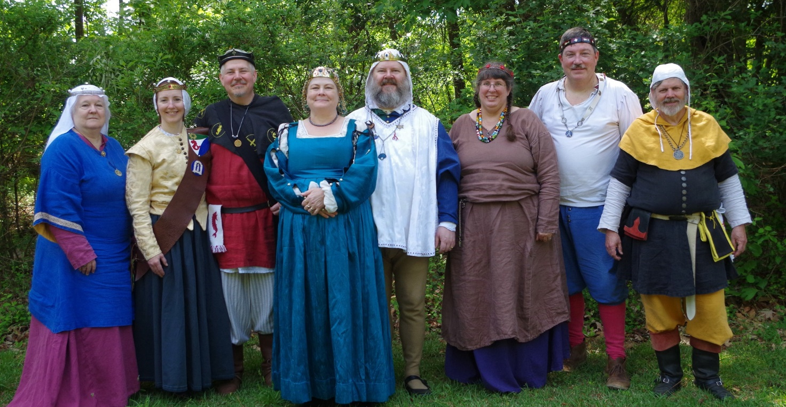

Photo Credit:   
Current and past landed baronage at Baronial Birthday

# Arts & Science and Social Schedule

Classes start at 7pm unless otherwise noted! Classes are held at **Cornerstone Community Church** **1003 Moyer Rd, Newport News, VA 23608**. Business meeting nights will be hybrid in person and online.

|  |
| --- |
| Please check the baronial Facebook group for up to date meeting information. |

**3/6/2025**Learning how to use your sewing machine

**3/13/2025**Scribal Night

**3/20/2025**Business Meeting

**3/27/2025**Japanese Books Make and Take

**4/3/2025**Sari Tying / Veil Draping

**4/10/2025**Scribal Night

**4/17/2025**Business Meeting

**4/24/2025**6 Embroidery Stitches from the 16th C

**5/1/2025**Hedeby Bags

**5/8/2025**Baronial Event last minute planning or tasks

**5/15/2025**Scribal Night

**5/22/2025**Business Meeting and Pennsic Planning

**5/29/2025**Shields: Start to Finish

**6/5/2025**SCA First Aid

**6/7/2025**Group Sewing Day

**6/12/2025**Scribal Night

**6/19/2025**Business Meeting

**6/26/2025**Metal Jewelrymaking

**7/4/2025**July 4 Party and Business meeting

**7/10/2025**Loaner Garb and Gear Sort and Fix (at their Excellencies manor)

**7/12/2025**Group Sewing Day

**7/17/2025**Cheese!

**7/24/2025**Pennsic Packing

7/31/2025 No class, Pennsic Prep

9/4/2025 Pennsic Recap and Planning

# Virtual A&S Opportunities

|  |  |  |
| --- | --- | --- |
| Virtual Atlantia | Atlantia has setup a Virtual A&S center which includes a calendar of online course offerings, the ability to request a class to be added to the calendar and a way to get credit for the University of Atlantia. Be sure to check it out for an update to date listing of virtual classes throughout the Kingdom. | <http://virtual.atlantia.sca.org/> |
| SCA Virtual Classroom and Artisan Display | Teachers and artisans can share the virtual resources they've created to make them available SCA-wide to continue to foster a learning environment. | <https://www.facebook.com/groups/virtualsca/> |
| Known World Discord | A large discord server that has chat rooms for multiple topics, lots of classes, feedback, and opportunities to connect with artists, fighters, and anyone else across the Known World. | <https://discord.gg/bDavK8> |

Know of any opportunities not listed here? Let us know so we can add them!

Contact the Chronicler via Email, Facebook, or Discord

# Kingdom Calendar

*Please refer to the* [*Kingdom Calendar*](https://atlantia.sca.org/calendar/) *website for up to date information regarding event cancellations or changes.*

#### **March-2025**

03-01 - 03-01 : [Kingdom Arts & Sciences Festival (TBD)](https://atlantia.sca.org/event/?event_id=ced0ae3b) :*(Atlantia)* (Q K ) [](https://moas.atlantia.sca.org/persona-pentathlon)

03-08 - 03-16 : [Gulf Wars XXXIII (TBD)](https://atlantia.sca.org/event/?event_id=86bf1cc3) :*(Gleann Abhann)* (Q K )

03-09 - 03-09 : [CURIA 2025](https://atlantia.sca.org/event/?event_id=3c688f81) :*(Atlantia)*

03-15 - 03-15 : [St. Urho's Tournament](https://atlantia.sca.org/event/?event_id=677f0aa8) :*Statesville NC (Salesberie Glen)*

03-22 - 03-22 : [Storvik's Performer's Revel](https://atlantia.sca.org/event/?event_id=6789ab7d) :*Cheverly (Hyattsville) MD (Storvik)*

03-28 - 03-30 : [Hidden Mountain Baronial Birthday](https://atlantia.sca.org/event/?event_id=671949ab) :*Bennettsville SC (Hidden Mountain)*

03-29 - 03-29 : [Defending the Gate](https://atlantia.sca.org/event/?event_id=66427319) :*Spotsylvania VA (Sudentorre)* (Q K )

#### **April-2025**

04-05 - 04-05 : [Spring Coronation (TBD)](https://atlantia.sca.org/event/?event_id=e0b05df1) : (Atlantia) [](https://moas.atlantia.sca.org/cultura-atlantia)

04-12 - 04-12 : [Dragons Fire IV: Birth of the Dragon](https://atlantia.sca.org/event/?event_id=664b66f7) :Easley SC (Saint Georges)

04-12 - 04-12 : [Festival of Elvegast](https://atlantia.sca.org/event/?event_id=e92a913c) :Hillsborough NC (Elvegast)

04-12 - 04-12 : [Night at the Faire](https://atlantia.sca.org/event/?event_id=677af308) :*Severn MD (Lochmere)*

04-18 - 04-20 : [Queen's Rapier 2025](https://atlantia.sca.org/event/?event_id=67a55cf1) :*Halifax NC (Raven's Cove)* (Q )

04-18 - 04-20 : [Canterbury Tales: Missile Madness Reloaded](https://atlantia.sca.org/event/?event_id=6752d140) :*Monroe VA (Seven Hills)*

04-24 - 04-27 : [LEAFS (Learning Equestrian, Agriculture, and Forestry Symposium)](https://atlantia.sca.org/event/?event_id=66852824) :Upper Marlboro MD (Highland Foorde)

04-25 - 04-27 : [Revenge of the Stitch X](https://atlantia.sca.org/event/?event_id=66bcbea5) :*Denton MD ()*

04-25 - 04-27 : [Baronial Spring Camp](https://atlantia.sca.org/event/?event_id=a6face14) :Apex NC (Windmasters' Hill)

#### **May-2025**

05-03 - 05-03 : [Spring Crown Tournament (TBD)](https://atlantia.sca.org/event/?event_id=427fa35d) :*(Atlantia)* [](https://moas.atlantia.sca.org/tempore-atlantia)

**05-09 - 05-11 :**[**Return to Sherwood**](https://atlantia.sca.org/event/?event_id=665cc924)**:*Hayes VA (Tir-y-Don)* (Q K )**

05-09 - 05-11 : [Hawkwood's XXI Baronial Birthday: One Night In Marrakesh](https://atlantia.sca.org/event/?event_id=671562b4) :*Old Fort NC (Hawkwood)*

05-17 - 05-18 : [Victory on the Vine II](https://atlantia.sca.org/event/?event_id=671e206e) :*Culpeper VA (Ponte Alto)*

05-17 - 05-17 : [Not Quite Quarterly Braggin Rights Tournament V](https://atlantia.sca.org/event/?event_id=6771f317):*AIKEN SC (Ritterwald)* (Q K Pr P )

05-17 - 05-17 : [Skewered! V: Tenoch's Table](https://atlantia.sca.org/event/?event_id=6703fcf3) :*Gaithersburg MD (Roxbury Mill)*

*05-23 - 05-26 :*[*Gem Joust / Investiture*](https://atlantia.sca.org/event/?event_id=6792ed55)*:Ashland VA (Caer Mear) (Q K Pr P )*

05-31 - 05-31 : [On Target!](https://atlantia.sca.org/event/?event_id=67560dbe) :*Annapolis MD (Lochmere)*

#### **June-2025**

06-06 - 06-08 : [Rumors of War- Part Deux](https://atlantia.sca.org/event/?event_id=678ee87a) :*Bryson City NC (Stormwall)*

06-06 - 06-08 : [Royal Archery Tournament](https://atlantia.sca.org/event/?event_id=678e9efe) :*Booneville NC (Sacred Stone)*

06-14 - 06-14 : [Summer University (TBD)](https://atlantia.sca.org/event/?event_id=c5f7dafd) :*(Atlantia)*

06-20 - 06-22 : [Storvik Novice Tournament](https://atlantia.sca.org/event/?event_id=678e684e) :*Upper Marlboro MD (Storvik)*

#### **July-2025**

07-12 - 07-12 : [Procrastinators Paradise- Last Chance Authorization and Sewing Day](https://atlantia.sca.org/event/?event_id=677dd4bf) :*Waldorf MD (Dun Carraig)*

07-19 - 07-19 : [Warrior’s Games](https://atlantia.sca.org/event/?event_id=6730fead) :*Harleyville SC (Tear-Sea's Shore)*

07-25 - 08-10 : [Pennsic War](https://atlantia.sca.org/event/?event_id=4ff3dfc1) :*(Atlantia)*

#### **Sept-2025**

09-05 - 09-07 : [Sacred Stone Baronial Birthday 2025: A Celebration of Mehregan](https://atlantia.sca.org/event/?event_id=679708a1) :*Boonville NC (Sacred Stone)* (Q K )

09-13 - 09-13 : [Stierbach Baronial Birthday](https://atlantia.sca.org/event/?event_id=678e8e2f) :*Culpeper VA (Stierbach)* (Q K )

09-20 - 09-20 : [Fall University (TBD)](https://atlantia.sca.org/event/?event_id=88ef90b5) :*(Atlantia)*

09-26 - 09-28 : [Trial By Fire & Lochmere Arrow: Alba gu bràth!](https://atlantia.sca.org/event/?event_id=66eb7df7) :*Glen Arm MD (Bright Hills)*

#### **Oct-2025**

10-04 - 10-04 : [Fall Coronation (TBD)](https://atlantia.sca.org/event/?event_id=ddd88316) :*(Atlantia)* (Q ) [](https://moas.atlantia.sca.org/cultura-atlantia)

10-11 - 10-17 : [War of the Wings, 2025](https://atlantia.sca.org/event/?event_id=67901f7d) :*Boonville NC (Atlantia)* (Q K )

10-31 - 11-02 : [Dance of the Dead: A Festival of Bones](https://atlantia.sca.org/event/?event_id=67a5664f) :*Nanjemoy MD (Dun Carraig)*

#### **Nov-2025**

11-07 - 11-09 : [Fall Crown Tournament (TBD)](https://atlantia.sca.org/event/?event_id=42e6fbe5) :*(Atlantia)* [](https://moas.atlantia.sca.org/tempore-atlantia)

#### **Dec-2025**

12-06 - 12-06 : [Unevent 2025](https://atlantia.sca.org/event/?event_id=dd54418d) :*(Atlantia)*

# The Barony Around the Web

Many members of the populace have a Web Presence. Please visit their websites and share in the great content. Please contact the Chronicler if you want to promote your site.

Baroness Jane Fox <https://jezebeljane.blogspot.com/>

Baron John Biggeheved <https://biggeheved.com/>

Mistress Kaleeb the Green Eyed <http://kaleeb.galtham.org/>

Learn Fiore <http://learnfiore.org/>

Baron Llwyd Aldrydd <http://baronllwyd.org/>

Lady Mariss Ghijs <https://opusmariss.wordpress.com>

Lady Mevanou verch Reys Yriskynit <https://mvry1sca.wordpress.com/>

## Baronial website

Our Web Minister maintains our baronial website. He can be contacted with any content changes that need to be made.

<https://www.tirydon.atlantia.sca.org>

## Baronial Facebook Group

We share some informal announcements and share content on our Facebook group. It’s another way to stay connected with those in the Barony.

<https://www.facebook.com/groups/343471645861986/>

## Kingdom eNewsletters

Log in with your SCA Member Portal username and password. This requires at least an associate membership to access. Please contact SCA corporate with any log in issues.

<https://members.sca.org/apps/#SignIn>

# Baronial Meeting Notes

|  |  |
| --- | --- |
| Location: | Cornerstone Community Church and virtual |
| Date and Time:  Mar 20, 2025 | Next Meeting’s Date and Time:  Thurs Mar 20, 7:00pm Cornerstone Community Church |

Baron and Baroness

Nice to see so much involvement at University. Our A&S champion was the only Baronial entrant in KASF. Please send in award recommendations for Spring event. Please copy us if you send in Kingdom recommendations on the Kingdom website so we can support.

Please let Their Excellencies know if you will be attending upcoming events, so the appropriate tentage can be brought. Also, any contributions for gift baskets are appreciated.

Anyone who is interested in being a deputy for any office is encouraged to contact that officer.

Officer Reports

### Seneschal

### NTR

### Exchequer

### We have $8600 in our account.

### Chatelaine

### Mosaic Festival- April 26 – application has been submitted. Please think about how you can participate!

### Fall-o-ween, there is interest in doing again.

### Harvest Faire, will research.

### Check Daffodil Festival - Also maybe breweries demo, like other re-enactment groups.

### Adopt-A-Highway is still in the works.

Possible participation in a Hampton redevelopment event.

### Chronicler

Submission deadline is the 25th. Please send content.

### Herald

### NTR.

### Knight Marshal

### Practices continue – check the FB page for up to date information. Fighter get-togethers might be scheduled if the ground isn’t suitable for fighting.

### Archery

### Inside at Wilcox due to cold. Please contact the Archery Marshall if you will be attending.

### Equestrian

### Practices at Emerald Ridge Stables are scheduled for March 9 and June 1. The Hastilude is typically held on Labor Day weekend – please attend!

### Arts and Sciences

It is great to see so many people participating in A&S nights. Please suggest classes you would like to teach or things you want to be taught.

Social Media

Please let the Social Media Minister know if you have any ideas or suggestions to expand our media footprint.

### Web Minister

The website is set up for Baronial Birthday. Looking for Deputy or replacement. Not a difficult or time consuming job if someone really wants to do it - Yrsa might Deputy, will need to get warranted**.**

Old & New Business

## Old Business

05-09 - 05-11 : [Tir-y-Don Baronial Birthday](https://atlantia.sca.org/event/?event_id=665cc924) :*Hayes VA (Tir-y-Don)* 50th year anniversary of first event. The theme is, Return to Sherwood! So dust off those clothes of Lincoln green and prepare to join Robin and his merry band of thieves! Please think of ideas for A&S competitions – this is a chance to display all that the SCA does. If anyone is interested in staff position, let Pam & Michelle know. - Sarah will head registration and gate - Christina will do Newcomers Point.

WE NEED HELP! Please volunteer to help at the gate, at Newcomer’s Point, at A&S competitions, as herald, as retainer, and most especially, IN THE KITCHEN!

Proposed we put deadline on requesting refund for feast. Caer Mear states must request refund at least 7 days before, otherwise unless we re sell the spot, no refund. Field space at Ice Castles, being researched by JC. Pennsic camp - land has been registered. We need to replace the stove and a new shower head, needs a button to turn off flow on the head (check camper supply store). Procedures written by Llwyd and Kaleeb going to be posted for reference. Michelle had an idea about an artisan faire, think of date or location (Community Center, library, fighter practice shelter), and what we would want to display. Invite newcomers, public.

Next Mosey (March)

## New Business

Please think about the baronial camp for Gem Joust (Memorial Day weekend) if you are planning on attending. Also, if you are attending Pennsic (July 25 – Aug 10) and/or War of the Wings (Oct 11 – 17), Her Excellency is coordinating camping.

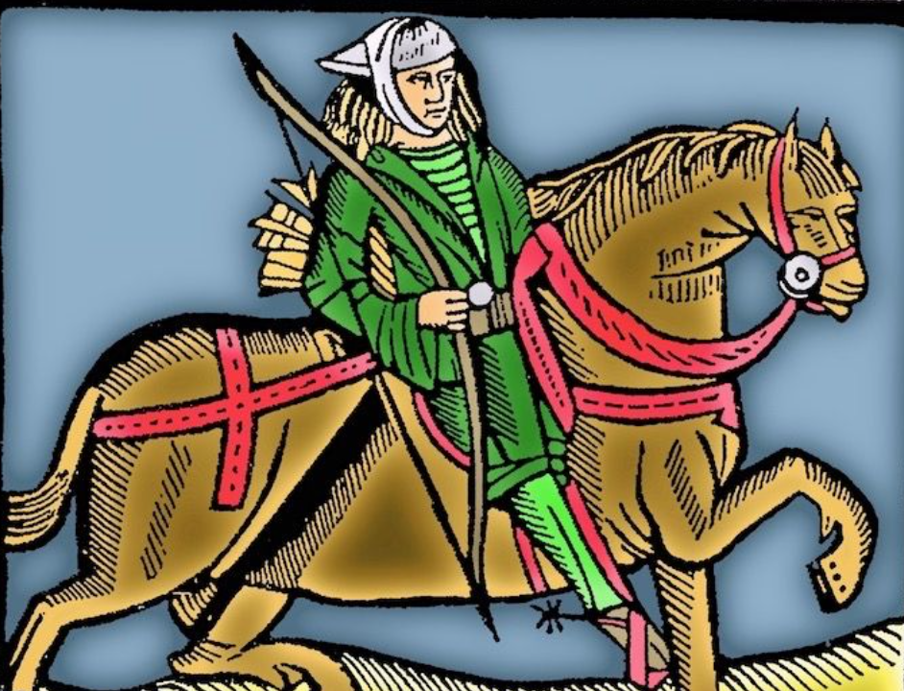

This woodcut was used by the medieval printer Caxton to illustrate both the Gest of Robin Hood and Chaucer's Canterbury Tales.

# Baronial Officer Regnum

|  |  |  |  |
| --- | --- | --- | --- |
| http://tirydon.atlantia.sca.org/wp-content/uploads/2018/11/tyd-1-251x300-1.gif | **Baron:** | Jean-Claude du Calais (Jim Cunningham) | [baron@tirydon.atlantia.sca.org](mailto:baron@tirydon.atlantia.sca.org) 757-968-5303 NLT 9pm |
| http://tirydon.atlantia.sca.org/wp-content/uploads/2018/11/tyd-1-251x300-1.gif | **Baroness:** | Alyna of the Ilex (Holly Cunningham) | [baroness@tirydon.atlantia.sca.org](mailto:baroness@tirydon.atlantia.sca.org) 757-968-5303 NLT 9pm |
| http://tirydon.atlantia.sca.org/wp-content/uploads/2018/11/o_sen.gif | **Seneschal (President):** | Llwyd Aldrydd (Lloyd Eldred) | [seneschal@tirydon.atlantia.sca.org](mailto:seneschal@tirydon.atlantia.sca.org) (757) 875-0033 NLT 9pm |
| http://tirydon.atlantia.sca.org/wp-content/uploads/2018/11/o_exch.gif | **Chancellor of the Exchequer (Treasurer):** | Sarah Kennedy of Glengarry (Sarah Kennedy) | [exchequer@tirydon.atlantia.sca.org](mailto:exchequer@tirydon.atlantia.sca.org) NLT 9pm |
| http://tirydon.atlantia.sca.org/wp-content/uploads/2018/11/o_chat.gif | **Chatelaine (New member support):** | Andrei Barsukov (Andrew LaVinus) | [chatelaine@tirydon.atlantia.sca.org](mailto:chatelaine@tirydon.atlantia.sca.org)  (804) 869-8882 NLT 9:30pm |
| http://tirydon.atlantia.sca.org/wp-content/uploads/2018/11/o_chr.gif | **Chronicler**  **(Secretary):** | Anne van Sintmaartensdyck (Nancy Kiel) | [chronicler@tirydon.atlantia.sca.org](mailto:chronicler@tirydon.atlantia.sca.org) (757) 220-6857, leave a message NLT 9:30pm |
| http://tirydon.atlantia.sca.org/wp-content/uploads/2018/11/o_chr.gif | **Social Media:** | Skye Walker | [socialmedia@tirydon.atlantia.sca.org](mailto:socialmedia@tirydon.atlantia.sca.org) |
| http://tirydon.atlantia.sca.org/wp-content/uploads/2018/11/o_herald.gif | **Herald:** | Catheryn inghean Ui Dhubhshlaine (Amanda Carter) | [herald@tirydon.atlantia.sca.org](mailto:herald@tirydon.atlantia.sca.org) |
| http://tirydon.atlantia.sca.org/wp-content/uploads/2018/11/o_marshal.gif | **Knight’s Marshal:** | Christina O’Cleary  (Jessica Lavinus) | [marshal@tirydon.atlantia.sca.org](mailto:marshal@tirydon.atlantia.sca.org) NLT 9pm |
| http://tirydon.atlantia.sca.org/wp-content/uploads/2018/11/o_marshal.gif | **Marshal of Archery:** | Leofric of Oxenford (Mike Durling) | [archer@tirydon.atlantia.sca.org](mailto:archer@tirydon.atlantia.sca.org) |
| http://tirydon.atlantia.sca.org/wp-content/uploads/2018/11/o_as.gif | **Minister of Arts & Sciences:** | Cairistiona inghean Mhuireadhaigh (Carol Vanderspoel) | [moas@tirydon.atlantia.sca.org](mailto:moas@tirydon.atlantia.sca.org) (757) 819-3296 NLT 9:30pm |
| Office Badge | **Webminister:** | Llwyd Aldrydd (Lloyd Eldred) | [webminister@tirydon.atlantia.sca.org](mailto:webminister@tirydon.atlantia.sca.org) (757) 875-0033 NLT 9:30pm |

# Statement of Ownership, Submissions & Disclaimer

This is the Feb 2025 issue of the NoD-y-Rit, a publication of the Barony of Tir-y-Don of the Society for Creative Anachronism, Inc. The Nod-y-Rit is available from Anna van Sint Maartensdyjk (Nancy Kiel) at [chronicler@tirydon.atlantia.sca.org](mailto:chronicler@tirydon.atlantia.sca.org) and Nancy_kiel@hotmail.com. Subscriptions are free as all publications are available electronically. This newsletter is not a corporate publication of the Society for Creative Anachronism, Inc., and does not delineate SCA policies.

© Copyright 2024, Society for Creative Anachronism, Inc. For information on reprinting letters and artwork from this publication, please contact the Tir-y-Don Chronicler, who will assist you in contacting the original creator of the piece. Please respect the legal rights of our contributors.

Please send submissions to:

Nancy Kiel

108 Wilson Circle, Williamsburg VA

[chronicler@tirydon.atlantia.sca.org](mailto:chronicler@tirydon.atlantia.sca.org)

Nancy_kiel@hotmail.com

***Please, remember that all submissions to the NoD-y-Rit must be accompanied by an SCA release form.*** The first link leads you to the Society Chronicler’s links for forms. The last three links are for the forms that can be submitted on line via Internet Form Fills. Everyone is encouraged to consider contributing to the NoD-y-Rit.

Society Chronicler forms:

<http://chronicler.atlantia.sca.org/Releases.html>

Release form for writing or artwork:

<http://chronicler.atlantia.sca.org/ReleaseCreativeFillable.pdf>

Release form for photographs:

<http://chronicler.atlantia.sca.org/ReleasePhotographerFillable.pdf>

Release form for model(s) (the subject of your artwork or photograph):

<http://chronicler.atlantia.sca.org/ReleaseModelFillable.pdf>

# Marshal Information

## Image result for mINISTER OF LIST BADGE SCABecome a MOL

Want to serve the Fighter Community by providing Tournament organization and keeping the Fighting Authorizations documented? Consider becoming a Minister of the List.

Please visit the Kingdom MOL website for more information and forms: <http://mol.atlantia.sca.org/ForMoLs/index.html>

## Become a Marshal

Do you enjoy fighting activities at events and practices? Many folks invest significant time to keep these activities safe. Consider becoming a marshal to help keep these activities happening in the future.

Please visit the Earl Marshals Website for more information: <https://marshal.atlantia.sca.org/procedures/mit/>

## Marshal Event Report Submission

Participants, Fighters and Marshals can all submit Event reports for fighting activities. If you see something you wish to report visit the Kingdom Earl Marshal Website. Include things like injuries, equipment failures, or other issues you see.

Submit a report here: <https://warrant.atlantia.sca.org/reports/new/1>

## Warranted Marshals

The Kingdom maintains a list of warranted marshals and Marshals in Training. A list of marshals who have expired warrants is also maintained here.

Visit: <https://warrant.atlantia.sca.org/warrants/branch/6/1>

# Award Recommendations

## Baronial Award Recommendations

Baronial Award Recommendations are sent to the Coronet. Please use [baron@tirydon.atlantia.sca.org](https://d.docs.live.net/55395330e2cd57ab/SCA/NODYRIT/baron@tirydon.atlantia.sca.org)  and [baroness@tirydon.atlantia.sca.org](https://d.docs.live.net/55395330e2cd57ab/SCA/NODYRIT/baroness@tirydon.atlantia.sca.org).

## Kingdom Award Recommendations

The Kingdom maintains a database of award recommendations and what events potential recipients will attend in the future. Visit: <https://award.atlantia.sca.org/>

## Review your Order of Precedence Entry

Recent name change or award? Please visit the Atlantia’s Order of Precedence (OP) and request any updates or corrections as needed.

Visit the OP here: <http://op.atlantia.sca.org>

Submit Corrections requests here: <http://op.atlantia.sca.org/corrections.php>

Letters from Their Excellencies



Greetings Tir-y-Don!

Many hands make light work, and this ancient proverb is certainly applicable to SCA events. After attending several events and participating in various activities, you might want to start giving back part of your time so others can also enjoy the event or activity.

Volunteering can take many forms, and you can tailor it to your interests or abilities. The easiest way to contribute is by keeping an eye out for someone who needs help or fixing something that is out of place. SCA is a culture of courtesy, where if someone is struggling to carry something or set up something large (like a pavilion), they will mostly accept a helping hand.

More proactive volunteering is much needed throughout the Kingdom. For example, you can become a marshal, minister of the list, retainer, judge (of arts & sciences), herald announcements, fill an event staff position, or serve as event steward! Several of these positions require specific training; working at the Gate requires a class, and marshals or ministers of the list are warranted. These positions can be difficult for an event steward to fill and are a great way to give back part of your time to the overall organization. If you would like to know more about any of the volunteer opportunities just reach out and we can help.

Jean Claude, Baron and Alyna, Baroness