|  |
| --- |
| Barony of Tir-y-Don  The NoD-y-Rit  Jan AS 59 (CE 2025)  Volume 43 Issue 10 Society of Creative Anachronism (SCA Inc.) |

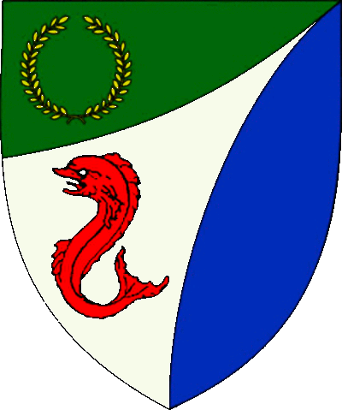

|  |
| --- |
| **Table of Contents**  Weekly Activities in the Barony 2  Arts & Science and Social Schedule 3  Virtual A&S Opportunities 3  Kingdom Calendar 4  The Barony Around the Web 6  Baronial Meeting Notes 7  Baronial Officer Regnum 10  Statement of Ownership 11  Submissions & Disclaimer 11  Marshal Information 12  Award Recommendations 12  Letters from Their Excellencies…….13 |

## The Coronet of the Barony of Tir-y-Don

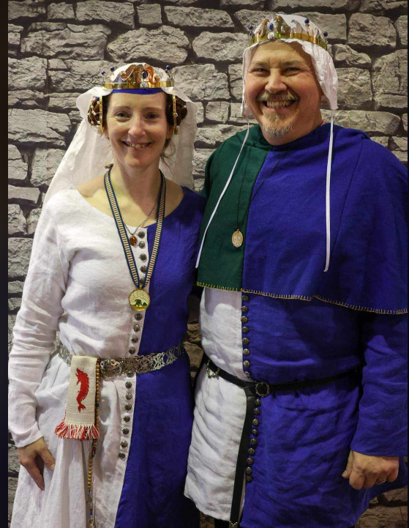

This is the Jan 2025 issue of the NoD-Y-Rit, a publication of the Barony of Tir-Y-Don of the Society for Creative Anachronism, Inc. The Nod-Y-Rit is available from Anna van Sint Maartensdyjk at chronicler@tirydon.atlantia.sca.org. Subscriptions are free as all publications are available electronically. This newsletter is not a corporate publication of the Society for Creative Anachronism, Inc., and does not delineate SCA policies.

© Copyright 2025, Society for Creative Anachronism, Inc. For information on reprinting letters and artwork from this publication, please contact the Tir-Y-Don Chronicler, who will assist you in contacting the original creator of the piece. Please respect the legal rights of our contributors.

Their Excellencies:

***Baron Jean-Claude de Calais***

***Baroness Alina of the Ilex***

*Photo Credit: Llwyd Aldrydd*

# Weekly Activities in the Barony

|  |  |  |
| --- | --- | --- |
| Sundays |  |  |
| **10AM** | Archery Practice Contact Marshal of Archery **Newport News City Park**  Archery Range | Call 757-888-3333 for Safety Class Schedule.  Call Marshal of Archery before attending. |
| Take the Archery Safety Class online. You can email the completed test to the parks department.  Your card will be emailed to you.  <https://www.nnva.gov/2561/Archery-Range> | | |
| **1PM** | Fighter Practice and Social Heavy/Rapier  Contact Knight Marshal | Please contact the Marshal if you wish to attend. |
| Mondays |  |  |
| **7PM** | Armory Night Contact Tim Prickett | Contact Tim before attending. |
| Thursdays |  |  |
| **7PM** | Arts & Sciences and Social Contact MOAS  Arts & Science and Social Schedule | Contact MOAS or Baroness Kaleeb for more details – In person, some hybrid sessions |

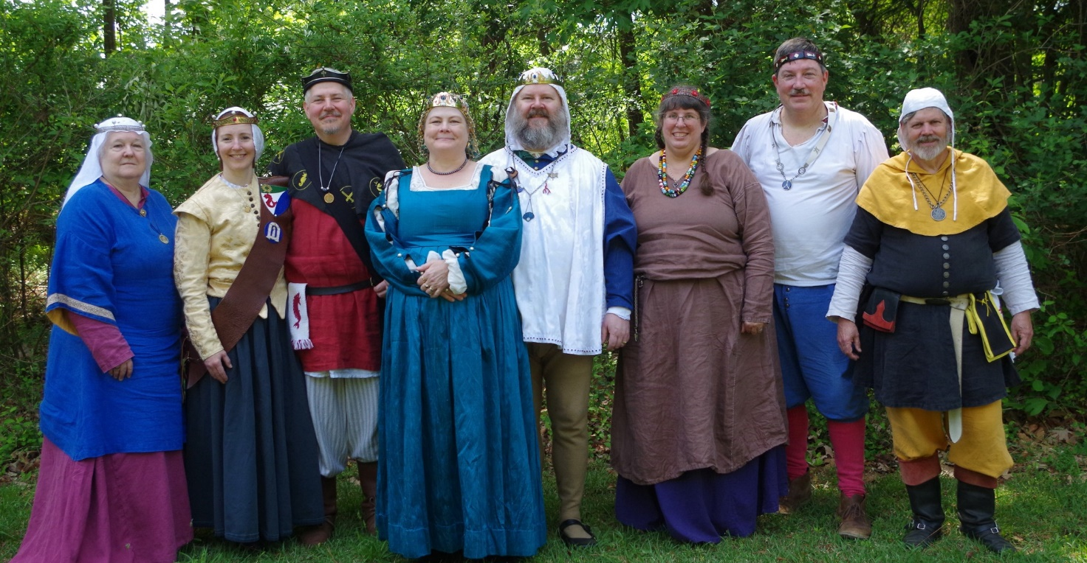

Photo Credit:   
Current and past landed baronage at Baronial Birthday

# Arts & Science and Social Schedule

Classes start at 7pm unless otherwise noted! Classes are held at **Cornerstone Community Church** **1003 Moyer Rd, Newport News, VA 23608**. Business meeting nights will be hybrid in person and online.

|  |
| --- |
| Please check the baronial Facebook group for up to date meeting information. |

* 2/6/2025 KASF Entry Prep
* 2/13/2025 (TBD Scribal)
* 2/20/2025 Business meeting / A&S Planning

Now Read This!!

# Do you have a topic you want to teach? Do you have a topic you would like to learn more about? THIS IS YOUR CHANCE – make your wishes known at the Feb 20 meeting.

# Virtual A&S Opportunities

|  |  |  |
| --- | --- | --- |
| Virtual Atlantia | Atlantia has setup a Virtual A&S center which includes a calendar of online course offerings, the ability to request a class to be added to the calendar and a way to get credit for the University of Atlantia. Be sure to check it out for an update to date listing of virtual classes throughout the Kingdom. | <http://virtual.atlantia.sca.org/> |
| SCA Virtual Classroom and Artisan Display | Teachers and artisans can share the virtual resources they've created to make them available SCA-wide to continue to foster a learning environment. | <https://www.facebook.com/groups/virtualsca/> |
| Known World Discord | A large discord server that has chat rooms for multiple topics, lots of classes, feedback, and opportunities to connect with artists, fighters, and anyone else across the Known World. | <https://discord.gg/bDavK8> |

Know of any opportunities not listed here? Let us know so we can add them!

Contact the Chronicler via Email, Facebook, or Discord

# Kingdom Calendar

*Please refer to the* [*Kingdom Calendar*](https://atlantia.sca.org/calendar/) *website for up to date information regarding event cancellations or changes.*

#### **Feb-2025**

02-08 - 02-08 : [Bright Hills Baronial Birthday](https://atlantia.sca.org/event/?event_id=66eb6df7) :*Manchester MD (Bright Hills)*

02-15 - 02-15 : [Celebration - Babur](https://atlantia.sca.org/event/?event_id=66d76a68) :*Ashland VA (Caer Mear)*

02-15 - 02-15 : [AEdult](https://atlantia.sca.org/event/?event_id=7b3b89a6) :*(Æthelmearc)* (P )

02-21 - 02-23 : [Ymir 50](https://atlantia.sca.org/event/?event_id=667057b2) :*Ellerbe NC (Windmasters' Hill)* (Q K )

#### **March-2025**

03-01 - 03-01 : [Kingdom Arts & Sciences Festival (TBD)](https://atlantia.sca.org/event/?event_id=ced0ae3b) :*(Atlantia)* (Q K ) [](https://moas.atlantia.sca.org/persona-pentathlon)

03-08 - 03-16 : [Gulf Wars XXXIII (TBD)](https://atlantia.sca.org/event/?event_id=86bf1cc3) :*(Gleann Abhann)* (Q K )

03-09 - 03-09 : [CURIA 2025](https://atlantia.sca.org/event/?event_id=3c688f81) :*(Atlantia)*

03-15 - 03-15 : [St. Urho's Tournament](https://atlantia.sca.org/event/?event_id=677f0aa8) :*Statesville NC (Salesberie Glen)*

03-22 - 03-22 : [Storvik's Performer's Revel](https://atlantia.sca.org/event/?event_id=6789ab7d) :*Cheverly (Hyattsville) MD (Storvik)*

03-28 - 03-30 : [Hidden Mountain Baronial Birthday](https://atlantia.sca.org/event/?event_id=671949ab) :*Bennettsville SC (Hidden Mountain)*

03-29 - 03-29 : [Defending the Gate](https://atlantia.sca.org/event/?event_id=66427319) :*Spotsylvania VA (Sudentorre)* (Q K )

#### **April-2025**

04-05 - 04-05 : [Spring Coronation (TBD)](https://atlantia.sca.org/event/?event_id=e0b05df1) : (Atlantia) [](https://moas.atlantia.sca.org/cultura-atlantia)

04-12 - 04-12 : [Dragons Fire IV: Birth of the Dragon](https://atlantia.sca.org/event/?event_id=664b66f7) :Easley SC (Saint Georges)

04-12 - 04-12 : [Festival of Elvegast](https://atlantia.sca.org/event/?event_id=e92a913c) :Hillsborough NC (Elvegast)

04-18 - 04-20 : [Canterbury Tales: Missile Madness Reloaded](https://atlantia.sca.org/event/?event_id=6752d140) :*Monroe VA (Seven Hills)*

04-24 - 04-27 : [LEAFS (Learning Equestrian, Agriculture, and Forestry Symposium)](https://atlantia.sca.org/event/?event_id=66852824) :Upper Marlboro MD (Highland Foorde)

04-25 - 04-27 : [Revenge of the Stitch X](https://atlantia.sca.org/event/?event_id=66bcbea5) :*Denton MD ()*

04-25 - 04-27 : [Baronial Spring Camp](https://atlantia.sca.org/event/?event_id=a6face14) :Apex NC (Windmasters' Hill)

#### **May-2025**

05-03 - 05-03 : [Spring Crown Tournament (TBD)](https://atlantia.sca.org/event/?event_id=427fa35d) :*(Atlantia)* [](https://moas.atlantia.sca.org/tempore-atlantia)

05-09 - 05-11 : [Tir-y-Don Baronial Birthday](https://atlantia.sca.org/event/?event_id=665cc924) :*Hayes VA (Tir-y-Don)*

05-09 - 05-11 : [Hawkwood's XXI Baronial Birthday: One Night In Marrakesh](https://atlantia.sca.org/event/?event_id=671562b4) :*Old Fort NC (Hawkwood)*

05-17 - 05-18 : [Victory on the Vine II](https://atlantia.sca.org/event/?event_id=671e206e) :*Culpeper VA (Ponte Alto)*

05-17 - 05-17 : [Not Quite Quarterly Braggin Rights Tournament V](https://atlantia.sca.org/event/?event_id=6771f317):*AIKEN SC (Ritterwald)* (Q K Pr P )

05-17 - 05-17 : [Skewered! V: Tenoch's Table](https://atlantia.sca.org/event/?event_id=6703fcf3) :*Gaithersburg MD (Roxbury Mill)*

05-31 - 05-31 : [On Target!](https://atlantia.sca.org/event/?event_id=67560dbe) :*Annapolis MD (Lochmere)*

#### **June-2025**

06-06 - 06-08 : [Rumors of War- Part Deux](https://atlantia.sca.org/event/?event_id=678ee87a) :*Bryson City NC (Stormwall)*

06-06 - 06-08 : [Royal Archery Tournament](https://atlantia.sca.org/event/?event_id=678e9efe) :*Booneville NC (Sacred Stone)*

06-14 - 06-14 : [Summer University (TBD)](https://atlantia.sca.org/event/?event_id=c5f7dafd) :*(Atlantia)*

06-20 - 06-22 : [Storvik Novice Tournament](https://atlantia.sca.org/event/?event_id=678e684e) :*Upper Marlboro MD (Storvik)*

#### **July-2025**

07-12 - 07-12 : [Procrastinators Paradise- Last Chance Authorization and Sewing Day](https://atlantia.sca.org/event/?event_id=677dd4bf) :*Waldorf MD (Dun Carraig)*

07-19 - 07-19 : [Warrior’s Games](https://atlantia.sca.org/event/?event_id=6730fead) :*Harleyville SC (Tear-Sea's Shore)*

07-25 - 08-10 : [Pennsic War](https://atlantia.sca.org/event/?event_id=4ff3dfc1) :*(Atlantia)*

#### **Sept-2025**

09-20 - 09-20 : [Fall University (TBD)](https://atlantia.sca.org/event/?event_id=88ef90b5) :*(Atlantia)*

09-26 - 09-28 : [Trial By Fire & Lochmere Arrow: Alba gu bràth!](https://atlantia.sca.org/event/?event_id=66eb7df7) :*Glen Arm MD (Bright Hills)*

# The Barony Around the Web

Many members of the populace have a Web Presence. Please visit their websites and share in the great content. Please contact the Chronicler if you want to promote your site.

Baroness Jane Fox <https://jezebeljane.blogspot.com/>

Baron John Biggeheved <https://biggeheved.com/>

Mistress Kaleeb the Green Eyed <http://kaleeb.galtham.org/>

Learn Fiore <http://learnfiore.org/>

Baron Llwyd Aldrydd <http://baronllwyd.org/>

Lady Mariss Ghijs <https://opusmariss.wordpress.com>

Lady Mevanou verch Reys Yriskynit <https://mvry1sca.wordpress.com/>

## Baronial website

Our Web Minister maintains our baronial website. He can be contacted with any content changes that need to be made.

<https://www.tirydon.atlantia.sca.org>

## Baronial Facebook Group

We share some informal announcements and share content on our Facebook group. It’s another way to stay connected with those in the Barony.

<https://www.facebook.com/groups/343471645861986/>

## Kingdom eNewsletters

Log in with your SCA Member Portal username and password. This requires at least an associate membership to access. Please contact SCA corporate with any log in issues.

<https://members.sca.org/apps/#SignIn>

# 

# Baronial Meeting Notes

|  |  |
| --- | --- |
| Location: | Cornerstone Community Church and virtual |
| Date and Time:  Jan 16, 2025 | Next Meeting’s Date and Time:  Thurs Feb 20, 7:00pm Cornerstone Community Church |

Baron and Baroness

Nice to see everyone jumping in to help at 12th Night. Good communication around the storm. Many deserving Baronial members recognized at 12th Night. Send in award recommendations for Spring event. Please copy us if you send in Kingdom recommendations so we can support.

Please let Their Excellencies know if you will be attending upcoming events, so the appropriate tentage can be brought. Also, any contributions for gift baskets are appreciated.

Anyone who is interested in being a deputy for any office is encouraged to contact that officer.

Officer Reports

### Seneschal

### Thanks to everyone who showed up and helped. Glad he wasn't convinced to cancel! Oriana and John cleared handicap spots then site cleared the rest. - Next Kingdom event is University. Lots of cool classes. All online, Saturday and Sunday the first weekend in Feb.

### Exchequer

### Receipts needed for final numbers by end of weekend. Rough estimate: Income $6503, $720 refunds, $3090 outstanding. Expecting to split $1500 with Kingdom. 131 adults 14nonmembers 82 feast, 7newcomers - new SCORES form (again

### Chatelaine

### Southampton Faire update, is no more.

### Mosaic Festival- April 26 - Fall-o-ween, there is interest in doing again.

### Harvest Faire, will research.

### Check Daffodil Festival - Also maybe breweries demo, like other re-enactment groups.

### Adopt-A-Highway is still in the works.

### Chronicler

Submission deadline is the 25th. Please send content.

### Herald

### Report: submitted quarterly report, 12th Night court report, and equestrian award paperwork submitted.

### Knight Marshal

### Planning session scheduled for 2/20, think about what you would like taught or want to teach - See Baronial website for schedule - Next week will be online to practice for University. Planning session scheduled for 2/20, think about what you would like taught or want to teach

### Archery

### Inside at Wilcox due to cold, Marinus held a shoot for your supper which was a success and they plan on hosting again.

### Equestrian

### Katrina (our hostess at Emerald Ridge Stables) is trying to set up dates for practices.

### Arts and Sciences

Please see the 12th Night website for competitions.

Social MediaGot footage at 12N - There's a highlights reel on Insta for awards. Officers got emails to schedule spotlight posts. If you're going to be involved in an event, please let the Social Media Minister know. Bluesky being researched. Remind app being used by Marinus to reach people not on social media a lot. Might need to find an alternative to Facebook.

### Web Minister

Looking for Deputy or replacement. Not a difficult or time consuming job if someone really wants to do it - Yrsa might Deputy, will need to get warranted**.**

Old & New Business

## Old Business

Got footage at 12N - There's a highlights reel on Insta for awards.

05-09 - 05-11 : [Tir-y-Don Baronial Birthday](https://atlantia.sca.org/event/?event_id=665cc924) :*Hayes VA (Tir-y-Don)* 50th year anniversary of first event. The theme is, Return to Sherwood! So dust off those clothes of Lincoln green and prepare to join Robin and his merry band of thieves! Please think of ideas for A&S competitions – this is a chance to display all that the SCA does. If anyone is interested in staff position, let Pam & Michelle know. - Sarah will head registration and gate - Christina will do Newcomers Point

## New Business

Proposed we put deadline on requesting refund for feast. Caer Mear states must request refund at least 7 days before, otherwise unless we re sell the spot, no refund. Field space at Ice Castles, being researched by JC. Pennsic camp - land has been registered. We need to replace the stove and a new shower head, needs a button to turn off flow on the head (check camper supply store). Procedures written by Llwyd and Kaleeb going to be posted for reference. Michelle had an idea about an artisan faire, think of date or location (Community Center, library, fighter practice shelter), and what we would want to display. Invite newcomers, public.

Next Mosey (March)

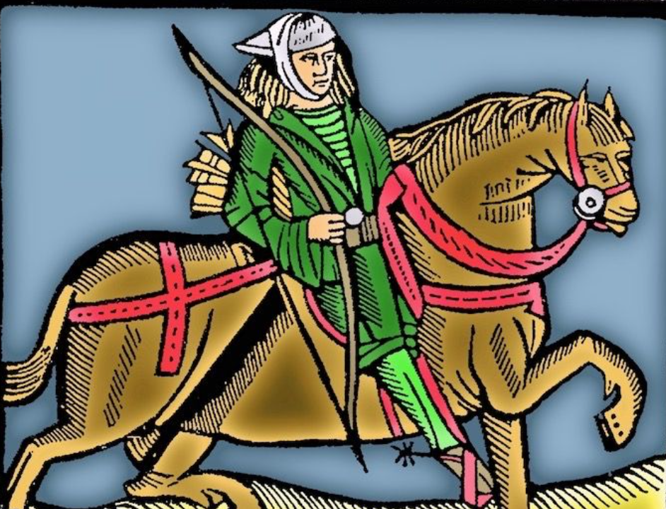

This woodcut was used by the medieval printer Caxton to illustrate both the Gest of Robin Hood and Chaucer's Canterbury Tales.

# Baronial Officer Regnum

|  |  |  |  |
| --- | --- | --- | --- |
| http://tirydon.atlantia.sca.org/wp-content/uploads/2018/11/tyd-1-251x300-1.gif | **Baron:** | Jean-Claude du Calais (Jim Cunningham) | [baron@tirydon.atlantia.sca.org](mailto:baron@tirydon.atlantia.sca.org) 757-968-5303 NLT 9pm |
| http://tirydon.atlantia.sca.org/wp-content/uploads/2018/11/tyd-1-251x300-1.gif | **Baroness:** | Alyna of the Ilex (Holly Cunningham) | [baroness@tirydon.atlantia.sca.org](mailto:baroness@tirydon.atlantia.sca.org) 757-968-5303 NLT 9pm |
| http://tirydon.atlantia.sca.org/wp-content/uploads/2018/11/o_sen.gif | **Seneschal (President):** | Llwyd Aldrydd (Lloyd Eldred) | [seneschal@tirydon.atlantia.sca.org](mailto:seneschal@tirydon.atlantia.sca.org) (757) 875-0033 NLT 9pm |
| http://tirydon.atlantia.sca.org/wp-content/uploads/2018/11/o_exch.gif | **Chancellor of the Exchequer (Treasurer):** | Sarah Kennedy of Glengarry (Sarah Kennedy) | [exchequer@tirydon.atlantia.sca.org](mailto:exchequer@tirydon.atlantia.sca.org) NLT 9pm |
| http://tirydon.atlantia.sca.org/wp-content/uploads/2018/11/o_chat.gif | **Chatelaine (New member support):** | Andrei Barsukov (Andrew LaVinus) | [chatelaine@tirydon.atlantia.sca.org](mailto:chatelaine@tirydon.atlantia.sca.org)  (804) 869-8882 NLT 9:30pm |
| http://tirydon.atlantia.sca.org/wp-content/uploads/2018/11/o_chr.gif | **Chronicler**  **(Secretary):** | Anne van Sintmaartensdyck (Nancy Kiel) | [chronicler@tirydon.atlantia.sca.org](mailto:chronicler@tirydon.atlantia.sca.org) (757) 220-6857, leave a message NLT 9:30pm |
| http://tirydon.atlantia.sca.org/wp-content/uploads/2018/11/o_chr.gif | **Social Media:** | Skye Walker | [socialmedia@tirydon.atlantia.sca.org](mailto:socialmedia@tirydon.atlantia.sca.org) |
| http://tirydon.atlantia.sca.org/wp-content/uploads/2018/11/o_herald.gif | **Herald:** | Catheryn inghean Ui Dhubhshlaine (Amanda Carter) | [herald@tirydon.atlantia.sca.org](mailto:herald@tirydon.atlantia.sca.org) |
| http://tirydon.atlantia.sca.org/wp-content/uploads/2018/11/o_marshal.gif | **Knight’s Marshal:** | Christina O’Cleary  (Jessica Lavinus) | [marshal@tirydon.atlantia.sca.org](mailto:marshal@tirydon.atlantia.sca.org) NLT 9pm |
| http://tirydon.atlantia.sca.org/wp-content/uploads/2018/11/o_marshal.gif | **Marshal of Archery:** | Leofric of Oxenford (Mike Durling) | [archer@tirydon.atlantia.sca.org](mailto:archer@tirydon.atlantia.sca.org) |
| http://tirydon.atlantia.sca.org/wp-content/uploads/2018/11/o_as.gif | **Minister of Arts & Sciences:** | Cairistiona inghean Mhuireadhaigh (Carol Vanderspoel) | [moas@tirydon.atlantia.sca.org](mailto:moas@tirydon.atlantia.sca.org) (757) 819-3296 NLT 9:30pm |
| Office Badge | **Webminister:** | Llwyd Aldrydd (Lloyd Eldred) | [webminister@tirydon.atlantia.sca.org](mailto:webminister@tirydon.atlantia.sca.org) (757) 875-0033 NLT 9:30pm |

# Statement of Ownership, Submissions & Disclaimer

This is the Jan 2025 issue of the NoD-y-Rit, a publication of the Barony of Tir-y-Don of the Society for Creative Anachronism, Inc. The Nod-y-Rit is available from Anna van Sint Maartensdyjk (Nancy Kiel) at [chronicler@tirydon.atlantia.sca.org](mailto:chronicler@tirydon.atlantia.sca.org) and Nancy_kiel@hotmail.com. Subscriptions are free as all publications are available electronically. This newsletter is not a corporate publication of the Society for Creative Anachronism, Inc., and does not delineate SCA policies.

© Copyright 2024, Society for Creative Anachronism, Inc. For information on reprinting letters and artwork from this publication, please contact the Tir-y-Don Chronicler, who will assist you in contacting the original creator of the piece. Please respect the legal rights of our contributors.

Please send submissions to:

Nancy Kiel

108 Wilson Circle, Williamsburg VA

[chronicler@tirydon.atlantia.sca.org](mailto:chronicler@tirydon.atlantia.sca.org)

Nancy_kiel@hotmail.com

***Please, remember that all submissions to the NoD-y-Rit must be accompanied by an SCA release form.*** The first link leads you to the Society Chronicler’s links for forms. The last three links are for the forms that can be submitted on line via Internet Form Fills. Everyone is encouraged to consider contributing to the NoD-y-Rit.

Society Chronicler forms:

<http://chronicler.atlantia.sca.org/Releases.html>

Release form for writing or artwork:

<http://chronicler.atlantia.sca.org/ReleaseCreativeFillable.pdf>

Release form for photographs:

<http://chronicler.atlantia.sca.org/ReleasePhotographerFillable.pdf>

Release form for model(s) (the subject of your artwork or photograph):

<http://chronicler.atlantia.sca.org/ReleaseModelFillable.pdf>

# Marshal Information

## Image result for mINISTER OF LIST BADGE SCABecome a MOL

Want to serve the Fighter Community by providing Tournament organization and keeping the Fighting Authorizations documented? Consider becoming a Minister of the List.

Please visit the Kingdom MOL website for more information and forms: <http://mol.atlantia.sca.org/ForMoLs/index.html>

## Become a Marshal

Do you enjoy fighting activities at events and practices? Many folks invest significant time to keep these activities safe. Consider becoming a marshal to help keep these activities happening in the future.

Please visit the Earl Marshals Website for more information: <https://marshal.atlantia.sca.org/procedures/mit/>

## Marshal Event Report Submission

Participants, Fighters and Marshals can all submit Event reports for fighting activities. If you see something you wish to report visit the Kingdom Earl Marshal Website. Include things like injuries, equipment failures, or other issues you see.

Submit a report here: <https://warrant.atlantia.sca.org/reports/new/1>

## Warranted Marshals

The Kingdom maintains a list of warranted marshals and Marshals in Training. A list of marshals who have expired warrants is also maintained here.

Visit: <https://warrant.atlantia.sca.org/warrants/branch/6/1>

# Award Recommendations

## Baronial Award Recommendations

Baronial Award Recommendations are sent to the Coronet. Please use [baron@tirydon.atlantia.sca.org](https://d.docs.live.net/55395330e2cd57ab/SCA/NODYRIT/baron@tirydon.atlantia.sca.org)  and [baroness@tirydon.atlantia.sca.org](https://d.docs.live.net/55395330e2cd57ab/SCA/NODYRIT/baroness@tirydon.atlantia.sca.org).

## Kingdom Award Recommendations

The Kingdom maintains a database of award recommendations and what events potential recipients will attend in the future. Visit: <https://award.atlantia.sca.org/>

## Review your Order of Precedence Entry

Recent name change or award? Please visit the Atlantia’s Order of Precedence (OP) and request any updates or corrections as needed.

Visit the OP here: <http://op.atlantia.sca.org>

Submit Corrections requests here: <http://op.atlantia.sca.org/corrections.php>

Letters from Their Excellencies



Greetings Tir-y-Don!

What a whirlwind few weeks it has been! We’d like to start by saying what an amazing group of people you all are. You came together despite all sorts of weather issues to put on an amazing Kingdom 12th Night! Every single person stepped up and stepped in to help. We are so proud to call this our home.

There’s a lot to look forward to in the New Year, so let’s talk a little bit about planning. We will be putting up polls on the Facebook page to see what events people plan on attending, to find out if we should get field space for a day shade. Keep an eye out for those and keep an eye on the Kingdom Calendar to see what events you might be excited about.

We also highly recommend carpooling to events if you are able. Not only does it help save gas money, but you get to know your fellow baronial members. Make sure to use the Facebook group or the Discord channel for planning purposes.

Lord Erikr has taken on the task of arranging retainers for us for events. Not like dental retainers, but people who volunteer to help us out at events and make sure we have the help we might need. We know that he plans to offer a class to explain details, but a quick overview would be that you would hang out with us at events, make sure that we get to where we need to be, and ensure that the baronial thrones are set up if there is a great court. There’s more to it than that, but we don’t want to take away from the upcoming class. Feel free to reach out if you would like to help.

We currently plan to attend the following events:

15 Feb: Celebration – Babur – Caer Mear (Richmond)

21-23 Feb: Ymir 50 – Windmaster’s Hill (Ellerbe NC)

1 Mar: Kingdom Arts and Sciences Festival (KASF) – Raleigh, NC

29 Mar: Defending the Gate – Sudentorre (Spotsylvania, VA)

5 Apr: Coronation - TBD

Looking forward to an exciting and fun year!

Jean Claude, Baron Alyna, Baroness