|  |
| --- |
| Barony of Tir-y-Don  The NoD-y-Rit  Nov AS 59 (CE 2024)  Volume 43 Issue 9 Society of Creative Anachronism (SCA Inc.) |

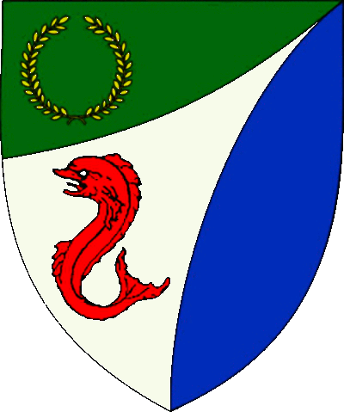

|  |
| --- |
| **Table of Contents**  Weekly Activities in the Barony 2  Arts & Science and Social Schedule 3  Virtual A&S Opportunities 3  Kingdom Calendar 4  The Barony Around the Web 6  Baronial Meeting Notes 7  Baronial Officer Regnum 10  Statement of Ownership 11  Submissions & Disclaimer 11  Marshal Information 12  Award Recommendations 12  Letters from Their Excellencies…….13 |

## The Coronet of the Barony of Tir-y-Don

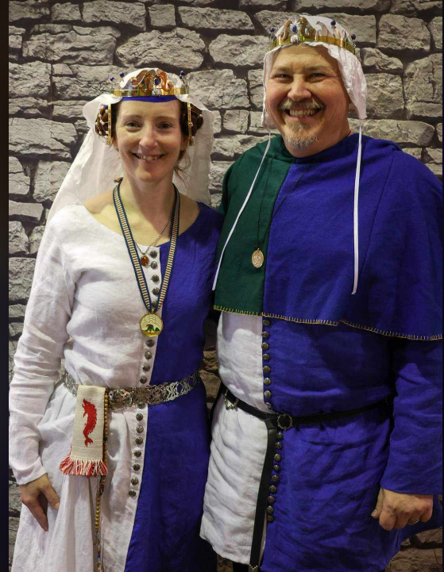

This is the Nov 2024 issue of the NoD-Y-Rit, a publication of the Barony of Tir-Y-Don of the Society for Creative Anachronism, Inc. The Nod-Y-Rit is available from Anna van Sint Maartensdyjk at chronicler@tirydon.atlantia.sca.org. Subscriptions are free as all publications are available electronically. This newsletter is not a corporate publication of the Society for Creative Anachronism, Inc., and does not delineate SCA policies.

© Copyright 2024, Society for Creative Anachronism, Inc. For information on reprinting letters and artwork from this publication, please contact the Tir-Y-Don Chronicler, who will assist you in contacting the original creator of the piece. Please respect the legal rights of our contributors.

Their Excellencies:

***Baron Jean-Claude de Calais***

***Baroness Alina of the Ilex***

*Photo Credit: Llwyd Aldrydd*

# Weekly Activities in the Barony

|  |  |  |
| --- | --- | --- |
| Sundays |  |  |
| **10AM** | Archery Practice Contact Marshal of Archery **Newport News City Park**  Archery Range | Call 757-888-3333 for Safety Class Schedule.  Call Marshal of Archery before attending. |
| Take the Archery Safety Class online. You can email the completed test to the parks department.  Your card will be emailed to you.  <https://www.nnva.gov/2561/Archery-Range> | | |
| **1PM** | Fighter Practice and Social Heavy/Rapier  Contact Knight Marshal | Please contact the Marshal if you wish to attend. |
| Mondays |  |  |
| **7PM** | Armory Night Contact Tim Prickett | Contact Tim before attending. |
| Thursdays |  |  |
| **7PM** | Arts & Sciences and Social Contact MOAS  Arts & Science and Social Schedule | Contact MOAS or Baroness Kaleeb for more details – In person, some hybrid sessions |

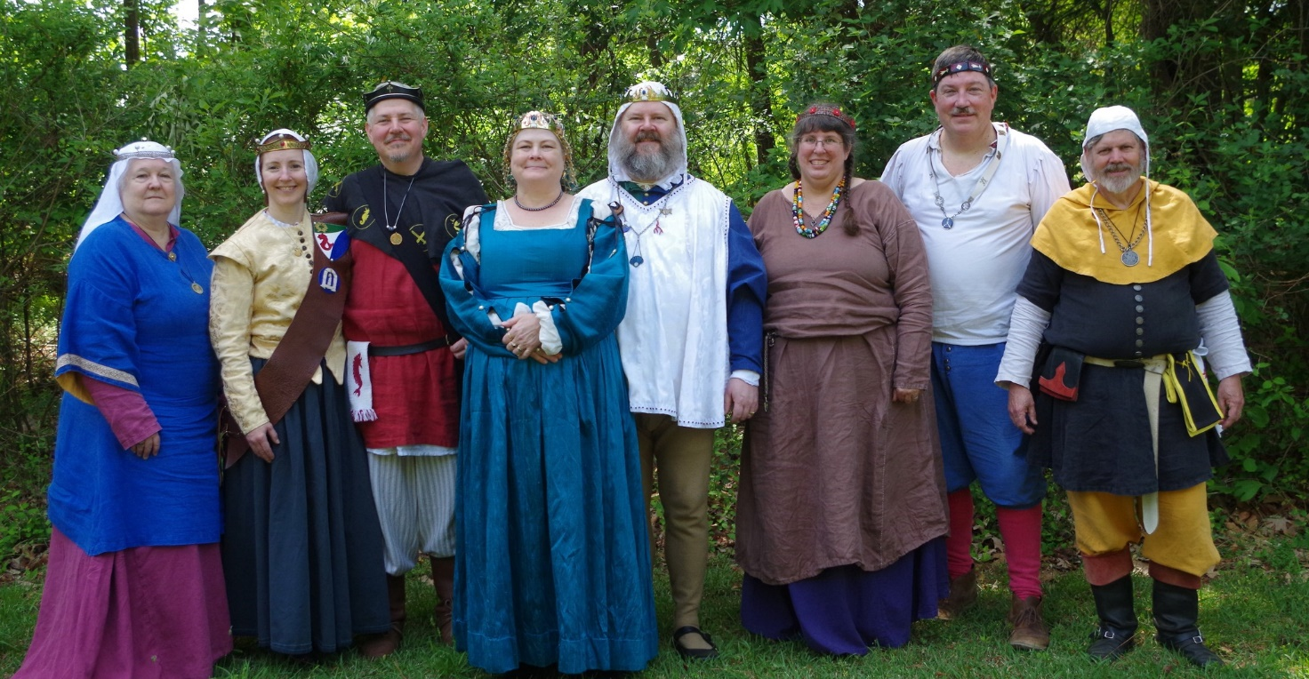

Photo Credit:   
Current and past landed baronage at Baronial Birthday

# Arts & Science and Social Schedule

Classes start at 7pm unless otherwise noted! Classes are held at **Cornerstone Community Church** **1003 Moyer Rd, Newport News, VA 23608**. Business meeting nights will be hybrid in person and online.

|  |
| --- |
| Please check the baronial Facebook group for up to date meeting information. |

* 9/12/2024 Viking Wire Weaving
* 9/19/2024 Business meeting
* 9/26/2024 Tudor Con Class Sharing
* 10/3/2024 Hedeby Bags Pt. 1: Overview
* 10/10/2024 Scribal
* 10/17/2024 12th Night Tokens Pt. 1
* 10/24/2024 Business meeting moved because of WoW
* 10/31/2024 no meeting, Halloween
* 11/7/2024 Hedeby Bags Pt. 2: Construction
* 11/14/2024 Scribal
* 11/21/2024 Business meeting
* 11/28/2024 no meeting, Thanksgiving
* 12/5/2024 12th Night Tokens / Roman Lecture
* 12/12/2024 (TBD Scribal)
* 12/19/2024 Business meeting / party with no meeting?
* 12/26/2024 no meeting because Christmas
* 1/2/2025 12th Night UFO: Tokens, Garb, Prep
* 1/9/2025 (TBD Scribal)
* 1/16/2025 Business meeting
* 1/23/2025 University Teachers Prep
* 1/30/2025 Hedeby Bags Pt 3: Sewing
* 2/6/2025 KASF Entry Prep
* 2/13/2025 (TBD Scribal)
* 2/20/2025 Business meeting / A&S Planning

# Virtual A&S Opportunities

|  |  |  |
| --- | --- | --- |
| Virtual Atlantia | Atlantia has setup a Virtual A&S center which includes a calendar of online course offerings, the ability to request a class to be added to the calendar and a way to get credit for the University of Atlantia. Be sure to check it out for an update to date listing of virtual classes throughout the Kingdom. | <http://virtual.atlantia.sca.org/> |
| SCA Virtual Classroom and Artisan Display | Teachers and artisans can share the virtual resources they've created to make them available SCA-wide to continue to foster a learning environment. | <https://www.facebook.com/groups/virtualsca/> |
| Known World Discord | A large discord server that has chat rooms for multiple topics, lots of classes, feedback, and opportunities to connect with artists, fighters, and anyone else across the Known World. | <https://discord.gg/bDavK8> |

Know of any opportunities not listed here? Let us know so we can add them!

Contact the Chronicler via Email, Facebook, or Discord

# Kingdom Calendar

*Please refer to the* [*Kingdom Calendar*](https://atlantia.sca.org/calendar/) *website for up to date information regarding event cancellations or changes.*

#### **Dec- 2024**

12-07 - 12-07 : [Unevent 2024 (TBD)](https://atlantia.sca.org/event/?event_id=f8065fe2) :*(Atlantia)* (P )

12-13 - 12-15 : [The Festival of Saturnalia](https://atlantia.sca.org/event/?event_id=663e9c96) :*Nanjemoy MD (Dun Carraig)*

12-13 - 12-15 : [Yule Toy Tourney](https://atlantia.sca.org/event/?event_id=66698bfe) :*Pickens SC (Nottinghill Coill)*

12-21 - 12-21 : [Yule Revel](https://atlantia.sca.org/event/?event_id=670f984d) :*Cheverly MD (Storvil)*

#### **Jan-2025**

01-11 - 01-11 : [Twelfth Night](https://atlantia.sca.org/event/?event_id=66cbb4dc) :*Newport News VA (Atlantia)* (Q K ) [](https://moas.atlantia.sca.org/tempore-atlantia)

01-17 - 01-19 : [Nottinghill Baronial Birthday XLV](https://atlantia.sca.org/event/?event_id=66b28162) :*Bennettsville SC (Nottinghill Coill)*

01-17 - 01-19 : [Raven's Cove Baronial Birthday & Investiture - A Yuletide Celebration](https://atlantia.sca.org/event/?event_id=670d5ac8) :*Richlands NC (Raven's Cove)* (Q K )

01-18 - 01-18 : [Highland Hearthglow](https://atlantia.sca.org/event/?event_id=8781d758) :*Thurmont MD (Highland Foorde)*

01-25 - 01-25 : [Tourney of Manannan Mac XLIII Lir](https://atlantia.sca.org/event/?event_id=66e07a8f):*Harleyville SC (Tear-Sea's Shore)*

01-25 - 01-25 : [Ice Castles/Barony of Black Diamond Investiture](https://atlantia.sca.org/event/?event_id=66ca176f) :*Lynchburg VA (Black Diamond)* (Q K )

01-25 - 01-25 : [Midwinter's Revel: Lunar New Year](https://atlantia.sca.org/event/?event_id=6689a0cd) :*Lothian MD (Lochmere)*

#### **Feb-2025**

02-01 - 02-02 : [University of Atlantia](https://atlantia.sca.org/event/?event_id=67099b2b) :*DC (Atlantia)*

02-08 - 02-08 : [Sir Walter Raleigh Costume Ball III](https://atlantia.sca.org/event/?event_id=6650b9fe) :*Durham NC (Buckston-on-Eno)*

02-08 - 02-08 : [Bright Hills Baronial Birthday](https://atlantia.sca.org/event/?event_id=66eb6df7) :*Manchester MD (Bright Hills)*

02-15 - 02-15 : [Celebration - Babur](https://atlantia.sca.org/event/?event_id=66d76a68) :*Ashland VA (Caer Mear)*

02-15 - 02-15 : [AEdult](https://atlantia.sca.org/event/?event_id=7b3b89a6) :*(Æthelmearc)* (P )

02-21 - 02-23 : [Ymir 50](https://atlantia.sca.org/event/?event_id=667057b2) :*Ellerbe NC (Windmasters' Hill)* (Q K )

#### **March-2025**

03-01 - 03-01 : [Kingdom Arts & Sciences Festival (TBD)](https://atlantia.sca.org/event/?event_id=ced0ae3b) :*(Atlantia)* (Q K ) [](https://moas.atlantia.sca.org/persona-pentathlon)

03-08 - 03-16 : [Gulf Wars XXXIII (TBD)](https://atlantia.sca.org/event/?event_id=86bf1cc3) :*(Gleann Abhann)* (Q K )

03-22 - 03-22 : [Ponte Alto Baronial Birthday Bloodbath](https://atlantia.sca.org/event/?event_id=672d4aa3) :*Vienna VA (Ponte Alto)*

03-28 - 03-30 : [Hidden Mountain Baronial Birthday](https://atlantia.sca.org/event/?event_id=671949ab) :*Bennettsville SC (Hidden Mountain)*

03-29 - 03-29 : [Defending the Gate](https://atlantia.sca.org/event/?event_id=66427319) :*Spotsylvania VA (Sudentorre)* (Q K )

#### **April-2025**

04-05 - 04-05 : [Spring Coronation (TBD)](https://atlantia.sca.org/event/?event_id=e0b05df1) : (Atlantia) [](https://moas.atlantia.sca.org/cultura-atlantia)

04-12 - 04-12 : [Dragons Fire IV: Birth of the Dragon](https://atlantia.sca.org/event/?event_id=664b66f7) :Easley SC (Saint Georges)

04-12 - 04-12 : [Festival of Elvegast](https://atlantia.sca.org/event/?event_id=e92a913c) :Hillsborough NC (Elvegast)

04-24 - 04-27 : [LEAFS (Learning Equestrian, Agriculture, and Forestry Symposium)](https://atlantia.sca.org/event/?event_id=66852824) :Upper Marlboro MD (Highland Foorde)

04-25 - 04-27 : [Baronial Spring Camp](https://atlantia.sca.org/event/?event_id=a6face14) :Apex NC (Windmasters' Hill)

#### **May-2025**

05-03 - 05-03 : [Spring Crown Tournament (TBD)](https://atlantia.sca.org/event/?event_id=427fa35d) :*(Atlantia)* [](https://moas.atlantia.sca.org/tempore-atlantia)

05-09 - 05-11 : [Tir-y-Don Baronial Birthday](https://atlantia.sca.org/event/?event_id=665cc924) :*Hayes VA (Tir-y-Don)*

05-09 - 05-11 : [Hawkwood's XXI Baronial Birthday: One Night In Marrakesh](https://atlantia.sca.org/event/?event_id=671562b4) :*Old Fort NC (Hawkwood)*

05-17 - 05-18 : [Victory on the Vine II](https://atlantia.sca.org/event/?event_id=671e206e) :*Culpeper VA (Ponte Alto)*

05-17 - 05-17 : [Skewered! V: Tenoch's Table](https://atlantia.sca.org/event/?event_id=6703fcf3) :*Gaithersburg MD (Roxbury Mill)*

# The Barony Around the Web

Many members of the populace have a Web Presence. Please visit their websites and share in the great content. Please contact the Chronicler if you want to promote your site.

Baroness Jane Fox <https://jezebeljane.blogspot.com/>

Baron John Biggeheved <https://biggeheved.com/>

Mistress Kaleeb the Green Eyed <http://kaleeb.galtham.org/>

Learn Fiore <http://learnfiore.org/>

Baron Llwyd Aldrydd <http://baronllwyd.org/>

Lady Mariss Ghijs <https://opusmariss.wordpress.com>

Lady Mevanou verch Reys Yriskynit <https://mvry1sca.wordpress.com/>

## Baronial website

Our Web Minister maintains our baronial website. He can be contacted with any content changes that need to be made.

<https://www.tirydon.atlantia.sca.org>

## Baronial Facebook Group

We share some informal announcements and share content on our Facebook group. It’s another way to stay connected with those in the Barony.

<https://www.facebook.com/groups/343471645861986/>

## Kingdom eNewsletters

Log in with your SCA Member Portal username and password. This requires at least an associate membership to access. Please contact SCA corporate with any log in issues.

<https://members.sca.org/apps/#SignIn>

# 

# Baronial Meeting Notes

|  |  |
| --- | --- |
| Location: | Cornerstone Community Church and virtual |
| Date and Time:  Nov 21, 2024 | Next Meeting’s Date and Time:  Thurs Dec 21, 7:00pm Cornerstone Community Church |

Baron and Baroness

Award recommendations needed. If you send in Kingdom awards please let us know; also update the system to let the Crown know which events you will be attending.

Please let Their Excellencies know if you will be attending upcoming events, so the appropriate tentage can be brought. Also, any contributions for gift baskets are appreciated.

Anyone who is interested in being a deputy for any office is encouraged to contact that officer.

Officer Reports

### Seneschal

### NTR

### Exchequer

### 12th Night registration is open online.

### Chatelaine

### Please think about having a Baronial presence at the next Mosaic Festival in Newport News, April 5-6 .

### Chronicler

Submission deadline is the 25th. Please send content.

### Herald

A new award for equestrians has been submitted. **I am looking for a replacement – please contact me if you are interested.**

### Knight Marshal

### Please check Facebook regarding upcoming practices, and joint practices. Would a later practice time improve attendance? Please share your thoughts.

### .Archery

### Turnout for practice is good. Make sure you have your card for shooting at Newport News park! A new practice site is available at Wilcox Bait & Tackle on Jefferson, but costs $10 per person per hour.

### Equestrian

Practices are once a month regionally. Please make sure you are authorized for ground crew at our upcoming event over Labor Day weekend. Sir T’nek, Master Jean Claude, and Master Aldrydd are looking into the possibility of fighting on horseback.

### Arts and Sciences

Please see the 12th Night website for competitions.

Social Media

### Member spotlights are in the works.

### Web Minister

Needs to update Officer Regnum for A&S and Social Media. Llwyd will ask for appropriate information to post on the site. You may wish to update your information with your particular interests. **He is looking for a replacement; the site runs on Wordpress.**

Old & New Business

## Old Business

Please offer to help at 12th Night – we want to put our best foot forward!  
  
The Christmas party will be held 12/21 at 110 Edgewood Lane, Williamsburg.

05-09 - 05-11 : [Tir-y-Don Baronial Birthday](https://atlantia.sca.org/event/?event_id=665cc924) :*Hayes VA (Tir-y-Don)* 50th year anniversary of first event. The theme is, Return to Sherwood! So dust off those clothes of Lincoln green and prepare to join Robin and his merry band of thieves! Please think of ideas for A&S competitions – this is a chance to display all that the SCA does.

## New Business

The KASF budget has been approved.

# Baronial Officer Regnum

|  |  |  |  |
| --- | --- | --- | --- |
| http://tirydon.atlantia.sca.org/wp-content/uploads/2018/11/tyd-1-251x300-1.gif | **Baron:** | Jean-Claude du Calais (Jim Cunningham) | [baron@tirydon.atlantia.sca.org](mailto:baron@tirydon.atlantia.sca.org) 757-968-5303 NLT 9pm |
| http://tirydon.atlantia.sca.org/wp-content/uploads/2018/11/tyd-1-251x300-1.gif | **Baroness:** | Alyna of the Ilex (Holly Cunningham) | [baroness@tirydon.atlantia.sca.org](mailto:baroness@tirydon.atlantia.sca.org) 757-968-5303 NLT 9pm |
| http://tirydon.atlantia.sca.org/wp-content/uploads/2018/11/o_sen.gif | **Seneschal (President):** | Llwyd Aldrydd (Lloyd Eldred) | [seneschal@tirydon.atlantia.sca.org](mailto:seneschal@tirydon.atlantia.sca.org) (757) 875-0033 NLT 9pm |
| http://tirydon.atlantia.sca.org/wp-content/uploads/2018/11/o_exch.gif | **Chancellor of the Exchequer (Treasurer):** | Sarah Kennedy of Glengarry (Sarah Kennedy) | [exchequer@tirydon.atlantia.sca.org](mailto:exchequer@tirydon.atlantia.sca.org) NLT 9pm |
| http://tirydon.atlantia.sca.org/wp-content/uploads/2018/11/o_chat.gif | **Chatelaine (New member support):** | Andrei Barsukov (Andrew LaVinus) | [chatelaine@tirydon.atlantia.sca.org](mailto:chatelaine@tirydon.atlantia.sca.org)  (804) 869-8882 NLT 9:30pm |
| http://tirydon.atlantia.sca.org/wp-content/uploads/2018/11/o_chr.gif | **Chronicler**  **(Secretary):** | Anne van Sintmaartensdyck (Nancy Kiel) | [chronicler@tirydon.atlantia.sca.org](mailto:chronicler@tirydon.atlantia.sca.org) (757) 220-6857, leave a message NLT 9:30pm |
| http://tirydon.atlantia.sca.org/wp-content/uploads/2018/11/o_chr.gif | **Social Media:** | Skye Walker | [socialmedia@tirydon.atlantia.sca.org](mailto:socialmedia@tirydon.atlantia.sca.org) |
| http://tirydon.atlantia.sca.org/wp-content/uploads/2018/11/o_herald.gif | **Herald:** | Catheryn inghean Ui Dhubhshlaine (Amanda Carter) | [herald@tirydon.atlantia.sca.org](mailto:herald@tirydon.atlantia.sca.org) |
| http://tirydon.atlantia.sca.org/wp-content/uploads/2018/11/o_marshal.gif | **Knight’s Marshal:** | Christina O’Cleary  (Jessica Lavinus) | [marshal@tirydon.atlantia.sca.org](mailto:marshal@tirydon.atlantia.sca.org) NLT 9pm |
| http://tirydon.atlantia.sca.org/wp-content/uploads/2018/11/o_marshal.gif | **Marshal of Archery:** | Leofric of Oxenford (Mike Durling) | [archer@tirydon.atlantia.sca.org](mailto:archer@tirydon.atlantia.sca.org) |
| http://tirydon.atlantia.sca.org/wp-content/uploads/2018/11/o_as.gif | **Minister of Arts & Sciences:** | Cairistiona inghean Mhuireadhaigh (Carol Vanderspoel) | [moas@tirydon.atlantia.sca.org](mailto:moas@tirydon.atlantia.sca.org) (757) 819-3296 NLT 9:30pm |
| Office Badge | **Webminister:** | Llwyd Aldrydd (Lloyd Eldred) | [webminister@tirydon.atlantia.sca.org](mailto:webminister@tirydon.atlantia.sca.org) (757) 875-0033 NLT 9:30pm |

# Statement of Ownership, Submissions & Disclaimer

This is the Nov 2024 issue of the NoD-y-Rit, a publication of the Barony of Tir-y-Don of the Society for Creative Anachronism, Inc. The Nod-y-Rit is available from Anna van Sint Maartensdyjk (Nancy Kiel) at [chronicler@tirydon.atlantia.sca.org](mailto:chronicler@tirydon.atlantia.sca.org) and Nancy_kiel@hotmail.com. Subscriptions are free as all publications are available electronically. This newsletter is not a corporate publication of the Society for Creative Anachronism, Inc., and does not delineate SCA policies.

© Copyright 2024, Society for Creative Anachronism, Inc. For information on reprinting letters and artwork from this publication, please contact the Tir-y-Don Chronicler, who will assist you in contacting the original creator of the piece. Please respect the legal rights of our contributors.

Please send submissions to:

Nancy Kiel

108 Wilson Circle, Williamsburg VA

[chronicler@tirydon.atlantia.sca.org](mailto:chronicler@tirydon.atlantia.sca.org)

Nancy_kiel@hotmail.com

***Please, remember that all submissions to the NoD-y-Rit must be accompanied by an SCA release form.*** The first link leads you to the Society Chronicler’s links for forms. The last three links are for the forms that can be submitted on line via Internet Form Fills. Everyone is encouraged to consider contributing to the NoD-y-Rit.

Society Chronicler forms:

<http://chronicler.atlantia.sca.org/Releases.html>

Release form for writing or artwork:

<http://chronicler.atlantia.sca.org/ReleaseCreativeFillable.pdf>

Release form for photographs:

<http://chronicler.atlantia.sca.org/ReleasePhotographerFillable.pdf>

Release form for model(s) (the subject of your artwork or photograph):

<http://chronicler.atlantia.sca.org/ReleaseModelFillable.pdf>

# Marshal Information

## Image result for mINISTER OF LIST BADGE SCABecome a MOL

Want to serve the Fighter Community by providing Tournament organization and keeping the Fighting Authorizations documented? Consider becoming a Minister of the List.

Please visit the Kingdom MOL website for more information and forms: <http://mol.atlantia.sca.org/ForMoLs/index.html>

## Become a Marshal

Do you enjoy fighting activities at events and practices? Many folks invest significant time to keep these activities safe. Consider becoming a marshal to help keep these activities happening in the future.

Please visit the Earl Marshals Website for more information: <https://marshal.atlantia.sca.org/procedures/mit/>

## Marshal Event Report Submission

Participants, Fighters and Marshals can all submit Event reports for fighting activities. If you see something you wish to report visit the Kingdom Earl Marshal Website. Include things like injuries, equipment failures, or other issues you see.

Submit a report here: <https://warrant.atlantia.sca.org/reports/new/1>

## Warranted Marshals

The Kingdom maintains a list of warranted marshals and Marshals in Training. A list of marshals who have expired warrants is also maintained here.

Visit: <https://warrant.atlantia.sca.org/warrants/branch/6/1>

# Award Recommendations

## Baronial Award Recommendations

Baronial Award Recommendations are sent to the Coronet. Please use [baron@tirydon.atlantia.sca.org](https://d.docs.live.net/55395330e2cd57ab/SCA/NODYRIT/baron@tirydon.atlantia.sca.org)  and [baroness@tirydon.atlantia.sca.org](https://d.docs.live.net/55395330e2cd57ab/SCA/NODYRIT/baroness@tirydon.atlantia.sca.org).

## Kingdom Award Recommendations

The Kingdom maintains a database of award recommendations and what events potential recipients will attend in the future. Visit: <https://award.atlantia.sca.org/>

## Review your Order of Precedence Entry

Recent name change or award? Please visit the Atlantia’s Order of Precedence (OP) and request any updates or corrections as needed.

Visit the OP here: <http://op.atlantia.sca.org>

Submit Corrections requests here: <http://op.atlantia.sca.org/corrections.php>

Letters from Their Excellencies



Greetings to a Barony moving into the Holiday Season!

With Kingdom 12th Night right around the corner, let’s take a few minutes to discuss what that event is all about, what you can expect, and what you can do to be a great host for the Kingdom. 12th Night is taken from a few different places… You may know about the Shakespeare play “12th Night,” the 12 Days of Christmas, or the Epiphany. In the SCA, 12th Night is a traditional holiday celebration where people get together to catch up after the holidays, give gifts, play games, dance, and enjoy each other’s company. Every year, Atlantian Kingdom 12th Night is the 2nd weekend in January. In the past, we’ve also held an Inter-Baronial 12th Night for Tir-y-Don and Marinus. We hope to start that up again next year. Let’s clear up the gifts part… While some people bring small gifts like spice blends, cookies, soaps, or other handmade items, others may bring small gifts for friends from around the Kingdom that they haven’t seen in a while. Gift giving is not required or expected. It is simply a way that some show their generosity and holiday spirit. We are lucky this year that 12th Night is local. But while that certainly makes it easier to attend, it also means there are some expectations. We are the hosts of Their Majesties and the Kingdom and we want our guests to have a good time. Just like hosting a party at your house, we will need to do little things to make the event better for our guests. Some simple things like making sure water coolers are filled, or taking out trash, can make the event better. There will be plenty of ways to help from set up to clean up. If you have some time, please find the Event Steward Lady Christina and see what you can do; and try to set aside some time to help as many hands make light work. If you’d like to know more about 12th Night, or how you can help ahead of time, ask on one of the Baronial social media channels like Facebook or Discord. We’ll be happy to point you in the right direction.

Wishing you all Happy holidays!

Jean Claude, Baron

Alyna, Baroness