|  |
| --- |
| Barony of Tir-y-Don  The NoD-y-Rit  June - July AS 59 (CE 2024)  Volume 43 Issue 6 Society of Creative Anachronism (SCA Inc.) |

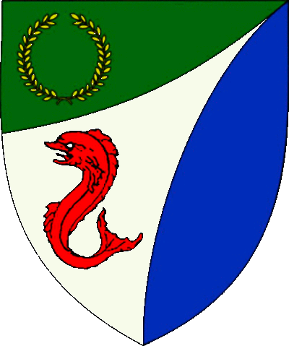

|  |
| --- |
| **Table of Contents**  Weekly Activities in the Barony 2  Arts & Science and Social Schedule 3  Virtual A&S Opportunities 3  Kingdom Calendar 4  The Barony Around the Web 5  Baronial Meeting Notes 6  Baronial Officer Regnum 7  Statement of Ownership 8  Submissions & Disclaimer 8  Marshal Information 9  Award Recommendations 9 |

## The Coronet of the Barony of Tir-y-Don

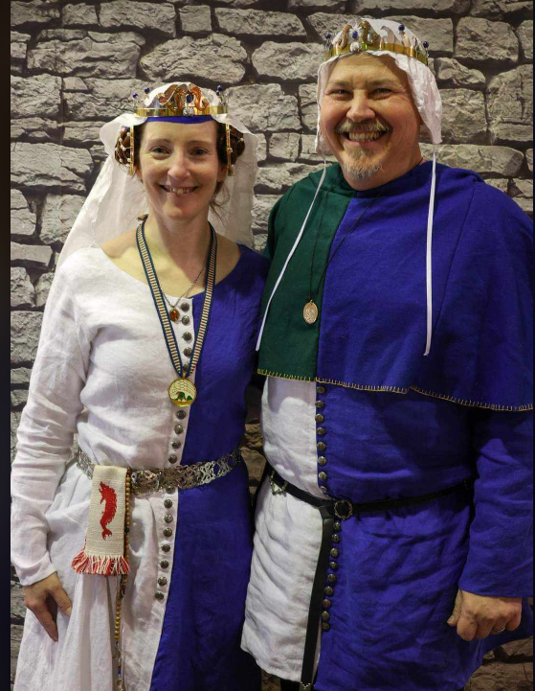

This is the May 2024 issue of the NoD-Y-Rit, a publication of the Barony of Tir-Y-Don of the Society for Creative Anachronism, Inc. The Nod-Y-Rit is available from Anna van Sint Maartensdyjk at chronicler@tirydon.atlantia.sca.org. Subscriptions are free as all publications are available electronically. This newsletter is not a corporate publication of the Society for Creative Anachronism, Inc., and does not delineate SCA policies.

© Copyright 2020, Society for Creative Anachronism, Inc. For information on reprinting letters and artwork from this publication, please contact the Tir-Y-Don Chronicler, who will assist you in contacting the original creator of the piece. Please respect the legal rights of our contributors.

Their Excellencies:

***Baron Jean-Claude de Calais***

***Baroness Alina of the Ilex***

*Photo Credit: Llwyd Aldrydd*

# Weekly Activities in the Barony

|  |  |  |
| --- | --- | --- |
| Sundays |  |  |
| **10AM** | Archery Practice Contact Marshal of Archery **Newport News City Park**  Archery Range | Call 757-888-3333 for Safety Class Schedule.  Call Marshal of Archery before attending. |
| Take the Archery Safety Class online. You can email the completed test to the parks department.  Your card will be emailed to you.  <https://www.nnva.gov/2561/Archery-Range> | | |
| **1PM** | Fighter Practice and Social Heavy/Rapier  Contact Knight Marshal | Please contact the Marshal if you wish to attend. |
| Mondays |  |  |
| **7PM** | Armory Night Contact Tim Prickett | Contact Tim before attending. |
| Thursdays |  |  |
| **7PM** | Arts & Sciences and Social Contact MOAS  Arts & Science and Social Schedule | Contact MOAS or Baroness Kaleeb for more details – In person, some hybrid sessions |

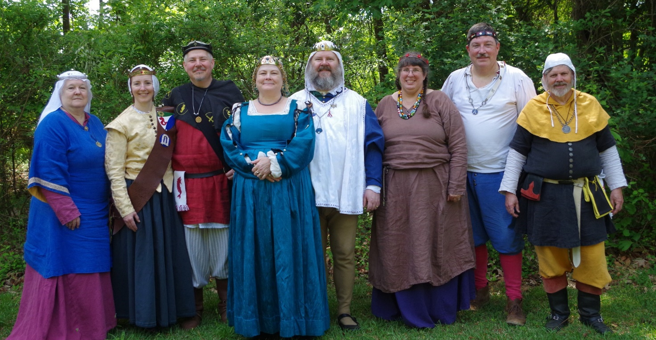

Photo Credit:   
Current and past landed baronage at Baronial Birthday

# Arts & Science and Social Schedule

Classes start at 7pm unless otherwise noted! Classes are held at **Cornerstone Community Church** **1003 Moyer Rd, Newport News, VA 23608**. Business meeting nights will be hybrid in person and online.

|  |
| --- |
| Please check the baronial Facebook group for up to date meeting information. |

July 11 Scribal (see FB event)

18 UFO and Pennsic prep

25 UFO and Pennsic prep

BREAK FOR PENNSIC

August 29 Planning for Fall & Winter Classes

# Virtual A&S Opportunities

|  |  |  |
| --- | --- | --- |
| Virtual Atlantia | Atlantia has setup a Virtual A&S center which includes a calendar of online course offerings, the ability to request a class to be added to the calendar and a way to get credit for the University of Atlantia. Be sure to check it out for an update to date listing of virtual classes throughout the Kingdom. | <http://virtual.atlantia.sca.org/> |
| SCA Virtual Classroom and Artisan Display | Teachers and artisans can share the virtual resources they've created to make them available SCA-wide to continue to foster a learning environment. | <https://www.facebook.com/groups/virtualsca/> |
| Known World Discord | A large discord server that has chat rooms for multiple topics, lots of classes, feedback, and opportunities to connect with artists, fighters, and anyone else across the Known World. | <https://discord.gg/bDavK8> |

Know of any opportunities not listed here? Let us know so we can add them!

Contact the Chronicler via Email, Facebook, or Discord

# Kingdom Calendar

*Please refer to the* [*Kingdom Calendar*](https://atlantia.sca.org/calendar/) *website for up to date information regarding event cancellations or changes.*

#### **July- 2024**

07-04 - 07-07 : [Known World Dance and Music Symposium](https://atlantia.sca.org/event/?event_id=868e3abe) :*(Middle)*

07-05 - 07-07 : [KINGDOM WAR PRACTICE II](https://atlantia.sca.org/event/?event_id=66441202) :*2239 Center Rd, Boonville NC (Sacred Stone)* (Q K Pr P )

07-05 - 07-07 : [1559: Dios de los Meurtos](https://atlantia.sca.org/event/?event_id=217a6608) :*(Meridies)* (Pr )

07-13 - 07-13 : [Warrior's Games 2024](https://atlantia.sca.org/event/?event_id=5dd86013) :*Harleyville SC (Tear-Sea's Shore)*

07-13 - 07-13 : [Sea Dogs Prepare for War!](https://atlantia.sca.org/event/?event_id=6660dd10) :*Waldorf MD (Dun Carraig)*

07-26 - 08-11 : [Pennsic War](https://atlantia.sca.org/event/?event_id=cf109633) :*(Aethelmearc)* (Q K )

#### **Aug- 2024**

08-17 - 08-17 : [Baronial Picnic & Scribal Workshop](https://atlantia.sca.org/event/?event_id=666347e0) :*Prosperity SC (Nottinghill Coill)*

08-30 - 09-01 : [Trial By Fire & Lochmere Arrow (Take 2)](https://atlantia.sca.org/event/?event_id=7e1a072f) :*Glen Arm MD (Bright Hills)*

08-30 - 09-02 : [Emerald Hastilude III](https://atlantia.sca.org/event/?event_id=66624ac7) :*Lanexa VA (Tir-y-Don)*

#### **September- 2024**

09-06 - 09-08 : [Battle on the Bay](https://atlantia.sca.org/event/?event_id=ac8d1bdc) :*Upper Marlboro MD (Lochmere)*

09-06 - 09-08 : [SSBB 2024: The Phoenix & The Dragon](https://atlantia.sca.org/event/?event_id=44d19f8a) :*Boonville NC (Sacred Stone)* (Q K Pr P )

09-13 - 09-15 : [Caravan Raids: Road to Byzantium](https://atlantia.sca.org/event/?event_id=42e6b066) :*Apex NC (Windmasters' Hill)* (P )

09-13 - 09-15 : [Raiders and Traders](https://atlantia.sca.org/event/?event_id=e54b735a) :*Chester SC (Nottinghill Coill)*

09-14 - 09-14 : [Stierbach Baronial Birthday](https://atlantia.sca.org/event/?event_id=37726f33) :*Culpeper VA (Stierbach)* (Q K Pr )

09-21 - 09-22 : [Fall University](https://atlantia.sca.org/event/?event_id=f4997709) :*Harleyville SC (Tear-Sea's Shore)*

09-27 - 09-29 : [Kingdom Royal Archery Tournament](https://atlantia.sca.org/event/?event_id=2bfc6a9c) :*Boonville NC (Isenfir)* (Q K )

09-27 - 09-29 : [Memento Mori: A Danse Macabre](https://atlantia.sca.org/event/?event_id=51d1b424) :*Old Fort NC (Hawkwood)*

09-28 - 09-28 : [Tournament of Silver Chalice](https://atlantia.sca.org/event/?event_id=dffe4057) :*Harleyville SC (Hidden Mountain)* (Pr )

#### **October- 2024**

10-05 - 10-05 : [Fall Coronation (TBD)](https://atlantia.sca.org/event/?event_id=33e37f10) :*(Atlantia)* [](https://moas.atlantia.sca.org/cultura-atlantia)

10-15 - 10-20 : [War of the Wings](https://atlantia.sca.org/event/?event_id=91b8ac6e)  : *Boonville, NC (Atlantia)* (Q K Pr P )

#### **November- 2024**

11-02 - 11-02 : [Fall Crown Tournament (TBD)](https://atlantia.sca.org/event/?event_id=76416c72) :*(Atlantia)* [](https://moas.atlantia.sca.org/tempore-atlantia)

11-08 - 11-10 : [Grit War 2024: A House Divided - Savory vs. Sweet](https://atlantia.sca.org/event/?event_id=63b248b8) :*Apex NC (Ursus Bay)* (P )

11-08 - 11-10 : [Highland Havoc](https://atlantia.sca.org/event/?event_id=762d10c8) :*Ijamsville MD (Highland Foorde)* (Q )

11-15 - 11-17 : [Feast of the Narwhal](https://atlantia.sca.org/event/?event_id=f73a36b8) :*Trenton SC (Cydllan Downs)*

11-15 - 11-17 : [Buckston Birthday 2024](https://atlantia.sca.org/event/?event_id=77a2abbf) :*Apex NC (Buckston-on-Eno)*

11-16 - 11-16 : [Holiday Faire](https://atlantia.sca.org/event/?event_id=924ec2b3) :*Fredericksburg VA (Stierbach)*

11-16 - 11-16 : [In a Phoenix Eye / Runestone](https://atlantia.sca.org/event/?event_id=4163e865) :*Lincolnton NC (Sacred Stone)*

#### **December- 2024**

12-07 - 12-07 : [Unevent 2024 (TBD)](https://atlantia.sca.org/event/?event_id=f8065fe2) :*(Atlantia)* (P )

12-13 - 12-15 : [Yule Toy Tournament](https://atlantia.sca.org/event/?event_id=66698bfe) :*Pickens SC (Nottinghill Coill)*

12-13 - 12-15 : [The Festival of Saturnalia](https://atlantia.sca.org/event/?event_id=663e9c96) :*Nanjemoy MD (Dun Carraig)*

#### **January-2025**

01-11 - 01-11 : [Kingdom Twelfth Night (TBD)](https://atlantia.sca.org/event/?event_id=3e3ffcc2) :*(Atlantia)*

01-18 - 01-18 : [Highland Hearthglow](https://atlantia.sca.org/event/?event_id=8781d758) :*Thurmont MD (Highland Foorde)*

#### **February-2025**

02-01 - 02-01 : [Winter University (TBD)](https://atlantia.sca.org/event/?event_id=2b6ad909) :*(Atlantia)*

02-08 - 02-08 : [Sir Walter Raleigh Costume Ball III](https://atlantia.sca.org/event/?event_id=6650b9fe) :*Durham NC (Buckston-on-Eno)*

02-21 - 02-23 : [Ymir 50](https://atlantia.sca.org/event/?event_id=667057b2) :*Ellerbe NC (Windmasters' Hill)* (Q K )

#### **March-2025**

03-01 - 03-01 : [Kingdom Arts & Sciences Festival (TBD)](https://atlantia.sca.org/event/?event_id=ced0ae3b) :*(Atlantia)* [](https://moas.atlantia.sca.org/persona-pentathlon)

03-29 - 03-29 : [Defending the Gate](https://atlantia.sca.org/event/?event_id=66427319) :*Spotsylvania VA (Sudentorre)*

#### **April-2025**

04-05 - 04-05 : [Spring Coronation (TBD)](https://atlantia.sca.org/event/?event_id=e0b05df1) :*(Atlantia)* [](https://moas.atlantia.sca.org/cultura-atlantia)

04-12 - 04-12 : [Festival of Elvegast](https://atlantia.sca.org/event/?event_id=e92a913c) :*Hillsborough NC (Elvegast)*

04-12 - 04-12 : [Dragons Fire IV: Birth of the Dragon](https://atlantia.sca.org/event/?event_id=664b66f7) :*Easley SC (Saint Georges)*

04-25 - 04-27 : [Baronial Spring Camp](https://atlantia.sca.org/event/?event_id=a6face14) :*Apex NC (Windmasters' Hill)*

# The Barony Around the Web

Many members of the populace have a Web Presence. Please visit their websites and share in the great content. Please contact the Chronicler if you want to promote your site.

Baroness Jane Fox <https://jezebeljane.blogspot.com/>

Baron John Biggeheved <https://biggeheved.com/>

Mistress Kaleeb the Green Eyed <http://kaleeb.galtham.org/>

Learn Fiore <http://learnfiore.org/>

Baron Llwyd Aldrydd <http://baronllwyd.org/>

Lady Mariss Ghijs <https://opusmariss.wordpress.com>

Lady Mevanou verch Reys Yriskynit <https://mvry1sca.wordpress.com/>

## Baronial website

Our Web Minister maintains our baronial website. He can be contacted with any content changes that need to be made.

<https://www.tirydon.atlantia.sca.org>

## Baronial Facebook Group

We share some informal announcements and share content on our Facebook group. It’s another way to stay connected with those in the Barony.

<https://www.facebook.com/groups/343471645861986/>

## Kingdom eNewsletters

Log in with your SCA Member Portal username and password. This requires at least an associate membership to access. Please contact SCA corporate with any log in issues.

<https://members.sca.org/apps/#SignIn>

# 

# Baronial Meeting Notes

|  |  |
| --- | --- |
| Location: | Cornerstone Community Church and virtual |
| Date and Time:  June 22 and July 4, 2024 | Next Meeting’s Date and Time:  Thurs 9/20, 7:00pm Cornerstone Community Church |

Baron and Baroness

We are making arrangements for Pennsic; please confirm your registration and contact Us regarding camping, set up and take down, and dinner. Also, please let Us know what days you will be fighting.

Please let Their Excellencies know if you will be attending upcoming events, so the appropriate tentage can be brought. Also, any contributions for gift baskets are appreciated.

Anyone who is interested in being a deputy for any office is encouraged to contact that officer.

Officer Reports

### Seneschal

NTR

### Exchequer

The signature card is continuing to be difficult, but she is persevering.

### Chatelaine

There is potentially a demo in Isenfir; stay tuned for details. He should know about the 12th Night bid by July 15th.

### Chronicler

Submission deadline is the 25th. Please send content.

### Herald

A new name has been accepted at Kingdom level. **I am looking for a replacement – please contact me if you are interested.**

### Knight Marshal

Deer Park in Newport News is the new practice site. Please check the website for the most current practice schedule.

### Archery

### Make sure you have your card for shooting at Newport News park! A new practice site is available at Wilcox Bait & Tackle on Jefferson, but costs $10 per person per hour. Sir Tnek is willing to schedule an arrow making class.

### Equestrian

Practices are once a month regionally. Please make sure you are authorized for ground crew at our upcoming event over Labor Day weekend. Sir T’nek, Master Jean Claude, and Master Aldrydd are looking into the possibility of fighting on horseback.

### Arts and Sciences

**A new minister of Arts and Sciences is needed!** You will need to schedule classes, encourage participation, and submit a quarterly report. Interested parties should contact the Seneschal.

### Social Media

Our new Social Media Minister is Skye Walker. She has sent a survey to the barony’s FB page – please take it to help her plan our media presence more effectively.

### Web Minister

The roster is in the process of being recovered. You may wish to update your information with your particular interests.

Old & New Business

## Old Business

**DATE CHANGE:** The 50th anniversary of Tir y don’s first event will be held at the Abingdon Ruritan Club, in Hayes, **May 9-11**, 2025. Yes, that’s Mother’s Day weekend. Dame Mariana and Baroness Hannah are the event stewards. There is space for camping, **equestrian**, fighting, and archery, as well as a hall and kitchen.

Our next event is the Hastilude over Labor Day weekend. It will be held at the Emerald Ridge Stables in Lanexa. Please register to attend on SCORES. We will need ground crew, someone to supervise lunch prep (sandwiches), and people to bring sweet baked goods for desserts. [https://tirydon.atlantia.sca.org/emerald2024](http://tirydon.atlantia.sca.org/emerald2024)

Don’t forget that Falloween is coming – Oct 5-6 in Newport News. Think about what you can demonstrate for the event.

Are you turning Japanese? (1980s’ throwback for you!) There is an exhibit of samurai armor through Aug 4, 2024, at the VMFA.

## New Business

$200 has been approved to buy new serving utensils for the Barony.

# Baronial Officer Regnum

|  |  |  |  |
| --- | --- | --- | --- |
| http://tirydon.atlantia.sca.org/wp-content/uploads/2018/11/tyd-1-251x300-1.gif | **Baron:** | Jean-Claude du Calais (Jim Cunningham) | [baron@tirydon.atlantia.sca.org](mailto:baron@tirydon.atlantia.sca.org) 757-968-5303 NLT 9pm |
| http://tirydon.atlantia.sca.org/wp-content/uploads/2018/11/tyd-1-251x300-1.gif | **Baroness:** | Alyna of the Ilex (Holly Cunningham) | [baroness@tirydon.atlantia.sca.org](mailto:baroness@tirydon.atlantia.sca.org) 757-968-5303 NLT 9pm |
| http://tirydon.atlantia.sca.org/wp-content/uploads/2018/11/o_sen.gif | **Seneschal (President):** | Llwyd Aldrydd (Lloyd Eldred) | [seneschal@tirydon.atlantia.sca.org](mailto:seneschal@tirydon.atlantia.sca.org) (757) 875-0033 NLT 9pm |
| http://tirydon.atlantia.sca.org/wp-content/uploads/2018/11/o_exch.gif | **Chancellor of the Exchequer (Treasurer):** | Sarah Kennedy of Glengarry (Sarah Kennedy) | [exchequer@tirydon.atlantia.sca.org](mailto:exchequer@tirydon.atlantia.sca.org) NLT 9pm |
| http://tirydon.atlantia.sca.org/wp-content/uploads/2018/11/o_chat.gif | **Chatelaine (New member support):** | Andrei Barsukov (Andrew LaVinus) | [chatelaine@tirydon.atlantia.sca.org](mailto:chatelaine@tirydon.atlantia.sca.org)  (804) 869-8882 NLT 9:30pm |
| http://tirydon.atlantia.sca.org/wp-content/uploads/2018/11/o_chr.gif | **Chronicler**  **(Secretary):** | Anne van Sintmaartensdyck (Nancy Kiel) | [chronicler@tirydon.atlantia.sca.org](mailto:chronicler@tirydon.atlantia.sca.org) (757) 220-6857, leave a message NLT 9:30pm |
| http://tirydon.atlantia.sca.org/wp-content/uploads/2018/11/o_chr.gif | **Social Media:** | Skye Walker | [socialmedia@tirydon.atlantia.sca.org](mailto:socialmedia@tirydon.atlantia.sca.org) |
| http://tirydon.atlantia.sca.org/wp-content/uploads/2018/11/o_herald.gif | **Herald:** | Catheryn inghean Ui Dhubhshlaine (Amanda Carter) | [herald@tirydon.atlantia.sca.org](mailto:herald@tirydon.atlantia.sca.org) |
| http://tirydon.atlantia.sca.org/wp-content/uploads/2018/11/o_marshal.gif | **Knight’s Marshal:** | Christina O’Cleary  (Jessica Lavinus) | [marshal@tirydon.atlantia.sca.org](mailto:marshal@tirydon.atlantia.sca.org) NLT 9pm |
| http://tirydon.atlantia.sca.org/wp-content/uploads/2018/11/o_marshal.gif | **Marshal of Archery:** | Leofric of Oxenford (Mike Durling) | [archer@tirydon.atlantia.sca.org](mailto:archer@tirydon.atlantia.sca.org) |
| http://tirydon.atlantia.sca.org/wp-content/uploads/2018/11/o_as.gif | **Minister of Arts & Sciences:** | Cairistiona inghean Mhuireadhaigh (Carol Vanderspoel) | [moas@tirydon.atlantia.sca.org](mailto:moas@tirydon.atlantia.sca.org) (757) 819-3296 NLT 9:30pm |
| Office Badge | **Webminister:** | Llwyd Aldrydd (Lloyd Eldred) | [webminister@tirydon.atlantia.sca.org](mailto:webminister@tirydon.atlantia.sca.org) (757) 875-0033 NLT 9:30pm |

# Statement of Ownership, Submissions & Disclaimer

This is the June - July 2024 issue of the NoD-y-Rit, a publication of the Barony of Tir-y-Don of the Society for Creative Anachronism, Inc. The Nod-y-Rit is available from Anna van Sint Maartensdyjk (Nancy Kiel) at [chronicler@tirydon.atlantia.sca.org](mailto:chronicler@tirydon.atlantia.sca.org) and Nancy_kiel@hotmail.com. Subscriptions are free as all publications are available electronically. This newsletter is not a corporate publication of the Society for Creative Anachronism, Inc., and does not delineate SCA policies.

© Copyright 2024, Society for Creative Anachronism, Inc. For information on reprinting letters and artwork from this publication, please contact the Tir-y-Don Chronicler, who will assist you in contacting the original creator of the piece. Please respect the legal rights of our contributors.

Please send submissions to:

Nancy Kiel

108 Wilson Circle, Williamsburg VA

[chronicler@tirydon.atlantia.sca.org](mailto:chronicler@tirydon.atlantia.sca.org)

Nancy_kiel@hotmail.com

***Please, remember that all submissions to the NoD-y-Rit must be accompanied by an SCA release form.*** The first link leads you to the Society Chronicler’s links for forms. The last three links are for the forms that can be submitted on line via Internet Form Fills. Everyone is encouraged to consider contributing to the NoD-y-Rit.

Society Chronicler forms:

<http://chronicler.atlantia.sca.org/Releases.html>

Release form for writing or artwork:

<http://chronicler.atlantia.sca.org/ReleaseCreativeFillable.pdf>

Release form for photographs:

<http://chronicler.atlantia.sca.org/ReleasePhotographerFillable.pdf>

Release form for model(s) (the subject of your artwork or photograph):

<http://chronicler.atlantia.sca.org/ReleaseModelFillable.pdf>

# Marshal Information

## Image result for mINISTER OF LIST BADGE SCABecome a MOL

Want to serve the Fighter Community by providing Tournament organization and keeping the Fighting Authorizations documented? Consider becoming a Minister of the List.

Please visit the Kingdom MOL website for more information and forms: <http://mol.atlantia.sca.org/ForMoLs/index.html>

## Become a Marshal

Do you enjoy fighting activities at events and practices? Many folks invest significant time to keep these activities safe. Consider becoming a marshal to help keep these activities happening in the future.

Please visit the Earl Marshals Website for more information: <https://marshal.atlantia.sca.org/procedures/mit/>

## Marshal Event Report Submission

Participants, Fighters and Marshals can all submit Event reports for fighting activities. If you see something you wish to report visit the Kingdom Earl Marshal Website. Include things like injuries, equipment failures, or other issues you see.

Submit a report here: <https://warrant.atlantia.sca.org/reports/new/1>

## Warranted Marshals

The Kingdom maintains a list of warranted marshals and Marshals in Training. A list of marshals who have expired warrants is also maintained here.

Visit: <https://warrant.atlantia.sca.org/warrants/branch/6/1>

# Award Recommendations

## Baronial Award Recommendations

Baronial Award Recommendations are sent to the Coronet. Please use [baron@tirydon.atlantia.sca.org](https://d.docs.live.net/55395330e2cd57ab/SCA/NODYRIT/baron@tirydon.atlantia.sca.org)  and [baroness@tirydon.atlantia.sca.org](https://d.docs.live.net/55395330e2cd57ab/SCA/NODYRIT/baroness@tirydon.atlantia.sca.org).

## Kingdom Award Recommendations

The Kingdom maintains a database of award recommendations and what events potential recipients will attend in the future. Visit: <https://award.atlantia.sca.org/>

## Review your Order of Precedence Entry

Recent name change or award? Please visit the Atlantia’s Order of Precedence (OP) and request any updates or corrections as needed.

Visit the OP here: <http://op.atlantia.sca.org>

Submit Corrections requests here: <http://op.atlantia.sca.org/corrections.php>

Letters from Their Excellencies

Greetings!  
  
Summer is here and with it come camping events. A wide range of camping experience resides within these lands and this month we would like to focus on some high level camping considerations. If you have questions, please reach out to Us or to the Campfire Facebook page. We want to make camping events enjoyable for you.  
  
Camping in the middle ages (at least for the ranks of the nobility) was more of a “glamping” affair. This Barony tends to take that to heart and many of us “move in” for the week/end as much as our vehicle and pocket will allow. So what do you need to know or have to camp in the SCA?  
  
First, check the event flier or website to find out if you have to declare where you are camping. Some events allow people and groups to register camps so your tent is next to people you know and you can pool resources (such as cooking or shower supplies). You may need to provide the size of your tent so the land managers can make sure they allow enough room for you. Then, if you are camping with a group, let the camp coordinator of that group know so they can include you in conversations about meals, and set up/take down chores. You are not required to participate in group meals but if you are using communal supplies then it’s nice to clean up after yourself and pitch in necessary supplies used by everyone such as dish detergent, trash bags, or paper towels.  
  
You do not need to buy a medieval pavilion and can use modern tents. Warning! A two-person tent means two people can lie down right next to each other in that tent. If you need to store clothes, a cooler, or sit up/stand to get dressed then you will need something larger.  
  
Many event sites get cool at night so be sure to pack a cloak, blanket, and enough bedding to keep you warm. If you are using an air mattress, it is a good idea to have insulation (like a blanket or sleeping bag) between you and the air-filled mattress as well as between the air-filled mattress and the ground.  
  
Event sites may not have water access so bring water for drinking and cleaning. Usually, the camp uses paper plates and plastic ware because it can be difficult to wash dishes. Bring a flashlight (with working batteries) for getting around the camp and to the bathroom facilities at night. The site may also post information about what types of fire can be used in camps. Some sites only allow above ground fire bowls or do not allow any open fires.

Keep a notebook or list of things you wish you had or if repairs and restock are needed in your supplies. Then, when you get ready to camp again you can be even more prepared. Several baronial members have camping checklists which we are happy to share with you. These are specific to the SCA and include things like: garb, armour, weapons, tent canvas, poles…

You also want to consider your modern needs and prepare to bring medications, preferred snacks or drinks, first aid needs and of course sunscreen and insect repellent. If you have an emergency medication or severe allergy, ask someone to be your on-site contact. Tell that person where you keep your emergency medications and what to do if you are in distress.  
  
For events where weather might be an issue, keep a set of dry clothes in your car or in a sealed, watertight bag in your tent. This way you can go home (or into town for longer events) with some level of comfort. At the least, dry shoes and socks can feel like the best thing in the world if you’ve taken down the camp in the rain.  
  
If you want to get even deeper into camping and nature, Atlantia has a Forester’s Guild which researches outdoor topics. Their goal is focused on historical accuracy so you might need to forego some modern amenities if you camp with them. The guild is a great way to learn more about nature and how people in the middle ages survived away from cities and villages.

Jean Claude and Alyna

Quintus Curtius, The Life and Deeds of Alexander the Great 1470-1475

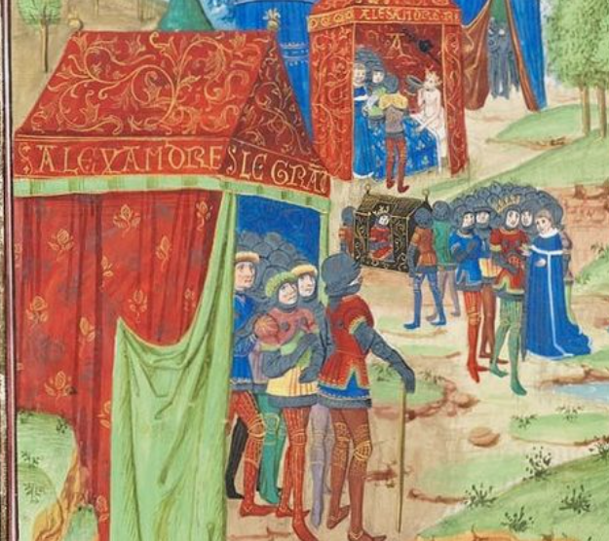

Princes of the East Princes of the West Master of the Cite des Dames: Livre du Chevalier Errant by Thomas de Saluces. c.1404 Bibliotheque Nationale MS. Fr. 12559

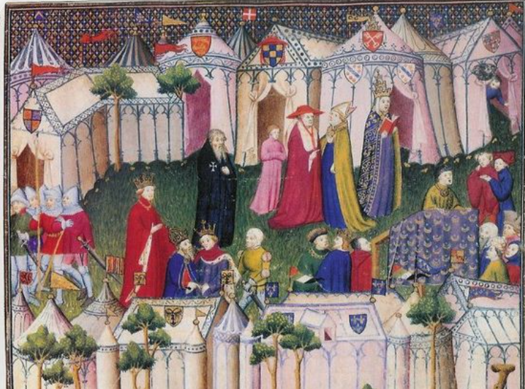

Photos courtesy of Dame Hrothny of Marinus

