Barony of Tir-y-Don
The NoD-Y-RIT
Apr AS 59 (CE 2024)
Volume 43 Issue 4 Society of Creative Anachronism (SCA Inc.)
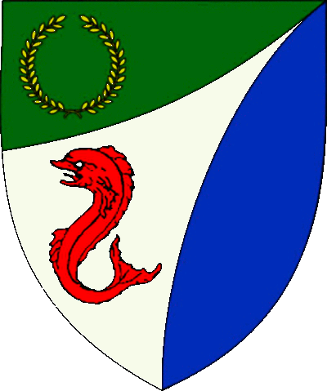

Table of Contents
Weekly Activities in the Barony 2
Arts & Science and Social Schedule 3
Virtual A&S Opportunities 3
Kingdom Calendar 4
The Barony Around the Web 5
Baronial Meeting Notes 6
Baronial Officer Regnum 7
Statement of Ownership 8
Submissions & Disclaimer 8
Marshal Information 9
Award Recommendations 9

The Coronet of the Barony of Tir-y-Don
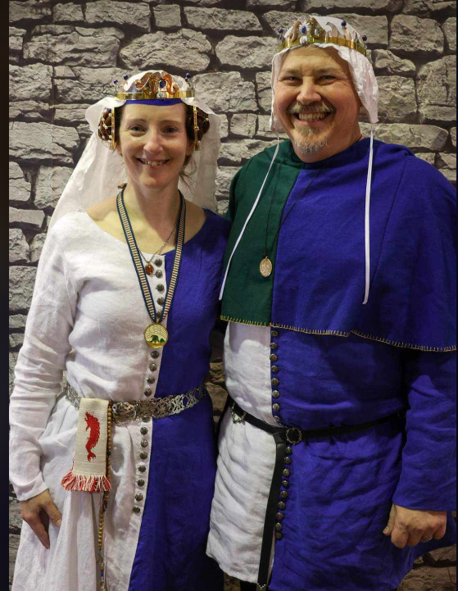
This is the Apr 2024 issue of the NoD-Y-Rit, a publication of the Barony of Tir-Y-Don of the Society for Creative Anachronism, Inc. The Nod-Y-Rit is available from Anna van Sint Maartensdyjk at chronicler@tirydon.atlantia.sca.org. Subscriptions are free as all publications are available electronically. This newsletter is not a corporate publication of the Society for Creative Anachronism, Inc., and does not delineate SCA policies.
© Copyright 2020, Society for Creative Anachronism, Inc. For information on reprinting letters and artwork from this publication, please contact the Tir-Y-Don Chronicler, who will assist you in contacting the original creator of the piece. Please respect the legal rights of our contributors.
Their Excellencies:
Baron Jean-Claude de Calais
Baroness Alina of the Ilex
Photo Credit: Llwyd Aldrydd

Weekly Activities in the Barony

Sundays
10AM | Archery Practice  Contact Marshal of Archery Newport News City Park  Archery Range | Call 757-888-3333 for Safety Class Schedule.  Call Marshal of Archery before attending.
Take the Archery Safety Class online. You can email the completed test to the parks department.
Your card will be emailed to you.
https://www.nnva.gov/2561/Archery-Range
1PM | Fighter Practice and Social  Heavy/Rapier  Contact Knight Marshal | Please contact the Marshal if you wish to attend.

Mondays
7PM | Armory Night  Contact Tim Prickett | Contact Tim before attending.

Thursdays
7PM | Arts & Sciences and Social  Contact MOAS  Arts & Science and Social Schedule | Contact MOAS or Baroness Kaleeb for more details – In person, some hybrid sessions
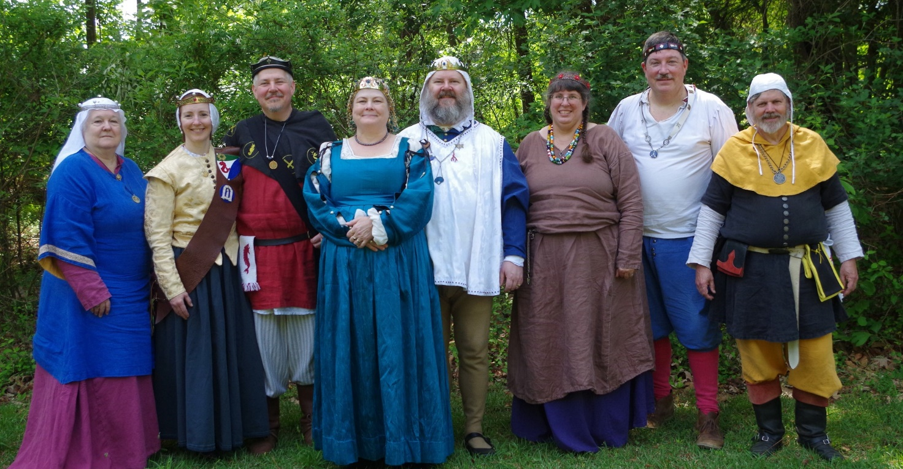
Photo Credit:
Current and past landed baronage at Baronial Birthday

Arts & Science and Social Schedule

Classes start at 7pm unless otherwise noted! Classes are held at Cornerstone Community Church 1003 Moyer Rd, Newport News, VA 23608. Business meeting nights will be hybrid in person and online.

Please check the baronial Facebook group for up to date meeting information.

May 2 Beginning Embroidery
9 Scribal (see FB event)
16 Business Meeting followed by Unfinished Objects
23 Dancing
30 Brewing Intro to and Conventions of Competition & Judging
June 6 Outdoor Games
13 Scribal (see FB event)
20 Business Meeting followed by Unfinished Objects
27 Woodburning and Pyrography
July 4 Party- details TBD
11 Scribal (see FB event)
18 Business Meeting followed by Requests for Pennsic University
BREAK FOR PENNSIC
August 29 Planning for Fall & Winter Classes

Virtual A&S Opportunities
Virtual Atlantia | Atlantia has setup a Virtual A&S center which includes a calendar of online course offerings, the ability to request a class to be added to the calendar and a way to get credit for the University of Atlantia. Be sure to check it out for an update to date listing of virtual classes throughout the Kingdom. | http://virtual.atlantia.sca.org/
SCA Virtual Classroom and Artisan Display | Teachers and artisans can share the virtual resources they've created to make them available SCA-wide to continue to foster a learning environment. | https://www.facebook.com/groups/virtualsca/
Known World Discord | A large discord server that has chat rooms for multiple topics, lots of classes, feedback, and opportunities to connect with artists, fighters, and anyone else across the Known World. | https://discord.gg/bDavK8
Know of any opportunities not listed here? Let us know so we can add them!
Contact the Chronicler via Email, Facebook, or Discord

Kingdom Calendar
Please refer to the Kingdom Calendar website for up to date information regarding event cancellations or changes.

May- 2024
05-03 - 05-05 : Spring Crown Tournament :Bennettsville SC (Hidden Mountain)
05-10 - 05-12 : Hawkwood Baronial Birthday XX: The Great Unicorn Hunt! :Old Fort NC (Hawkwood) (Q K )
05-11 - 05-11 : On Target :Annapolis MD (Lochmere)
05-18 - 05-18 : Dragon's Fire III :Easley SC (Saint Georges)
05-18 - 05-18 : Skewered IV: There and Back Again :Gaithersburg MD (Roxbury Mill)
05-24 - 05-27 : Ruby Joust XII :Ashland VA (Caer Mear) (Q K )

June- 2024
06-08 - 06-08 : Summer University (TBD) : (Atlantia)
06-15 - 06-15 : Not Quite Quarterly Braggin' Rights IV :Aiken SC (Ritterwald) (Q K )
06-15 - 06-15 : Victory on the Vine :Culpeper VA (Ponte Alto)
06-21 - 06-23 : Inter-Kingdom Fighter Practice: :Bryson City NC (Stormwall)
06-28 - 06-30 : Atlantia Bardic Madness :MATTHEWS NC (Atlantia)

July- 2024
07-04 - 07-07 : Known World Dance and Music Symposium : (Middle)
07-13 - 07-13 : Warrior's Games 2024 :Harleyville SC (Tear-Sea's Shore)
07-26 - 08-11 : Pennsic War : (Aethelmearc) (Q K )

Aug- 2024
08-30 - 09-01 : Trial By Fire & Lochmere Arrow (Take 2) :Glen Arm MD (Bright Hills)

September- 2024
09-06 - 09-08 : SSBB 2024: The Phoenix & The Dragon :Boonville NC (Sacred Stone)
09-06 - 09-08 : Battle on the Bay :Upper Marlboro MD (Lochmere)
09-13 - 09-15 : Raiders and Traders :Chester SC (Nottinghill Coill)
09-13 - 09-15 : Caravan Raids: Road to Byzantium :Apex NC (Windmasters' Hill)
09-14 - 09-14 : Stierbach Baronial Birthday :Culpeper VA (Stierbach) (Q K )
09-21 - 09-21 : Fall University :Harleyville SC (Tear-Sea's Shore)
09-26 - 09-29 : Kingdom Royal Archery Tournament :Boonville NC (Isenfir) (Q K )
09-27 - 09-29 : Memento Mori: A Danse Macabre :Old Fort NC (Hawkwood)
09-28 - 09-28 : Tournament of Silver Chalice :Harleyville SC (Hidden Mountain)

October- 2024
10-05 - 10-05 : Fall Coronation (TBD) : (Atlantia)
10-15 - 10-20 : War of the Wings (TBD) : (Atlantia)

November- 2024
11-02 - 11-02 : Fall Crown Tournament (TBD) : (Atlantia)
11-08 - 11-10 : Grit War 2024: A House Divided - Savory vs. Sweet :Apex NC (Ursus Bay)
11-08 - 11-10 : Highland Havoc :Ijamsville MD (Highland Foorde)
11-15 - 11-17 : Buckston Birthday 2024 :Apex NC (Buckston-on-Eno)
11-15 - 11-17 : Feast of the Narwhal :Trenton SC (Cydllan Downs)
11-16 - 11-16 : Holiday Faire :Fredericksburg VA (Stierbach)
11-16 - 11-16 : In a Phoenix Eye / Runestone :Lincolnton NC (Sacred Stone)

December- 2024
12-07 - 12-07 : Unevent 2024 (TBD) : (Atlantia)

January-2025
01-11 - 01-11 : Kingdom Twelfth Night (TBD) : (Atlantia)
01-18 - 01-18 : Highland Hearthglow :Thurmont MD (Highland Foorde)

The Barony Around the Web
Many members of the populace have a Web Presence. Please visit their websites and share in the great content. Please contact the Chronicler if you want to promote your site.
Baroness Jane Fox https://jezebeljane.blogspot.com/
Baron John Biggeheved https://biggeheved.com/
Mistress Kaleeb the Green Eyed http://kaleeb.galtham.org/
Learn Fiore http://learnfiore.org/
Baron Llwyd Aldrydd http://baronllwyd.org/
Lady Mariss Ghijs https://opusmariss.wordpress.com
Lady Mevanou verch Reys Yriskynit https://mvry1sca.wordpress.com/

Baronial website
Our Web Minister maintains our baronial website. He can be contacted with any content changes that need to be made.
https://www.tirydon.atlantia.sca.org

Baronial Facebook Group
We share some informal announcements and share content on our Facebook group. It’s another way to stay connected with those in the Barony.
https://www.facebook.com/groups/343471645861986/

Kingdom eNewsletters
Log in with your SCA Member Portal username and password. This requires at least an associate membership to access. Please contact SCA corporate with any log in issues.
https://members.sca.org/apps/#SignIn

Baronial Meeting Notes
Location: | Cornerstone Community Church and virtual
Date and Time:  Apr 18, 2024, 7:00 pm | Next Meeting’s Date and Time:  Thurs 5/16, 7:00pm Cornerstone Community Church
Baron and Baroness
Please let Their Excellencies know if you will be attending upcoming events, so the appropriate tentage can be brought. Also, any contributions for gift baskets are appreciated.
Anyone who is interested in being a deputy for any office is encouraged to contact that officer.

Officer Reports

Seneschal
NTR

Exchequer
Total bank account is approximately $10,000.

Chatelaine
Adopt a Highway has been discussed; VDOT has a map showing areas available for adoption. Please review the map and make suggestions regarding areas. Victory Blvd near Kiln Creek is a possibility.

Chronicler
Submission deadline is the 25th. Please send content.

Herald
Investiture and Quarterly reports have been submitted, as well as 2 names, 4 devices, and a badge. I am looking for a replacement – please contact me if you are interested.

Knight Marshal
Deer Park in Newport News is the new practice site. Please check the website for the most current practice schedule.

Archery

A new practice site is available at Wilcox Bait & Tackle on Jefferson, but costs $10 per person per hour. Sir Tnek is willing to schedule an arrow making class.

Equestrian
Not present. Practices are once a month regionally.

Arts and Sciences
Classes are held every Thursday at Cornerstone Community Church 1003 Moyer Rd, Newport News, VA 23608.

Social Media
An Instagram account has been set up, with pictures from the recent demos, and an A&S page.

Web Minister
The roster is in the process of being recovered. You may wish to update your information with your particular interests.
Old & New Business

Old Business
Barony members tripped the Light Fantastic at the Mosaic Festival in Hampton, and their demonstration was well-received.

The 50th anniversary of Tir y don’s first event will be held at the Abingdon Ruritan Club, in Hayes, April 11-13, 2025. Dame Mariana and Baroness Hannah are the event stewards. There is space for camping, equestrian, fighting, and archery, as well as a hall and kitchen.

New Business

If you are attending Ruby Joust, please see how you can help in terms of pavilion set up and food. If you are planning on camping, please let Baroness Alyna know as soon as possible, so that she can arrange space. We are also having a yard sale – if you would like to contribute anything, please make sure you have priced it. Baroness Kaleeb is coordinating the sale, so please contact her if you have additional questions.

Pennsic fast approaches, and the site is being made more ADA compliant. If you have a disability and need special accommodations, please contact the site as soon as possible. You will also need to create a new account to register for classes.

Baronial Officer Regnum
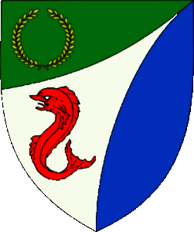 | Baron: | Jean-Claude du Calais  (Jim Cunningham) | baron@tirydon.atlantia.sca.org  757-968-5303 NLT 9pm
 | Baroness: | Alyna of the Ilex  (Holly Cunningham) | baroness@tirydon.atlantia.sca.org  757-968-5303 NLT 9pm
 | Seneschal (President): | Llwyd Aldrydd  (Lloyd Eldred) | seneschal@tirydon.atlantia.sca.org  (757) 875-0033 NLT 9pm
 | Chancellor of the Exchequer  (Treasurer): | Sarah Kennedy of Glengarry  (Sarah Kennedy) | exchequer@tirydon.atlantia.sca.org  NLT 9pm
 | Chatelaine  (New member support): | Andrei Barsukov  (Andrew LaVinus) | chatelaine@tirydon.atlantia.sca.org  (804) 869-8882 NLT 9:30pm
 | Chronicler  (Secretary): | Anne van Sintmaartensdyck (Nancy Kiel) | chronicler@tirydon.atlantia.sca.org  (757) 220-6857, leave a message NLT 9:30pm
 | Social Media: | Úlfhildr Járnsaxa Svǫnudóttir | socialmedia@tirydon.atlantia.sca.org
 | Herald: | Mary Taran of Glastonbury  (Mary Montgomery) | herald@tirydon.atlantia.sca.org
 | Knight’s Marshal: | Tnek the Ainissestor  (Kent Baldwin) | marshal@tirydon.atlantia.sca.org  NLT 9pm
 | Marshal of Archery: | Leofric of Oxenford  (Mike Durling) | archer@tirydon.atlantia.sca.org
 | Minister of Arts  & Sciences: | Cairistiona inghean Mhuireadhaigh  (Carol Vanderspoel) | moas@tirydon.atlantia.sca.org  (757) 819-3296 NLT 9:30pm
 | Webminister: | Llwyd Aldrydd  (Lloyd Eldred) | webminister@tirydon.atlantia.sca.org  (757) 875-0033 NLT 9:30pm

Statement of Ownership
This is the Nod-Y-Rit, a publication of the Barony of Tir-y-Don of the Society of Creative Anachronism, Inc (SCA). The Nod-Y-Rit is available from Nancy Kiel (chronicler@tirydon.atlantia.sca.org) Subscriptions are free as all publications are available electronically. This newsletter is not a corporate publication of Society of Creative Anachronism, Inc. and does not delineate SCA policies. (c) Copyright 2020, Society for Creative Anachronism, Inc. For information on reprinting letters and artwork from this publication, please contact the Chronicler of Tir-y-Don, who will assist you in contacting the original creator of the piece. Please respect the legal rights of our contributors.

Submissions & Disclaimer
This is the Apr 2024 issue of the NoD-Y-Rit, a publication of the Barony of Tir-Y-Don of the Society for Creative Anachronism, Inc. The Nod-Y-Rit is available from Anna van Sint Maartensdyjk at chronicler@tirydon.atlantia.sca.org. Subscriptions are free as all publications are available electronically. This newsletter is not a corporate publication of the Society for Creative Anachronism, Inc., and does not delineate SCA policies.
© Copyright 2020, Society for Creative Anachronism, Inc. For information on reprinting letters and artwork from this publication, please contact the Tir-Y-Don Chronicler, who will assist you in contacting the original creator of the piece. Please respect the legal rights of our contributors.
Please send submissions to:
Nancy Kiel
108 Wilson Circle, Williamsburg VA
chronicler@tirydon.atlantia.sca.org
Nancy_kiel@hotmail.com

Please, remember that all submissions to the NoD-Y-Rit must be accompanied by an SCA release form. The first link leads you to the Society Chronicler’s links for forms. The last three links are for the forms that can be submitted on line via Internet Form Fills. Everyone is encouraged to consider contributing to the NoD-Y-Rit.
Society Chronicler forms:
http://chronicler.atlantia.sca.org/Releases.html
Release form for writing or artwork:
http://chronicler.atlantia.sca.org/ReleaseCreativeFillable.pdf
Release form for photographs:
http://chronicler.atlantia.sca.org/ReleasePhotographerFillable.pdf
Release form for model(s) (the subject of your artwork or photograph):
http://chronicler.atlantia.sca.org/ReleaseModelFillable.pdf

Marshal Information

Become a MOL
Want to serve the Fighter Community by providing Tournament organization and keeping the Fighting Authorizations documented? Consider becoming a Minister of the List.
Please visit the Kingdom MOL website for more information and forms: http://mol.atlantia.sca.org/ForMoLs/index.html

Become a Marshal
Do you enjoy fighting activities at events and practices? Many folks invest significant time to keep these activities safe. Consider becoming a marshal to help keep these activities happening in the future.
Please visit the Earl Marshals Website for more information: https://marshal.atlantia.sca.org/procedures/mit/

Marshal Event Report Submission
Participants, Fighters and Marshals can all submit Event reports for fighting activities. If you see something you wish to report visit the Kingdom Earl Marshal Website. Include things like injuries, equipment failures, or other issues you see.
Submit a report here: https://warrant.atlantia.sca.org/reports/new/1

Warranted Marshals
The Kingdom maintains a list of warranted marshals and Marshals in Training. A list of marshals who have expired warrants is also maintained here.
Visit: https://warrant.atlantia.sca.org/warrants/branch/6/1

Award Recommendations

Baronial Award Recommendations
Baronial Award Recommendations are sent to the Coronet. Please use baron@tirydon.atlantia.sca.org and baroness@tirydon.atlantia.sca.org.

Kingdom Award Recommendations
The Kingdom maintains a database of award recommendations and what events potential recipients will attend in the future. Visit: https://award.atlantia.sca.org/

Review your Order of Precedence Entry
Recent name change or award? Please visit the Atlantia’s Order of Precedence (OP) and request any updates or corrections as needed.
Visit the OP here: http://op.atlantia.sca.org
Submit Corrections requests here: http://op.atlantia.sca.org/corrections.php

